**Practical File of C**

**(BCA 103)**

**BACHELOR OF COMPUTER APPLICATIONS**

**Academic Session: - 2021-22 Batch-2021-24**



**Submitted To: - Submitted By: -**

**Name- MRS. AMBOOJ YADAV Name: - Nishita Gupta**

**Programme: -BCA**

**Semester: -1**

**Shift: - EVENING**

**Division: - B**



. 1. Write a program to print “hello”…

CODE:

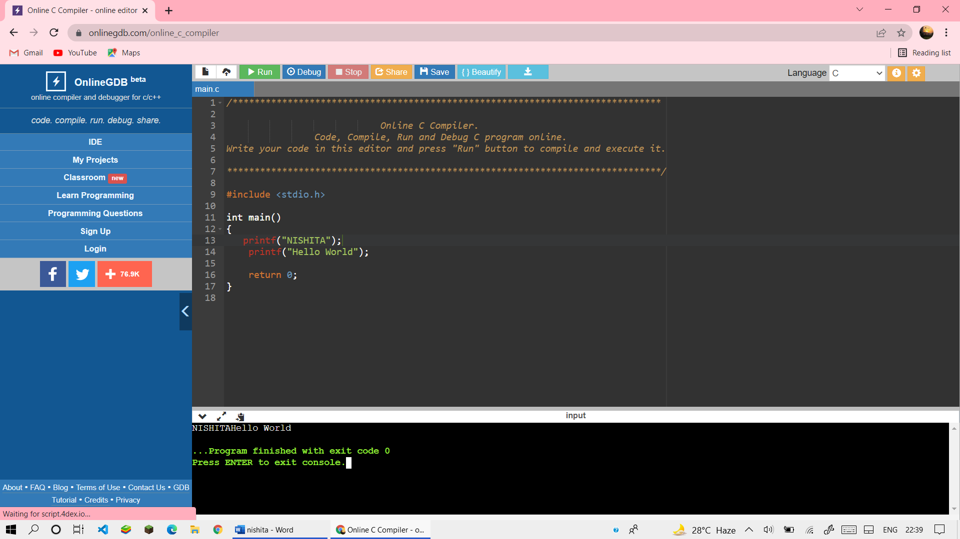

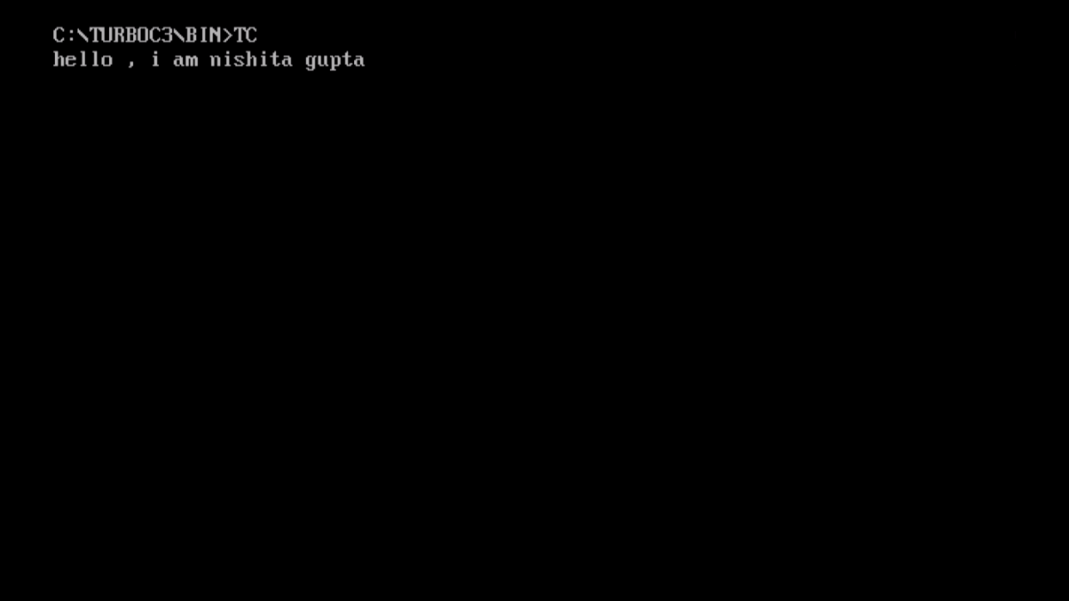

2). Write a program to print the sum of two numbers…

CODE:-

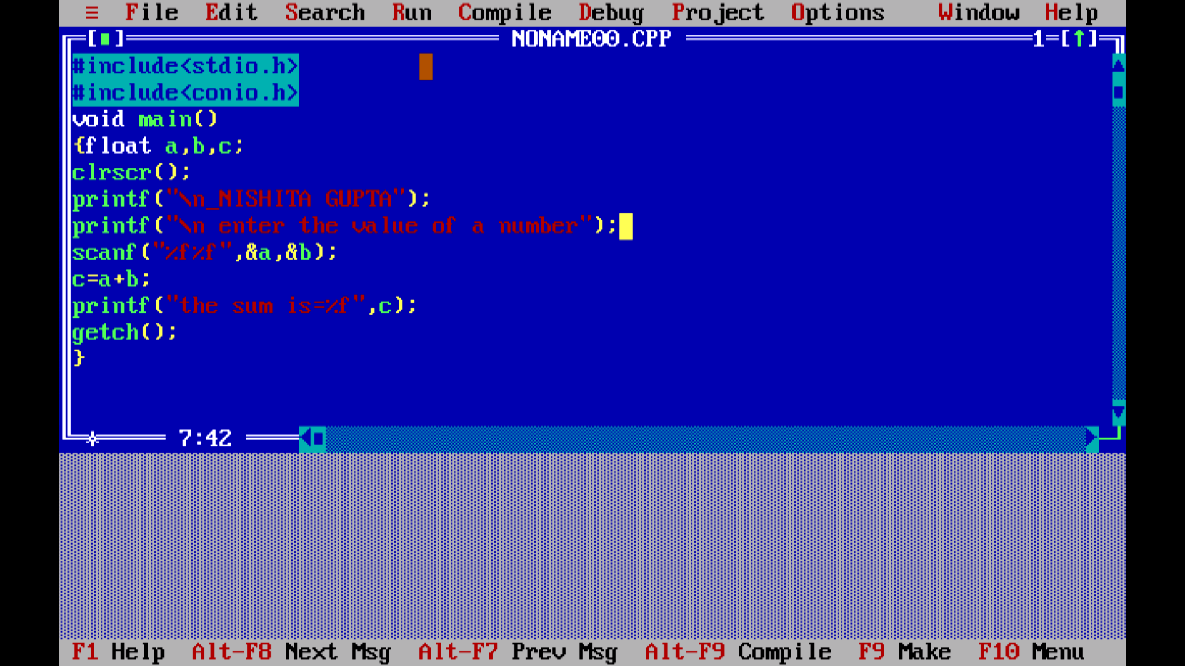

OUTPUT:-

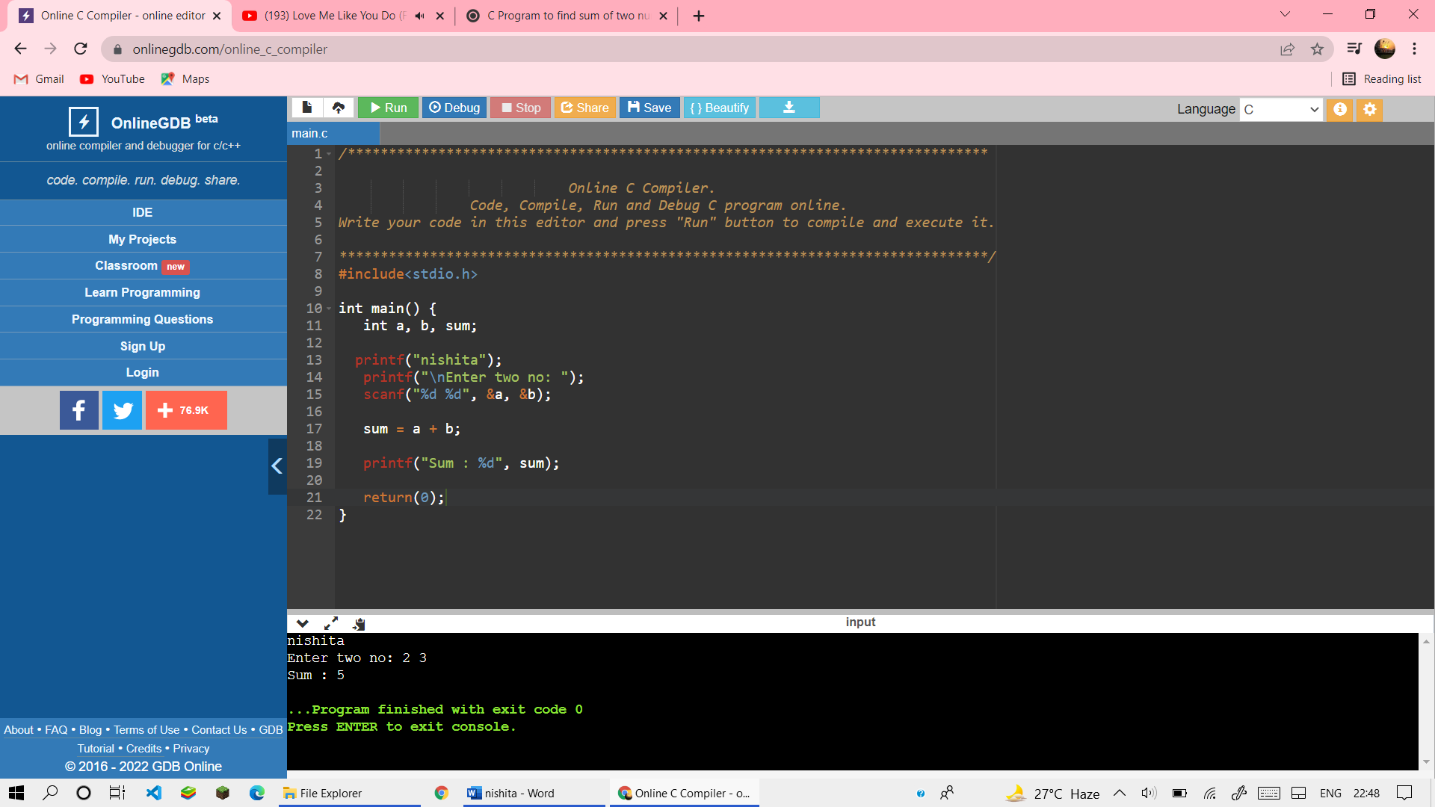

3). Write a program to print sum and percentage of five subjects…

CODE:-

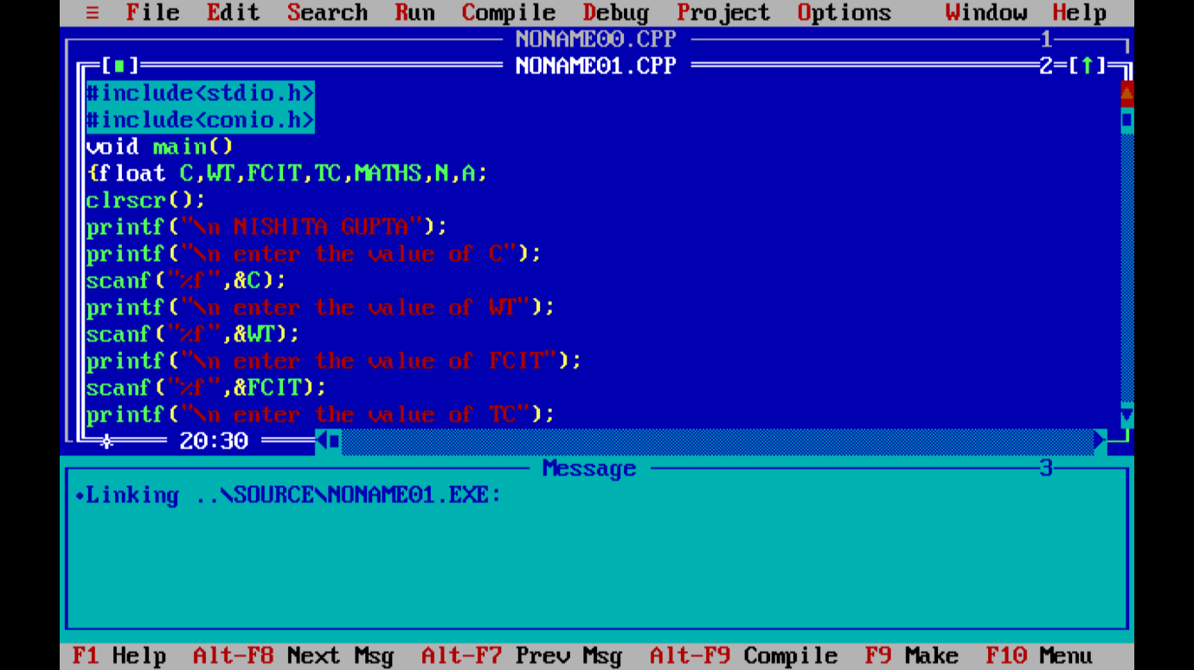

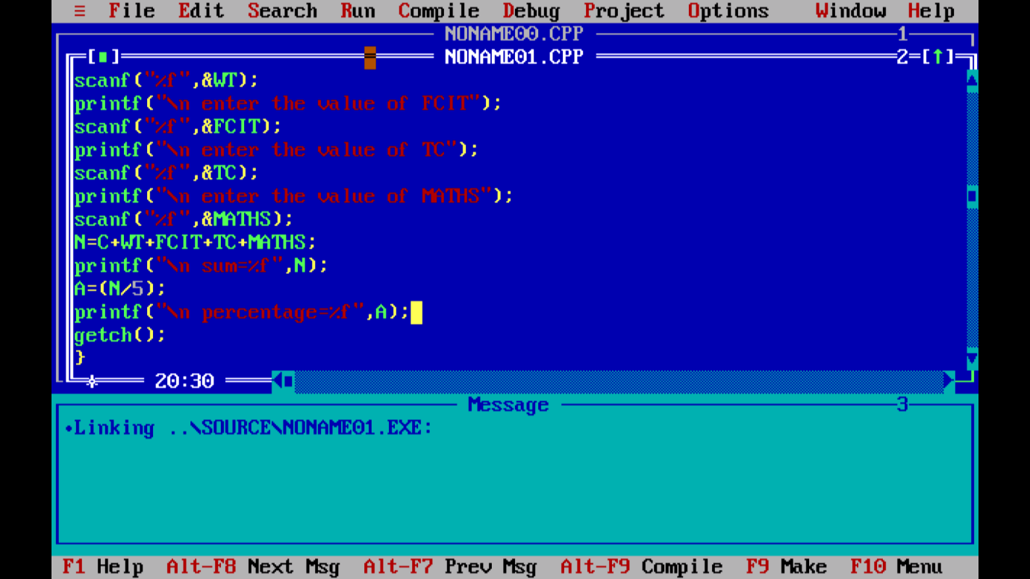

OUTPUT:-

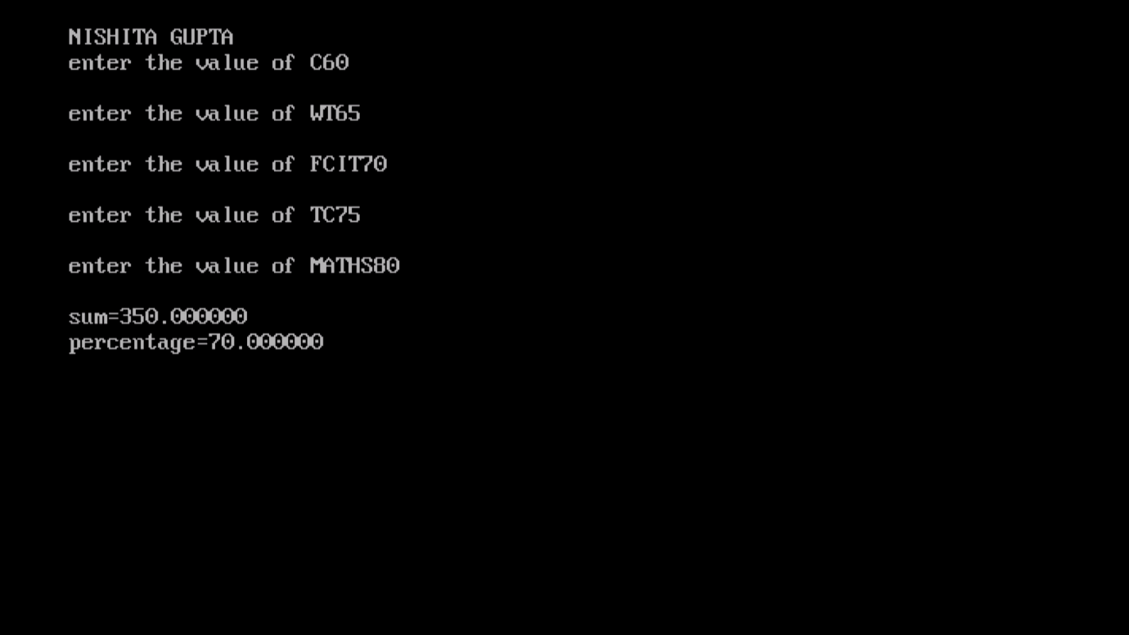

4). Write a program to print your resume.

CODE:-

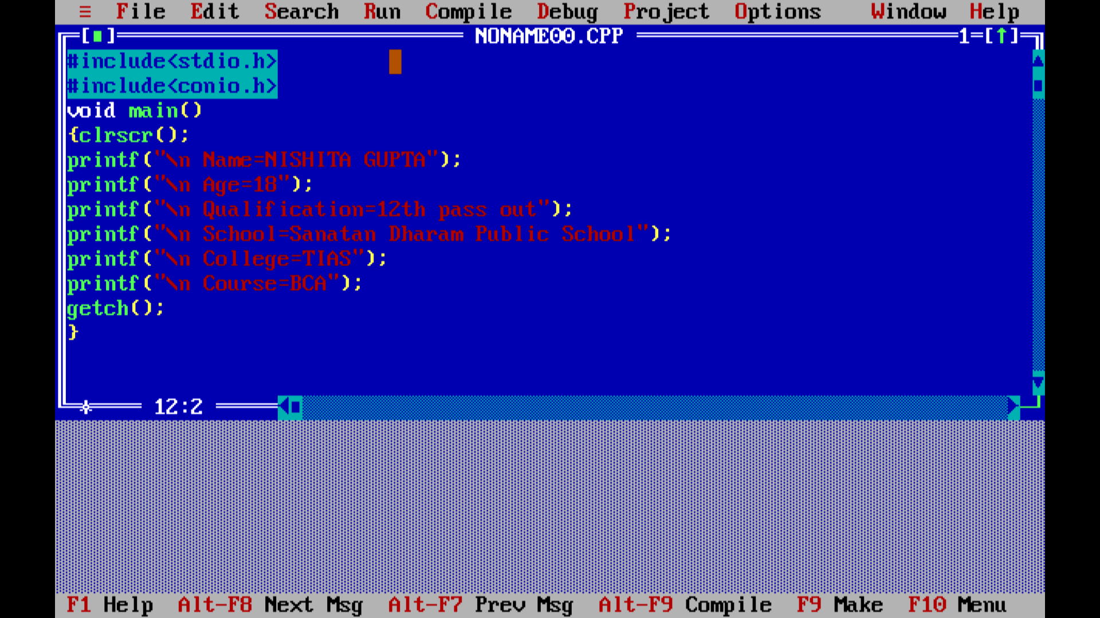

OUTPUT:-

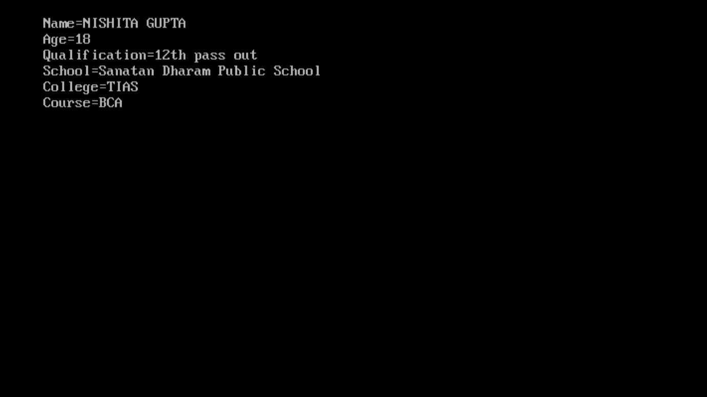

5). Write a program to print char type variable...

CODE:-

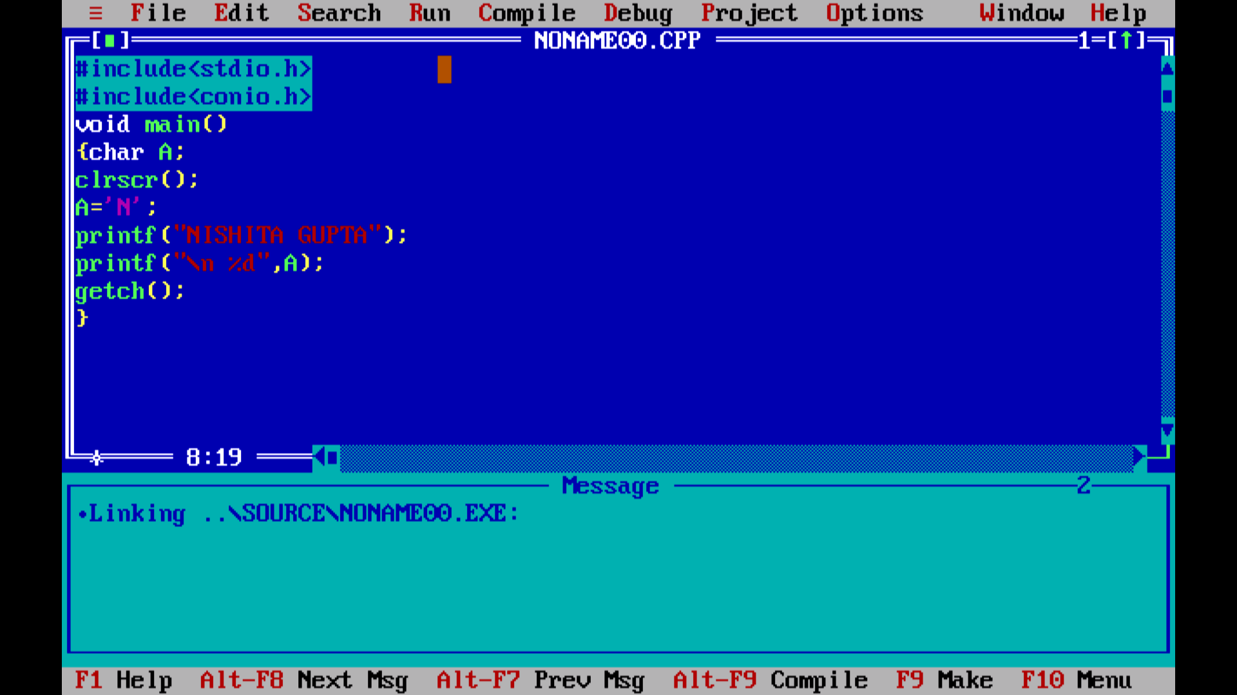

OUTPUT:-

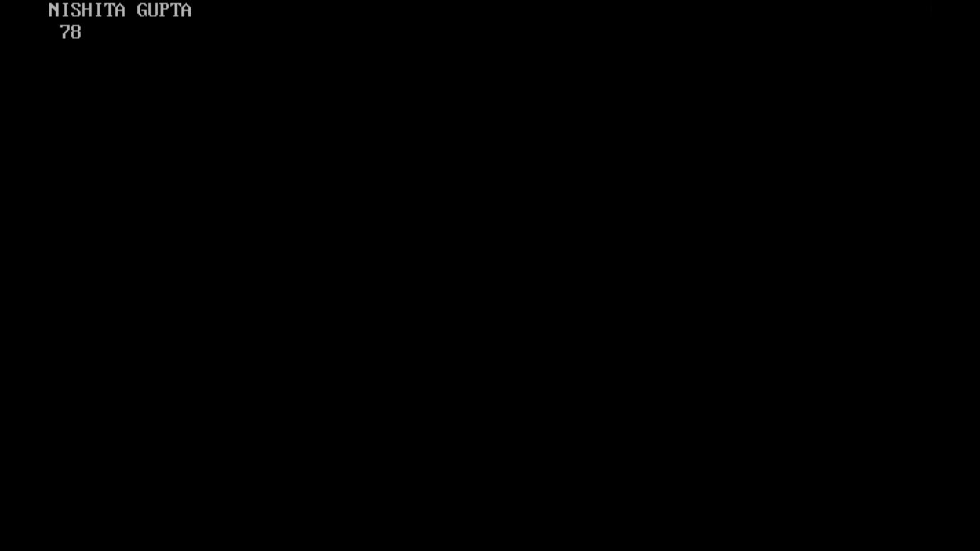

6). Write a program to print greatest number…

CODE:-

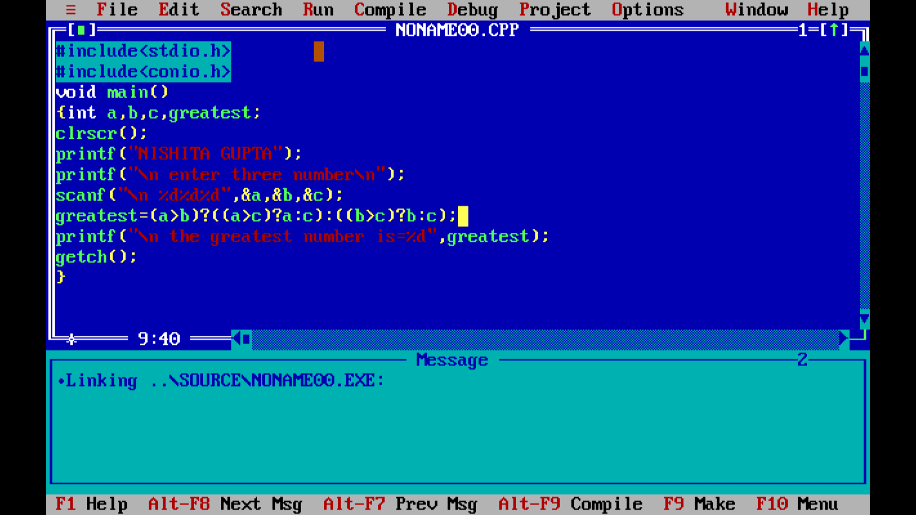

OUTPUT:-

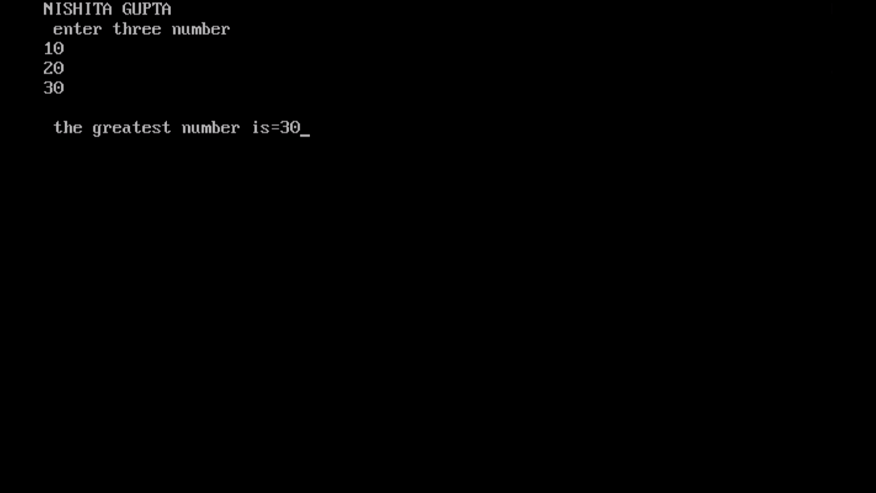

7).Write a program to find area and perimeter of circle given radius…

CODE:-

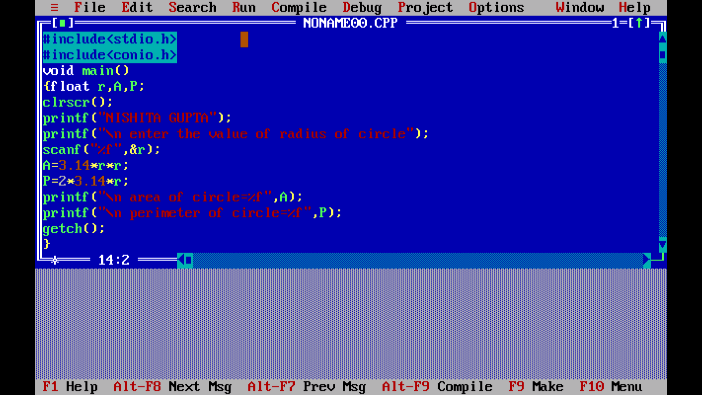

OUTPUT:-

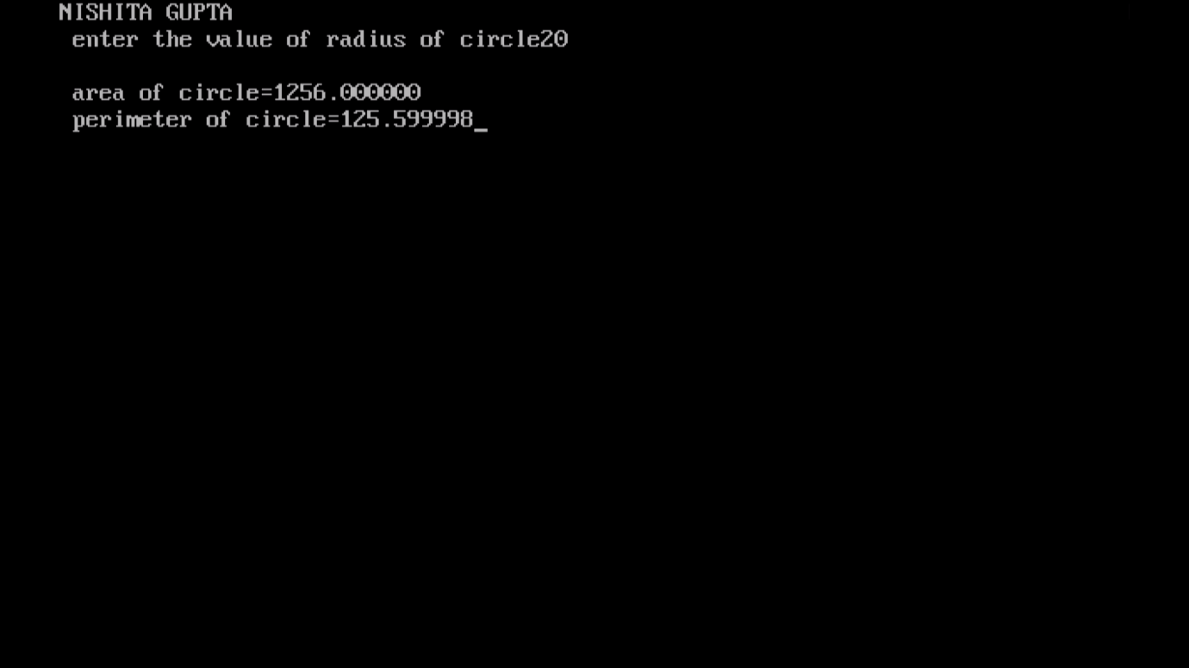

8).Write a program to print the size of variable.

CODE:-

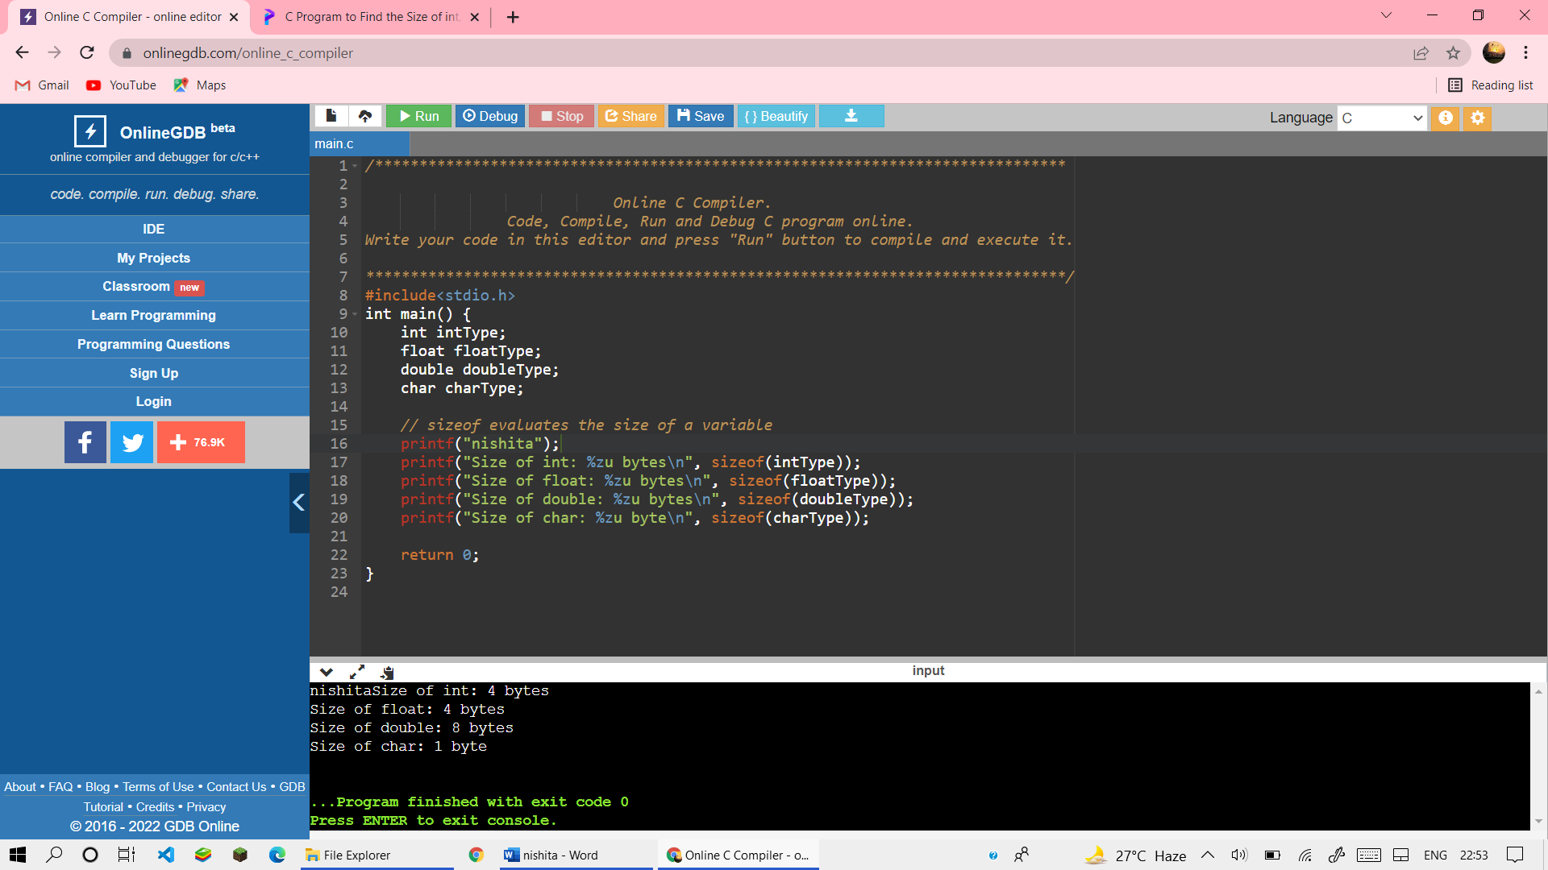

OUTPUT:-

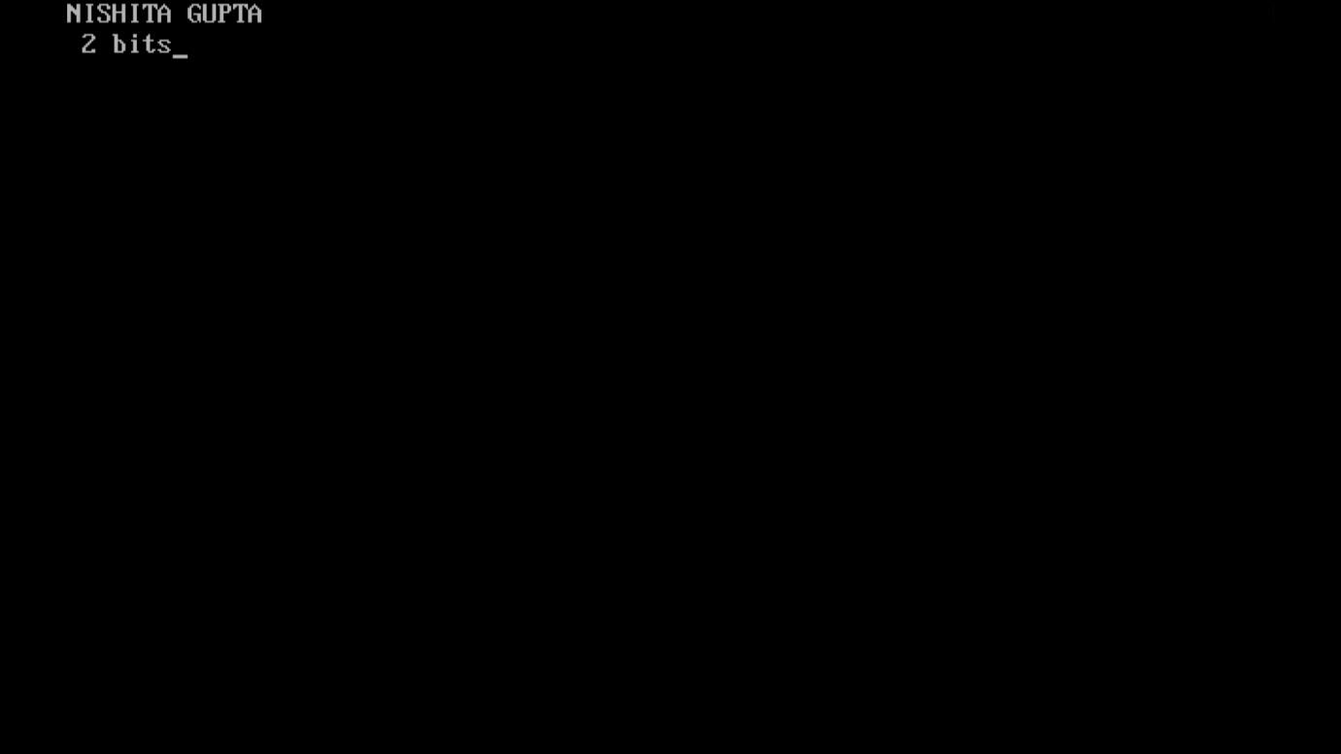

9).Write a program swap two number using third number.

CODE:-

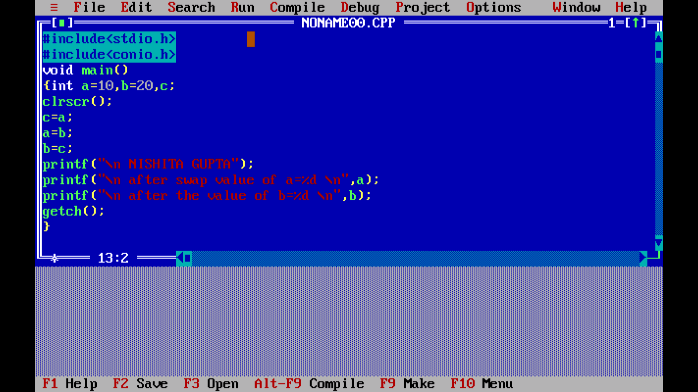

OUTPUT:-

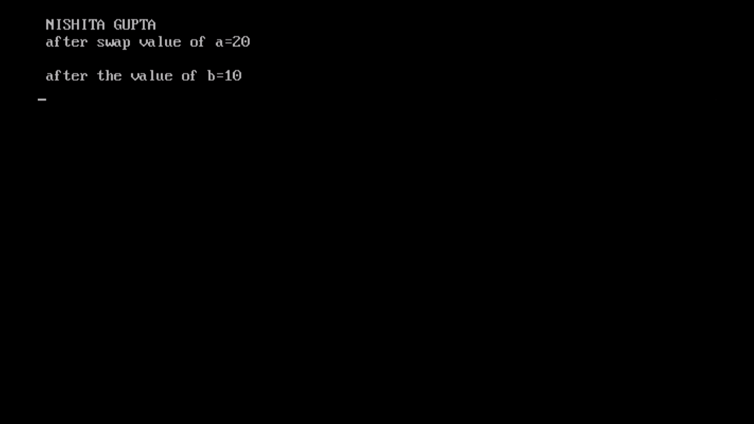

10).Write a menu driven program to construct calculator for following operation:+,-,*,division,average,%.

CODE:-

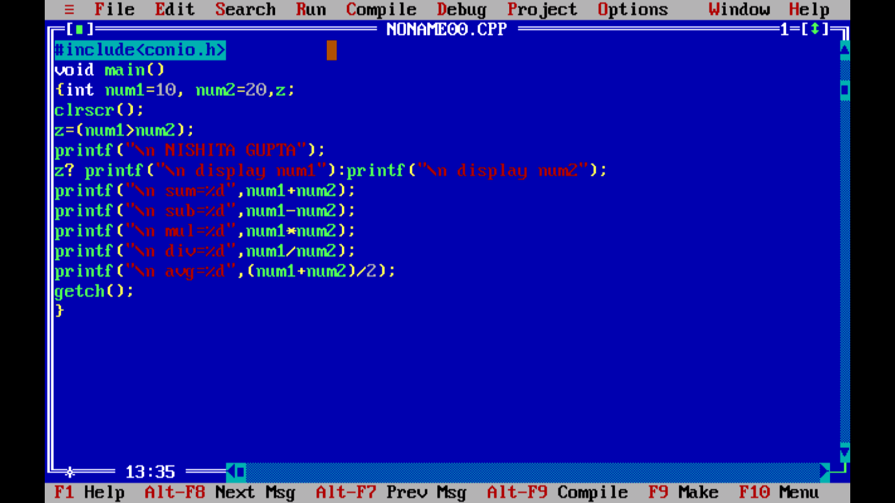

OUTPUT:-

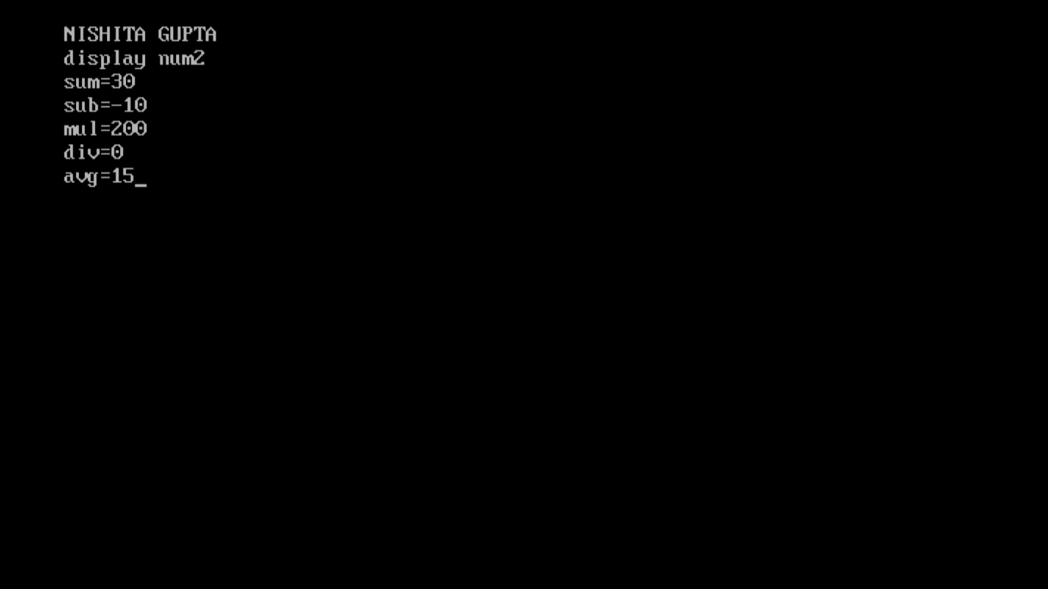

11). Write a program to display quotient and remainder.

CODE:-

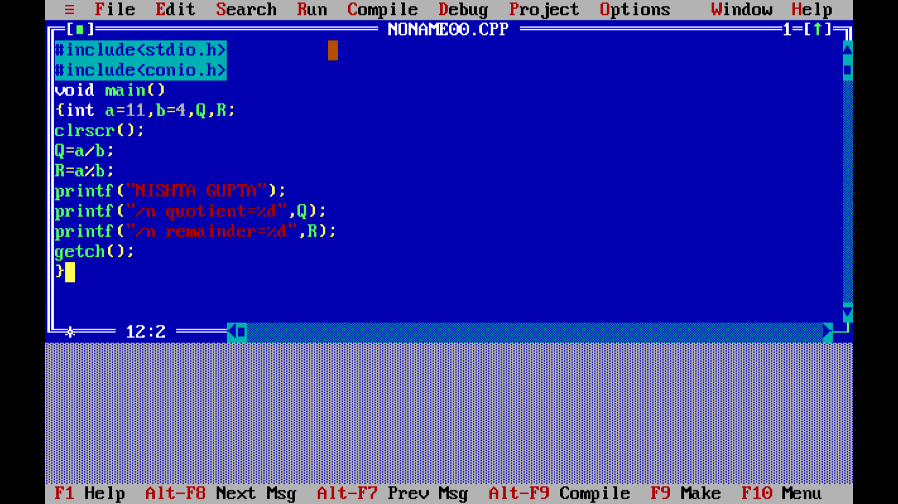

OUTPUT:-

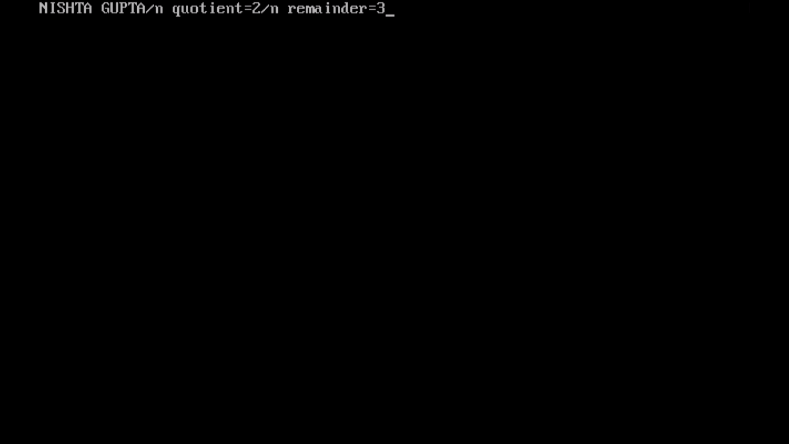

12).Write a program to check human are eligible for voating or not.

CODE:-

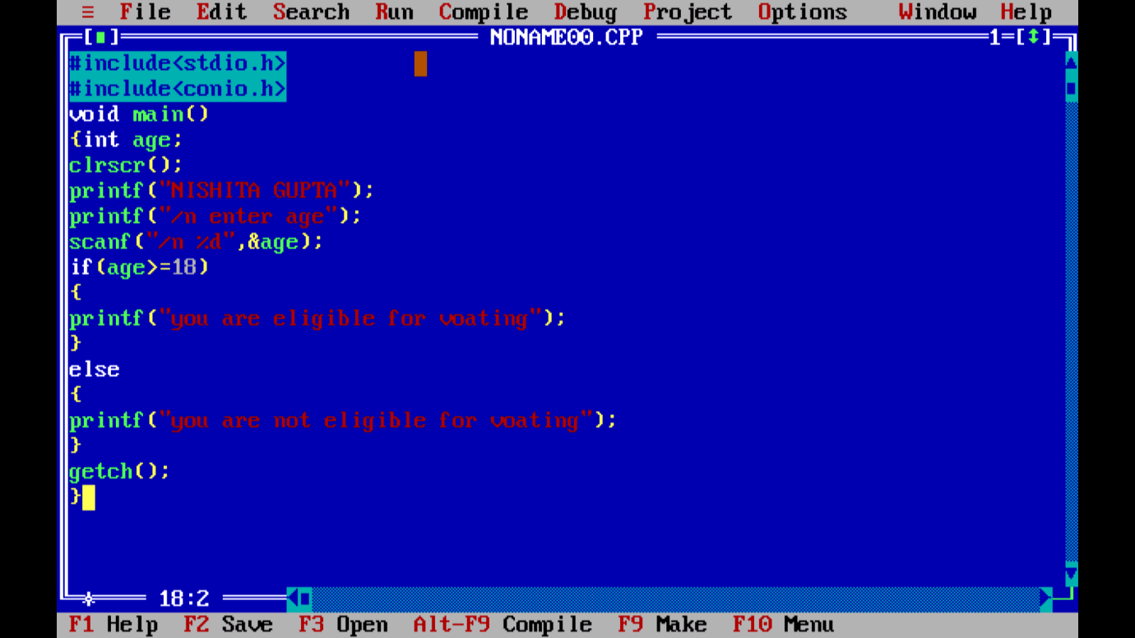

OUTPUT:-

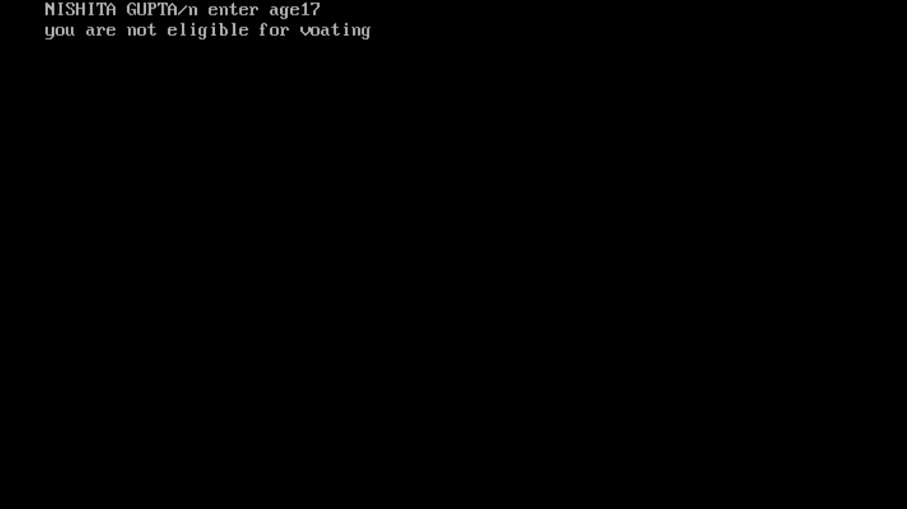

13). Write a program to check that number is even or odd.

CODE:-

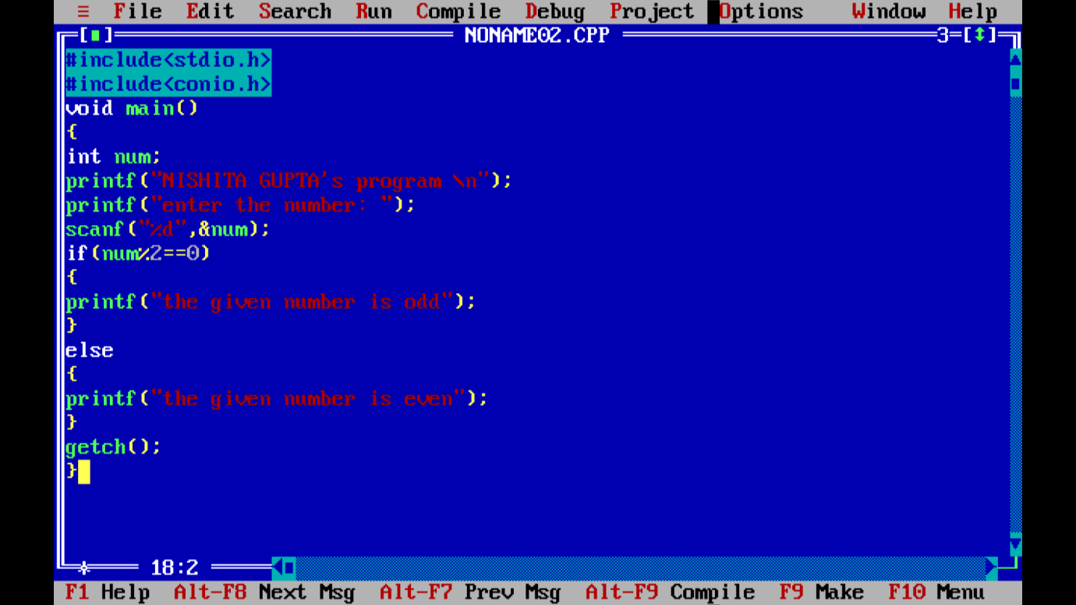

OUTPUT:-

14). Write a program to print datatypes and strings

Code:-

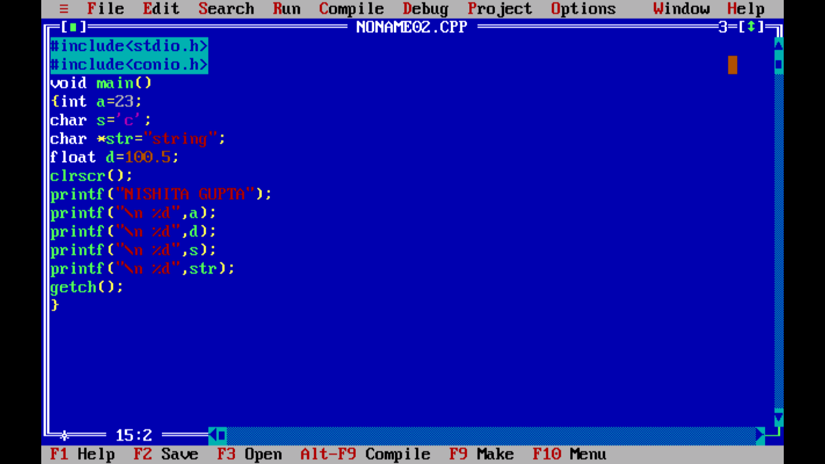

OUTPUT:-

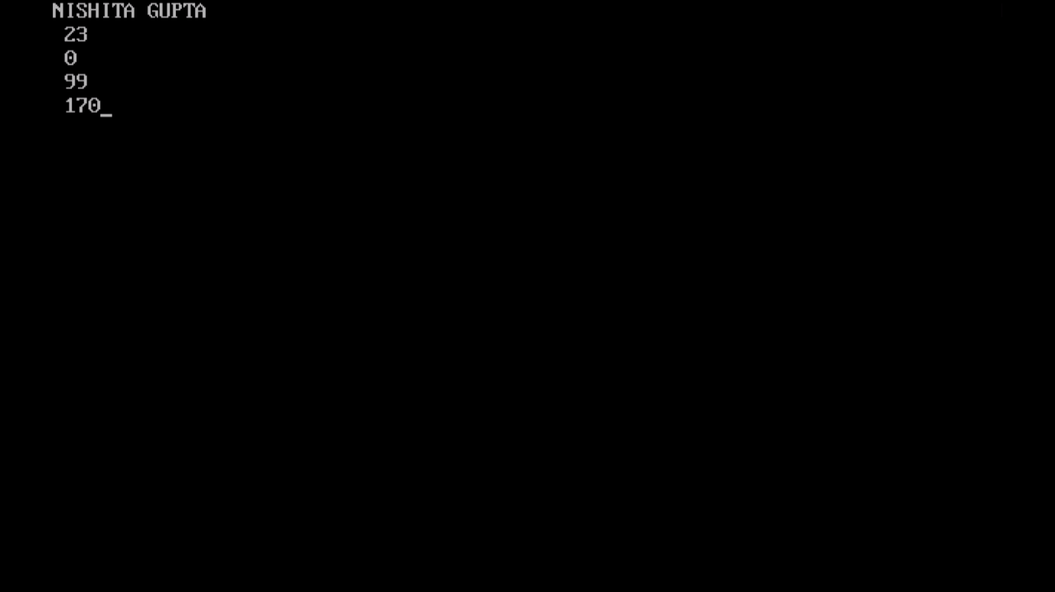

15).Write a program to swap 2 number without using third number:-

CODE:-

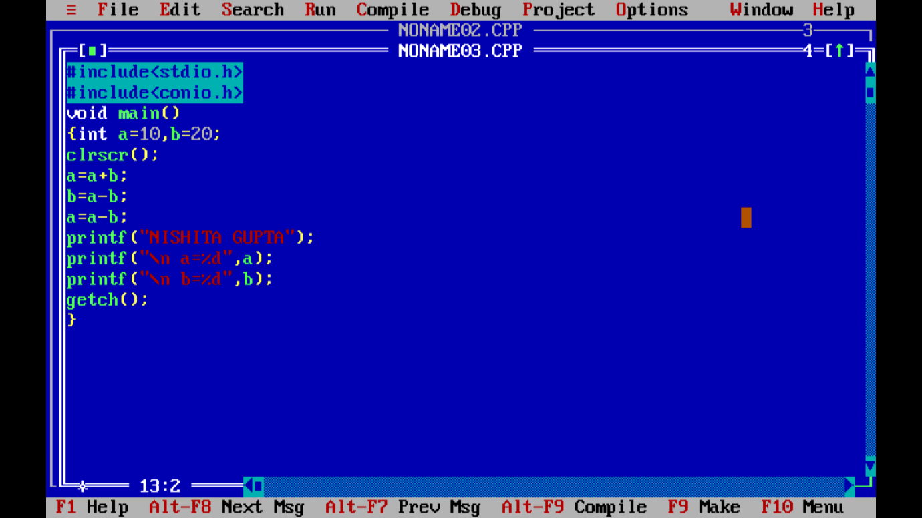

OUTPUT:-

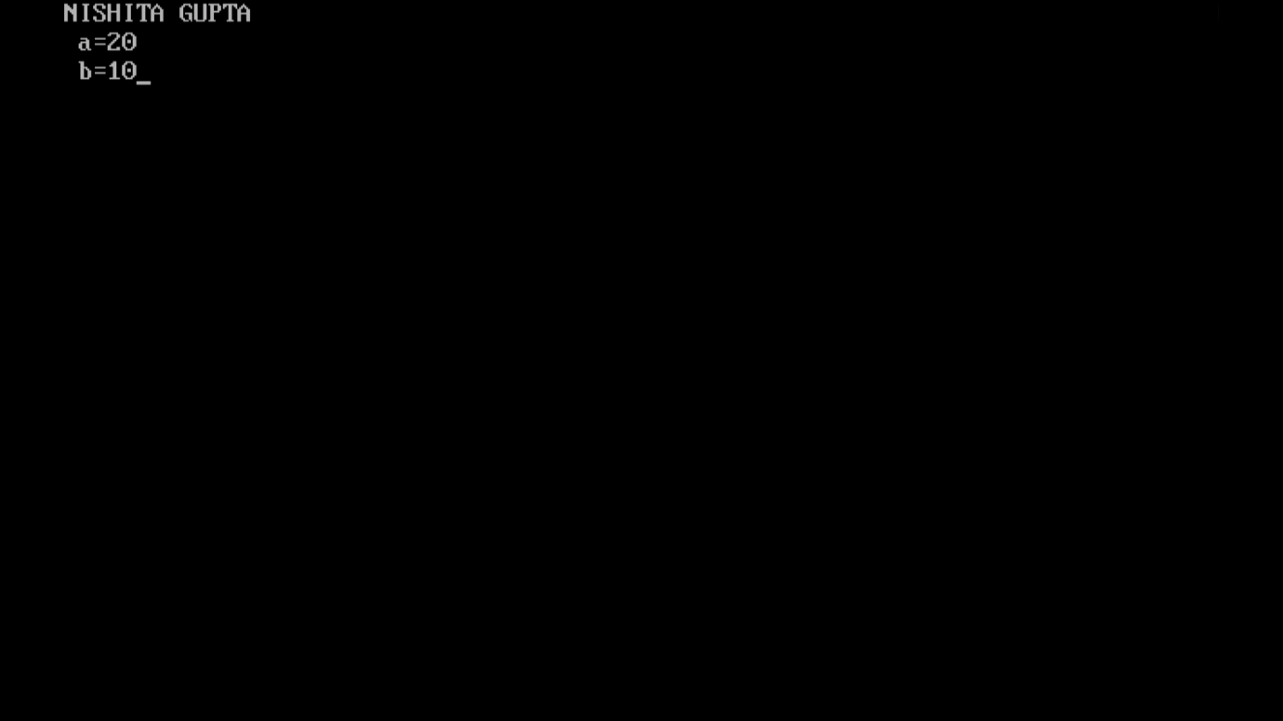

16). Write a program to find greatest or maximum of 3 number…

CODE:-

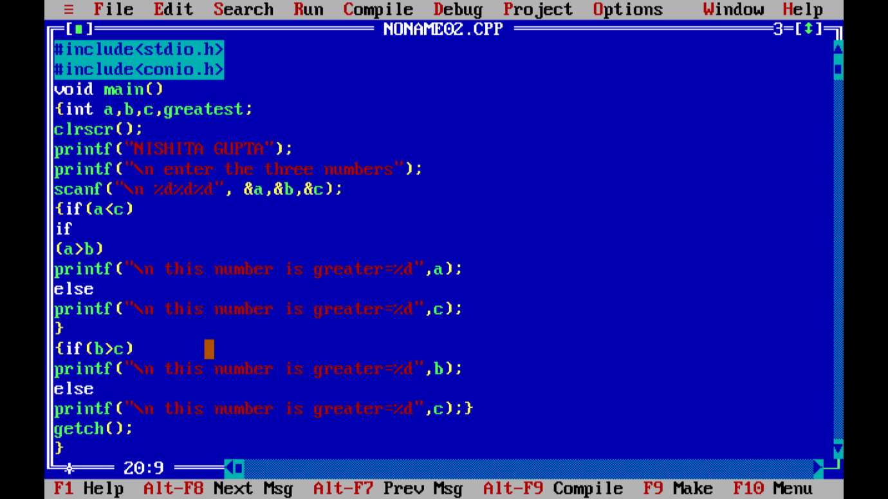

OUTPUT:-

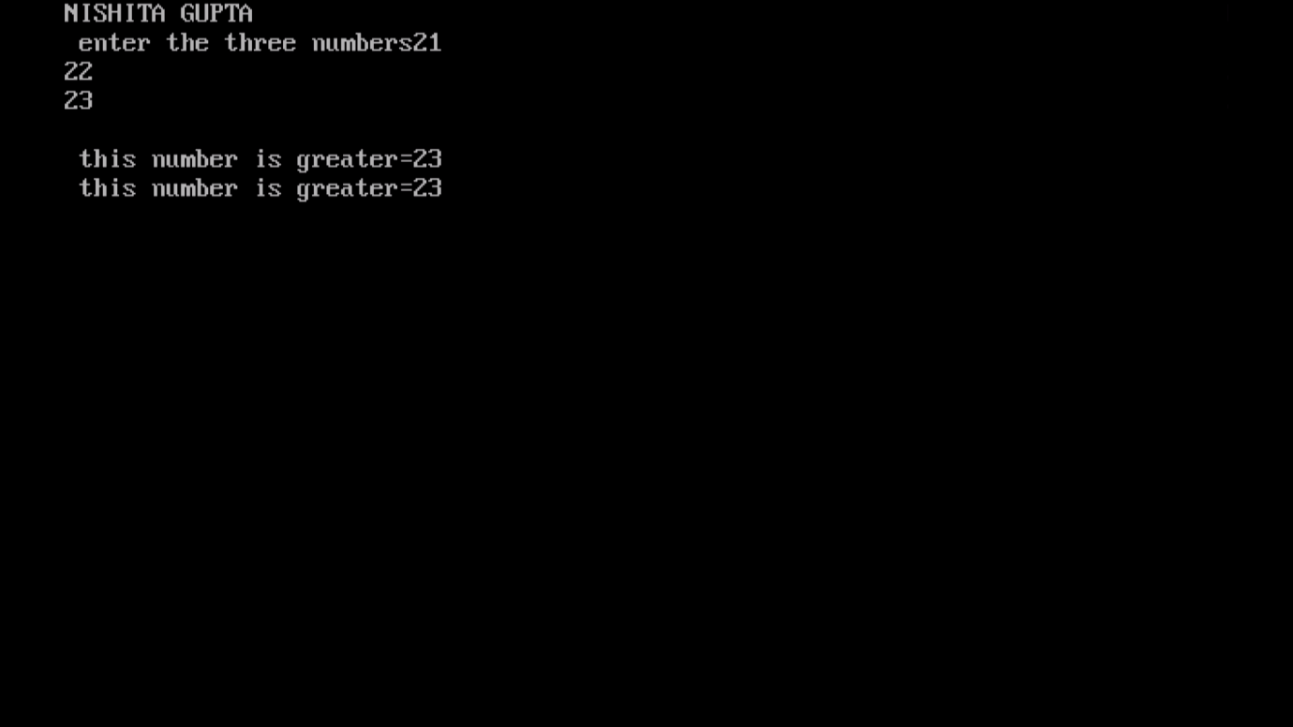

17).Write a program to print ascii value of character.

**CODE:-**

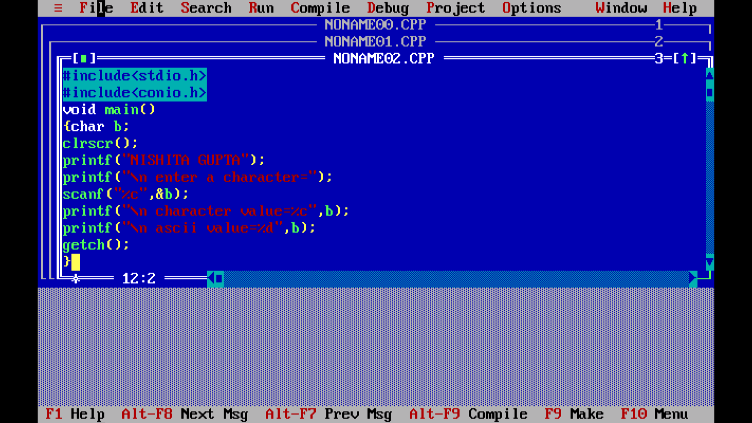

OUTPUT:-

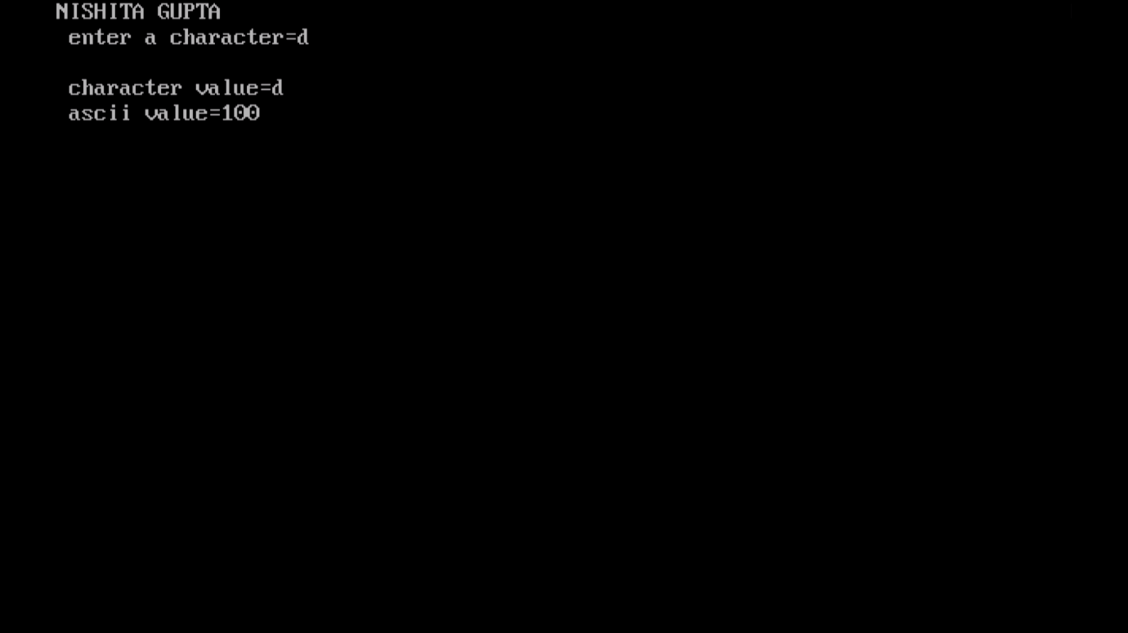

18).Write a program check no. is greater than 100 less than 1000.

CODE:-

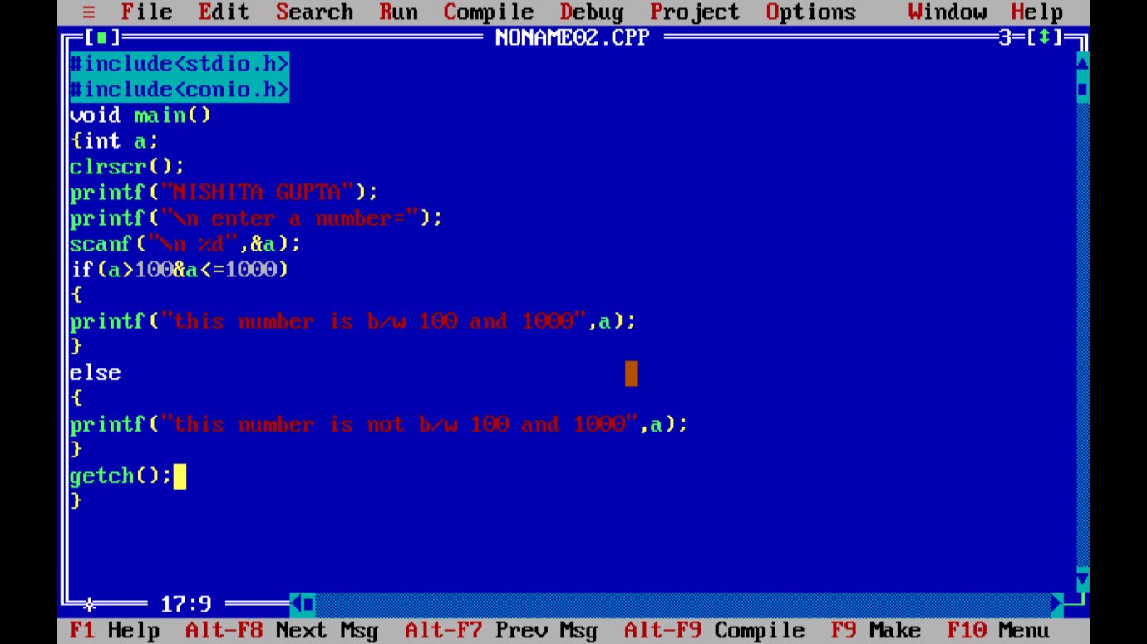

OUTPUT:-

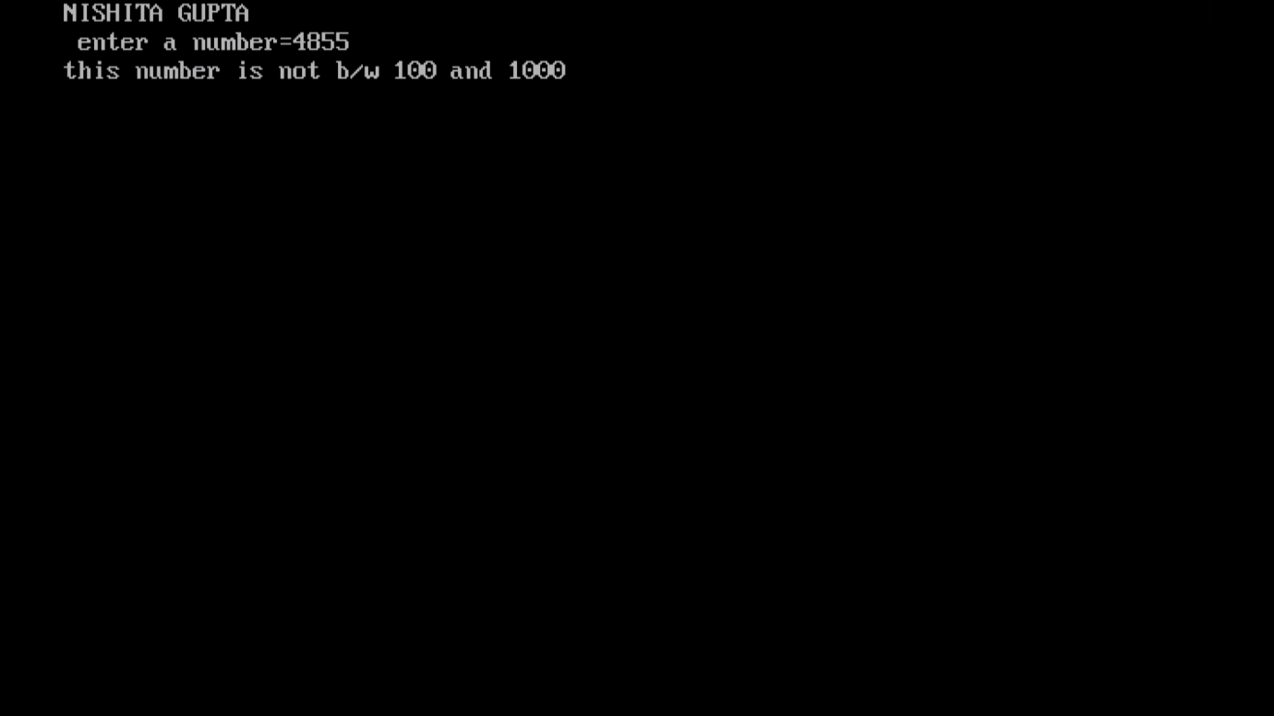

19). write a programme to change your Celsius offer Fahrenheit ?

CODE with output:-

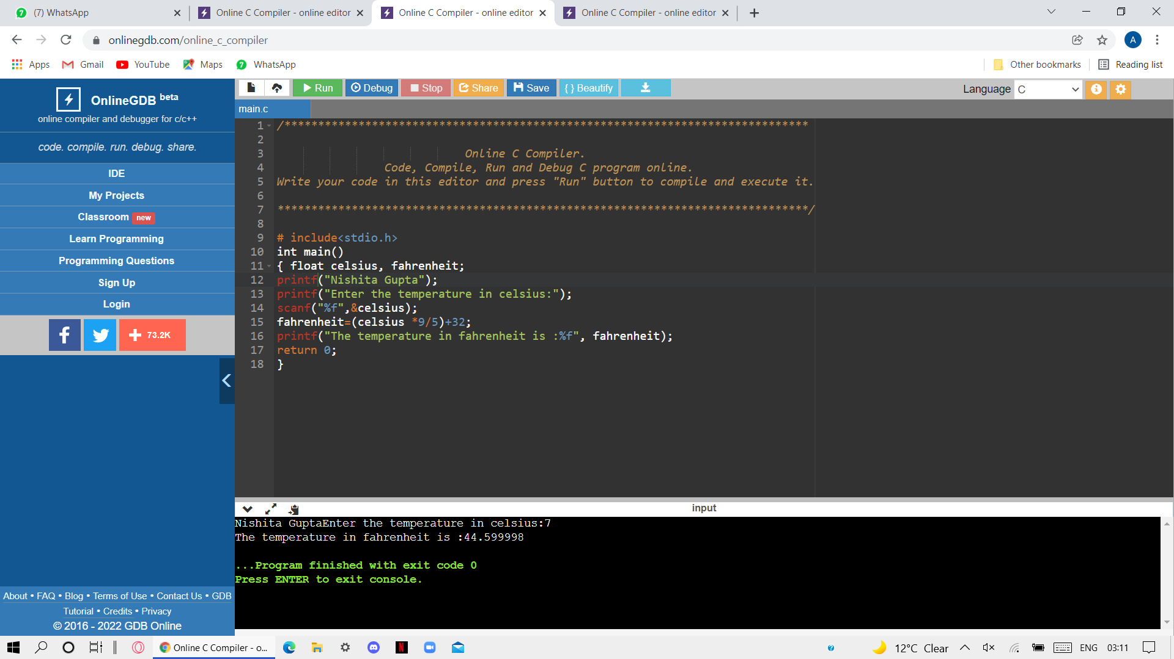

20). Write a programme to print sum of two numbers using externa function?

CODE: 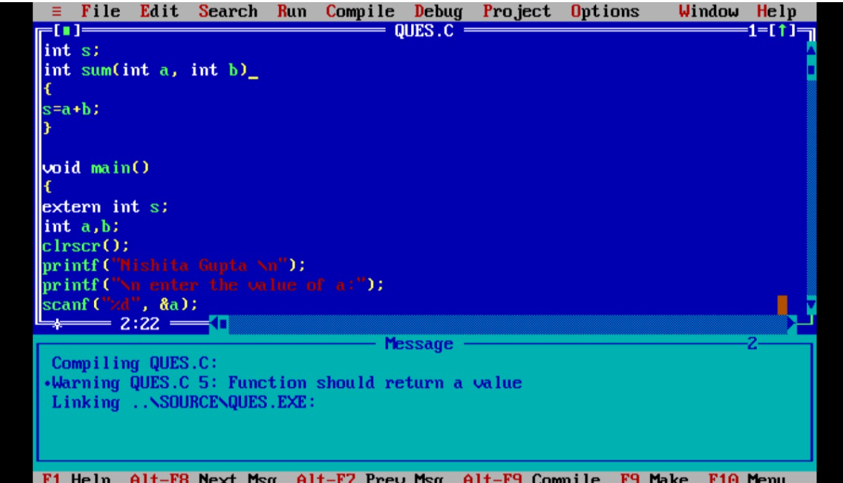

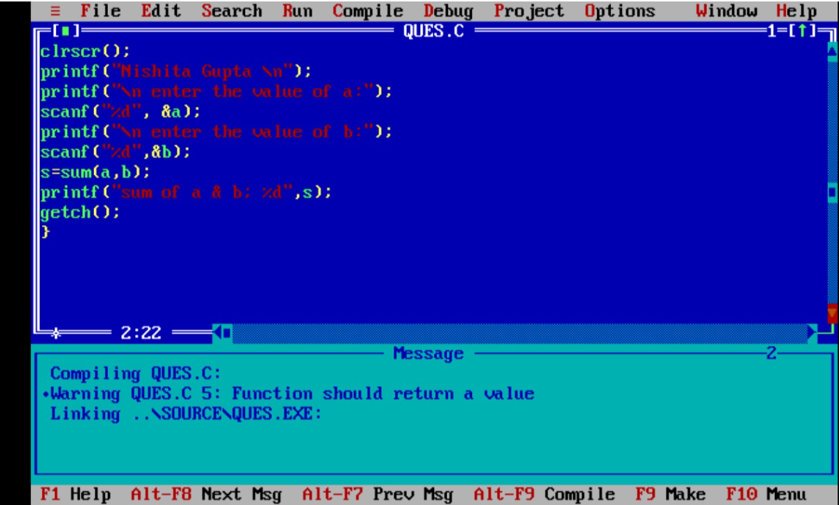

OUTPUT:-

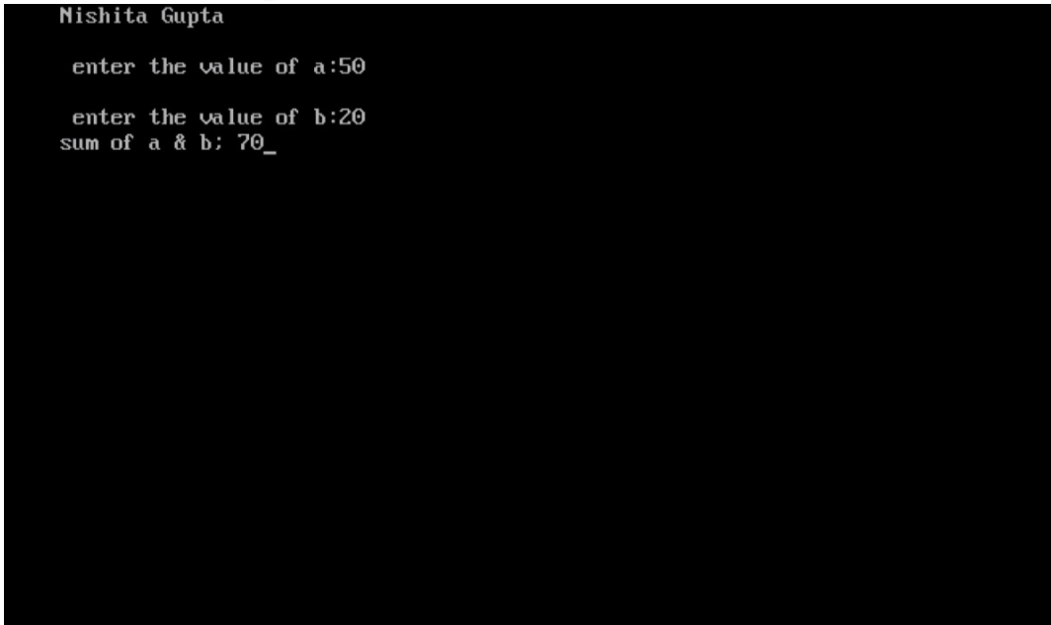

21). Write a programme to increase size of allocate memory of a string using realloc?

CODE:-

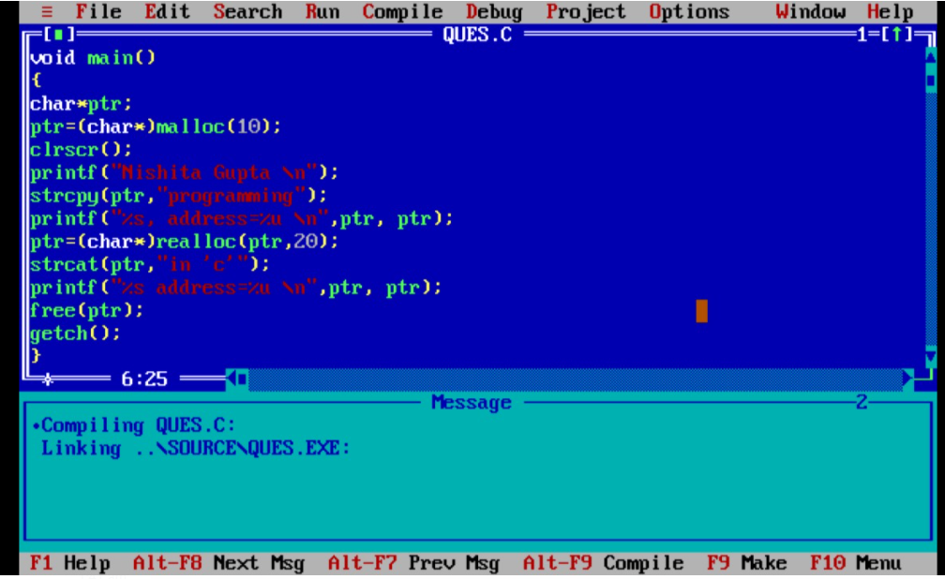

OUTPUT

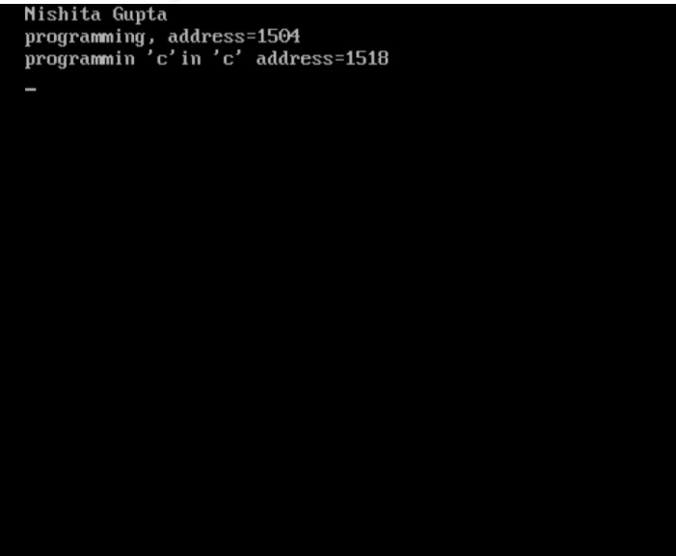

22). Write a programme to read an array and print this sum of all elements using dynamic memory allocation (use malloc)

CODE: 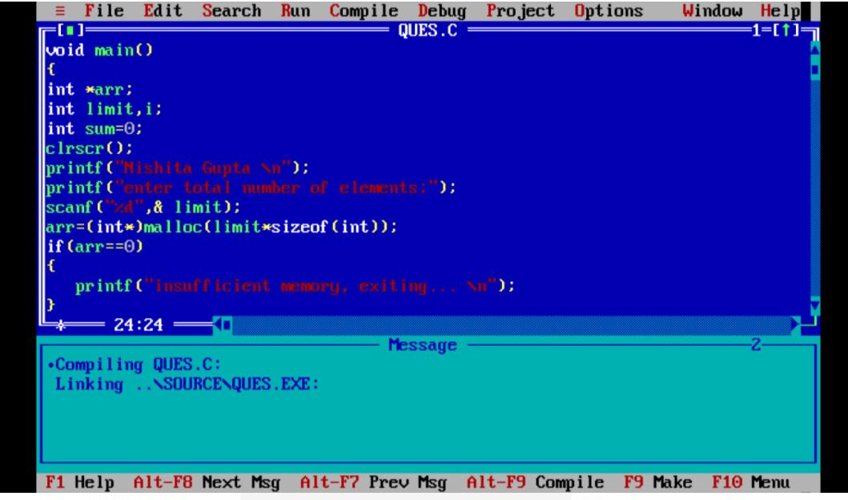

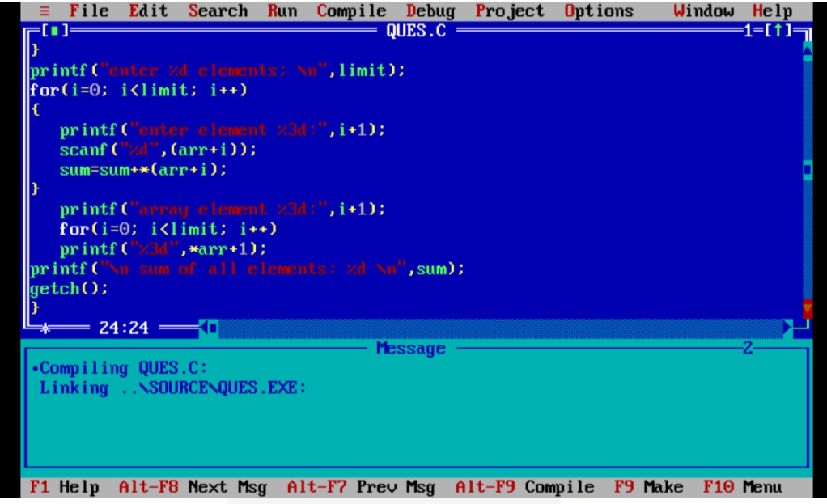OUTPUT:-

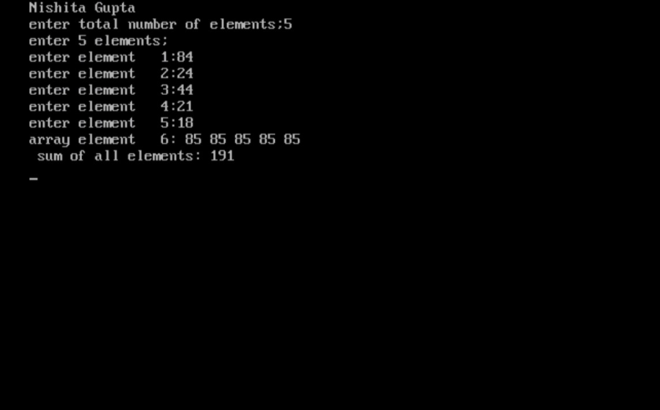

23). Write a programme to input element in an alley using dynamic memory allocation (USE calloc)

CODE:-

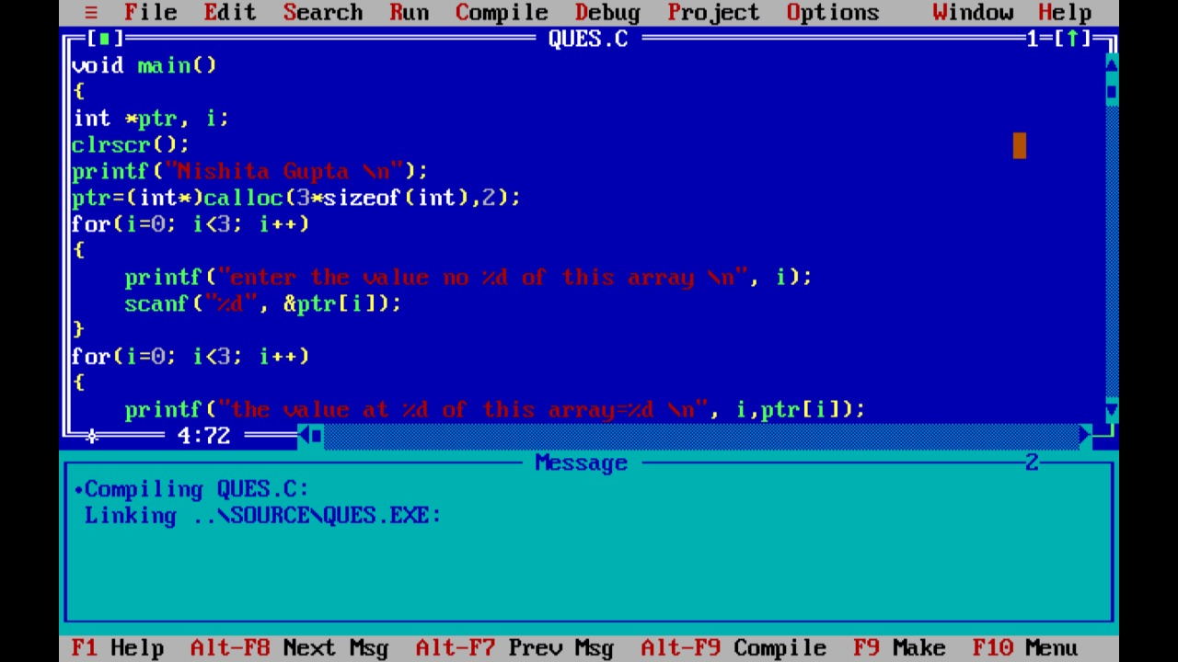

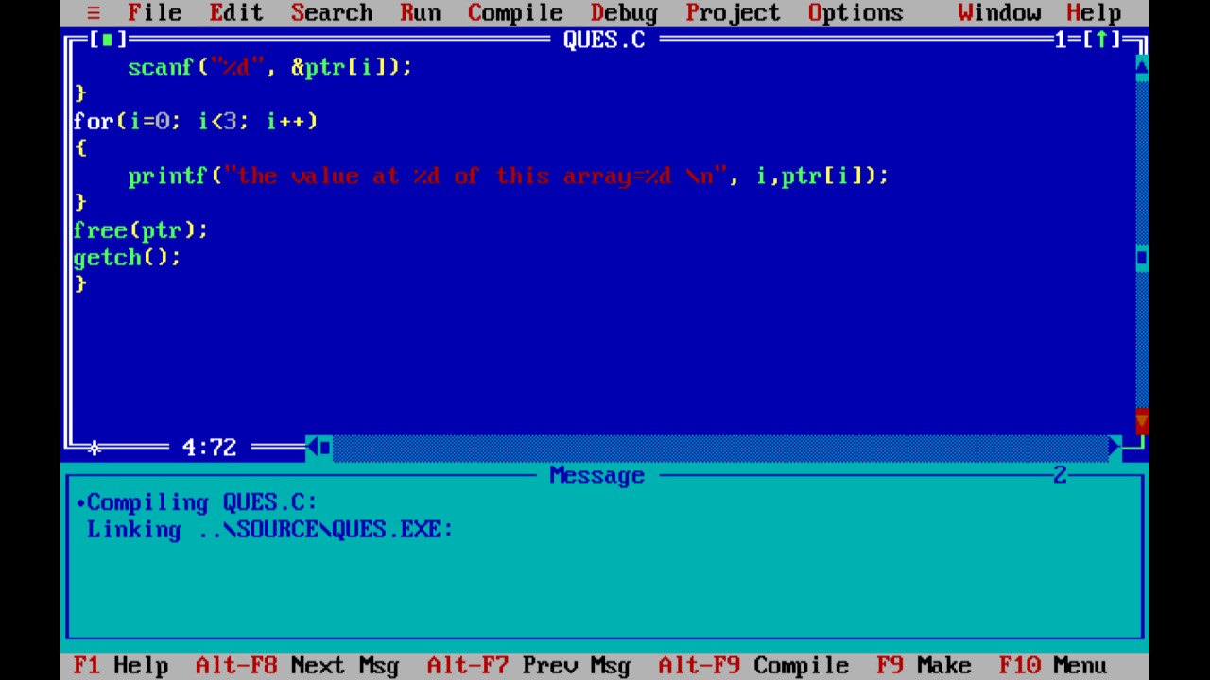OUTPUT:-

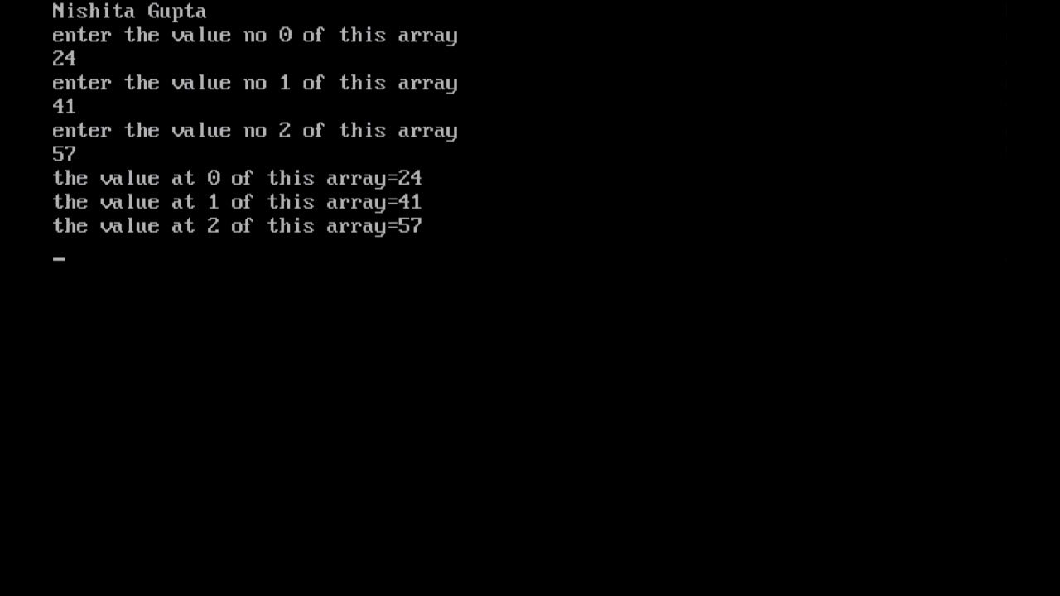

24). Write a programme to print string REVERSE using printer?

CODE:-

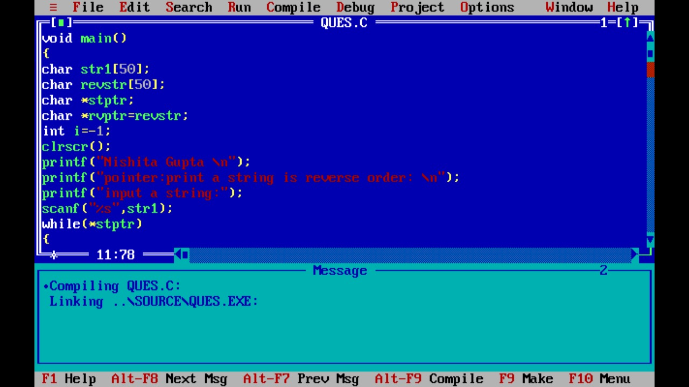

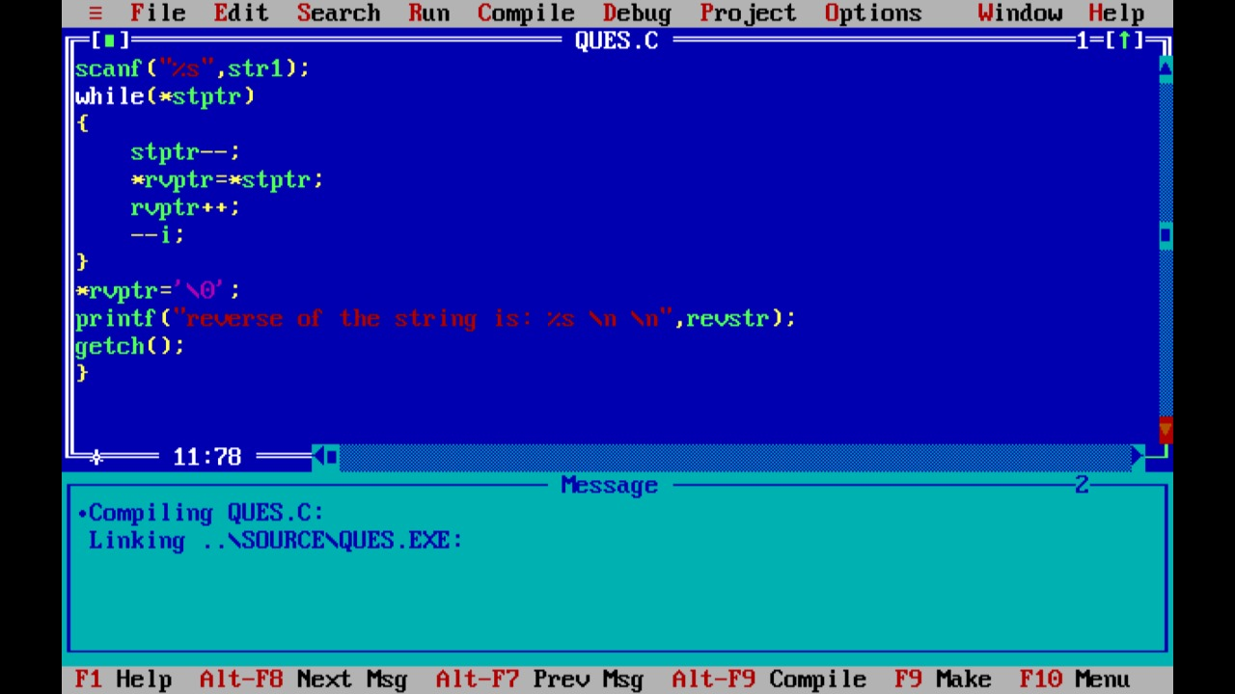

OUTPUT:-

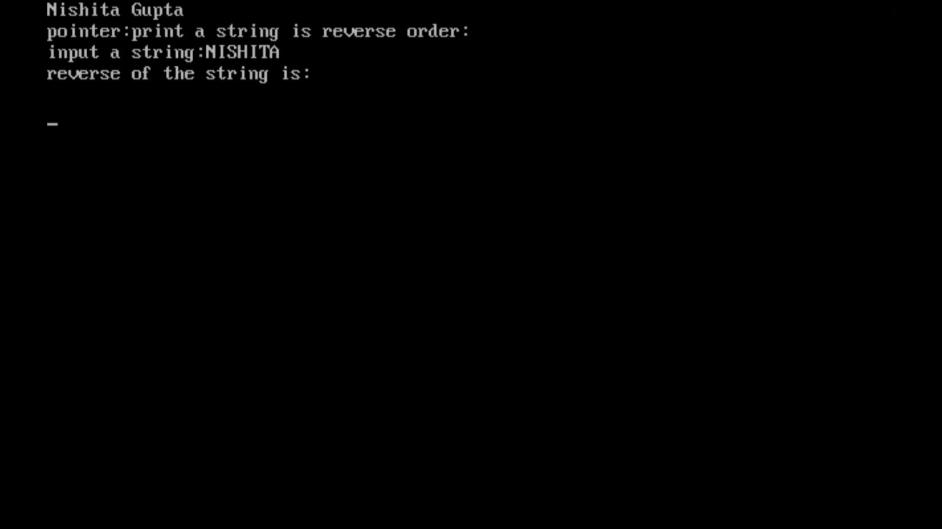

25). Write a programme to calculate the length of string using pointer?

CODE:-

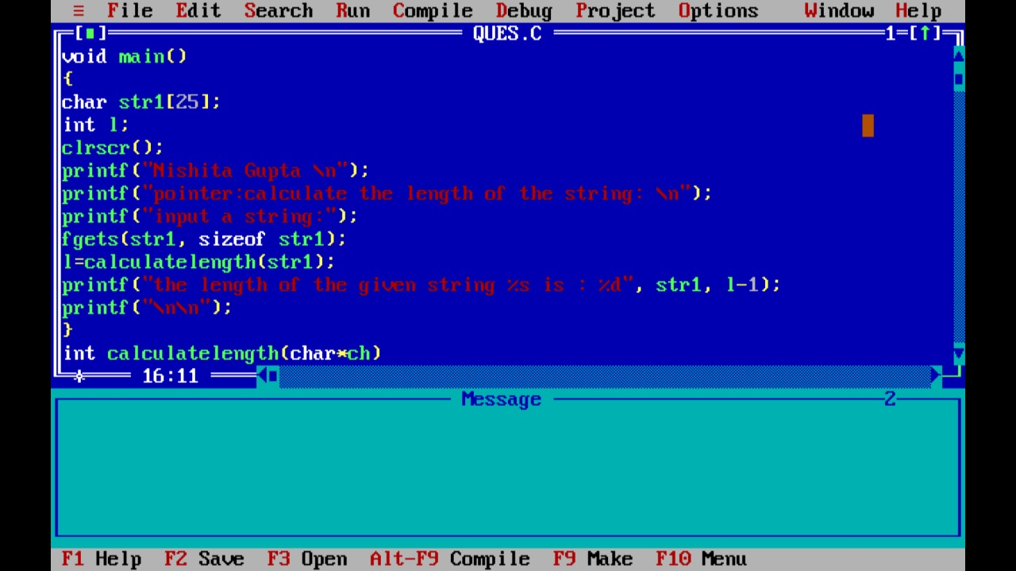

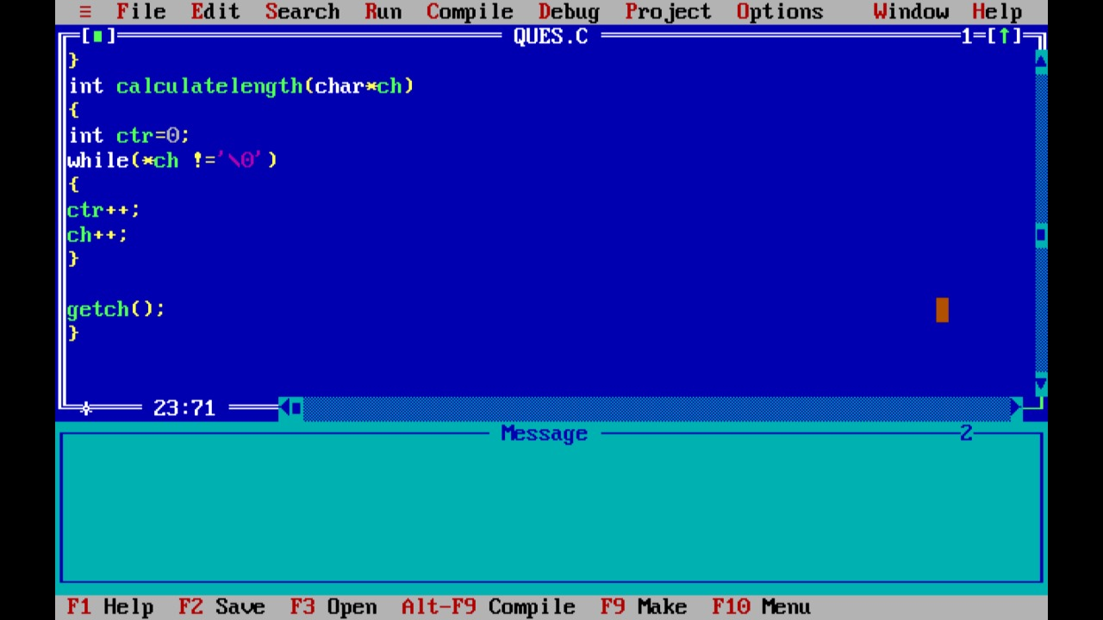

OUTPUT:-

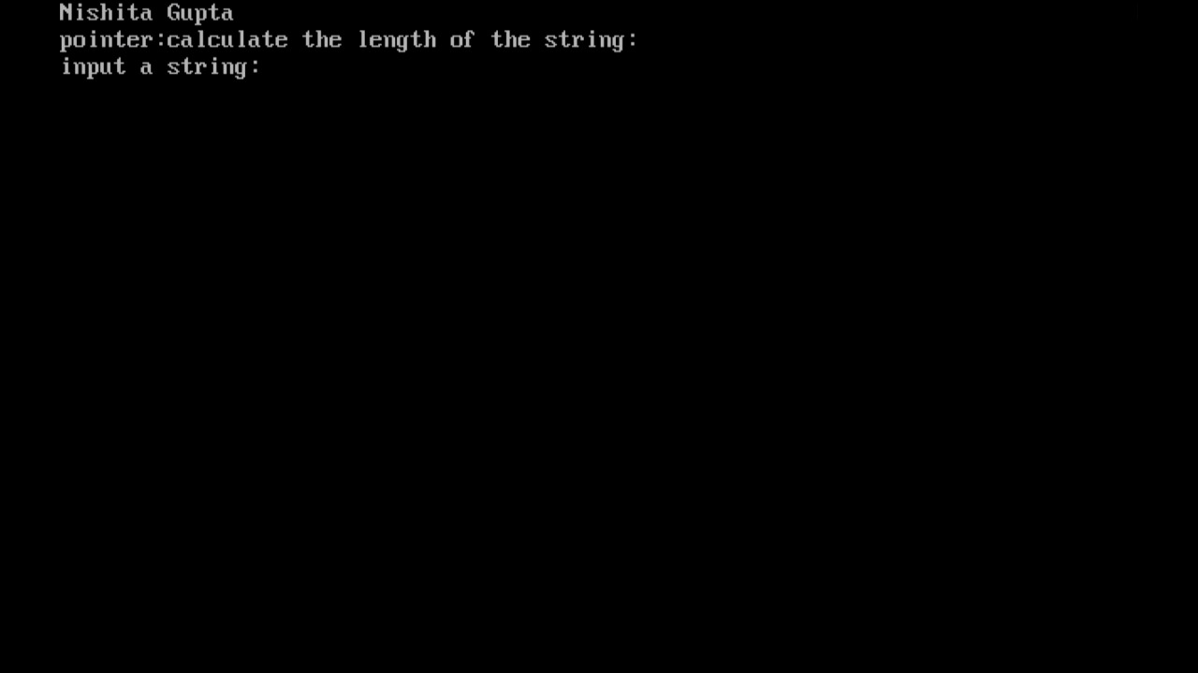

26). Write a program to odd or even print number is by using goto.

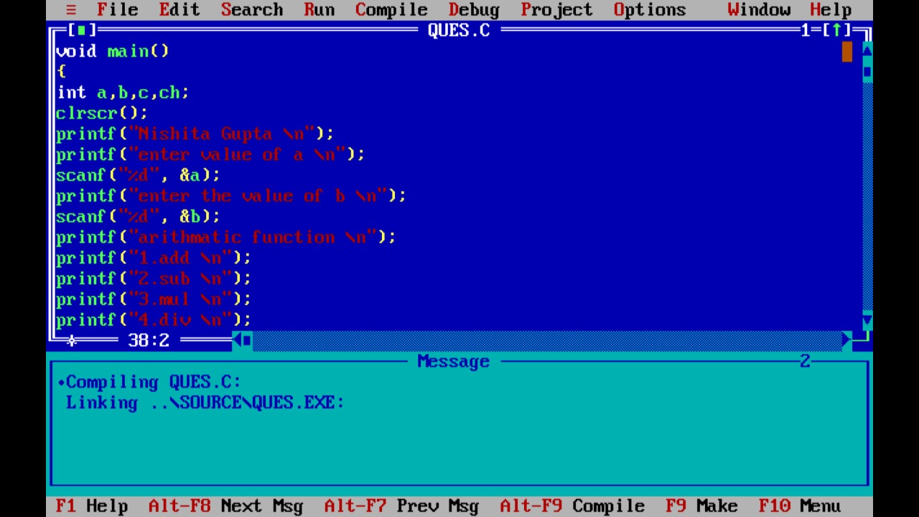

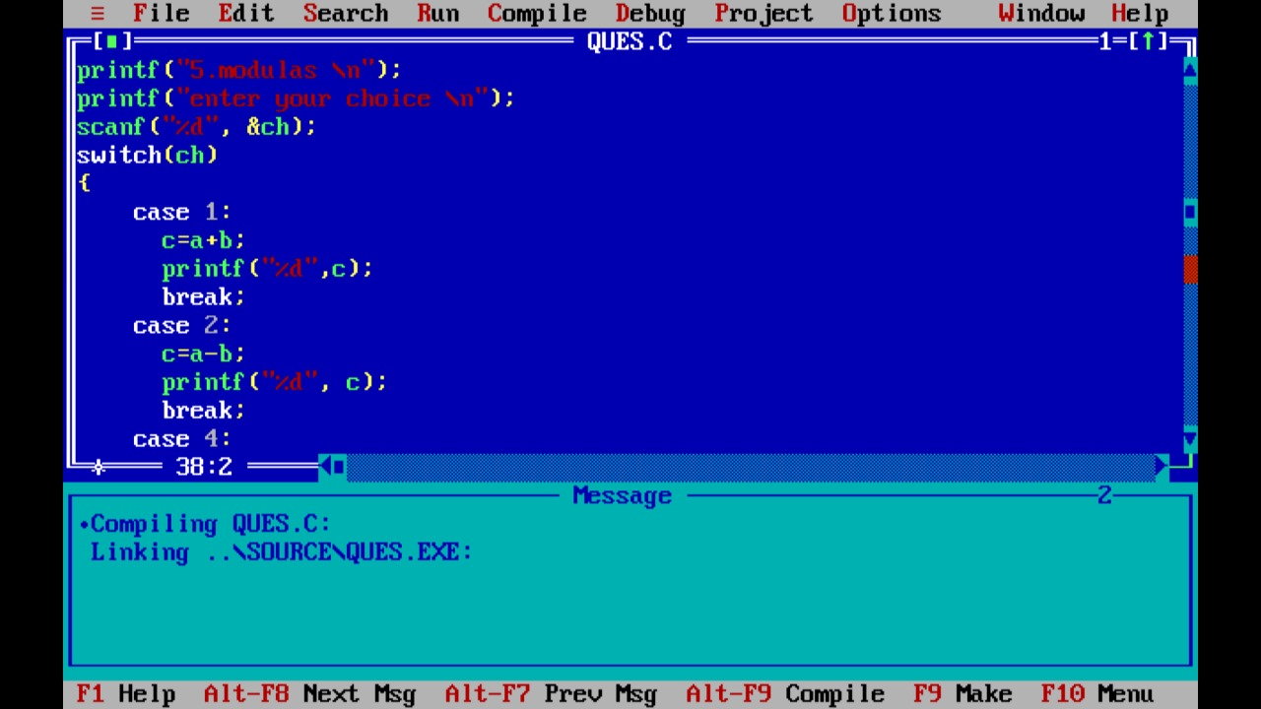

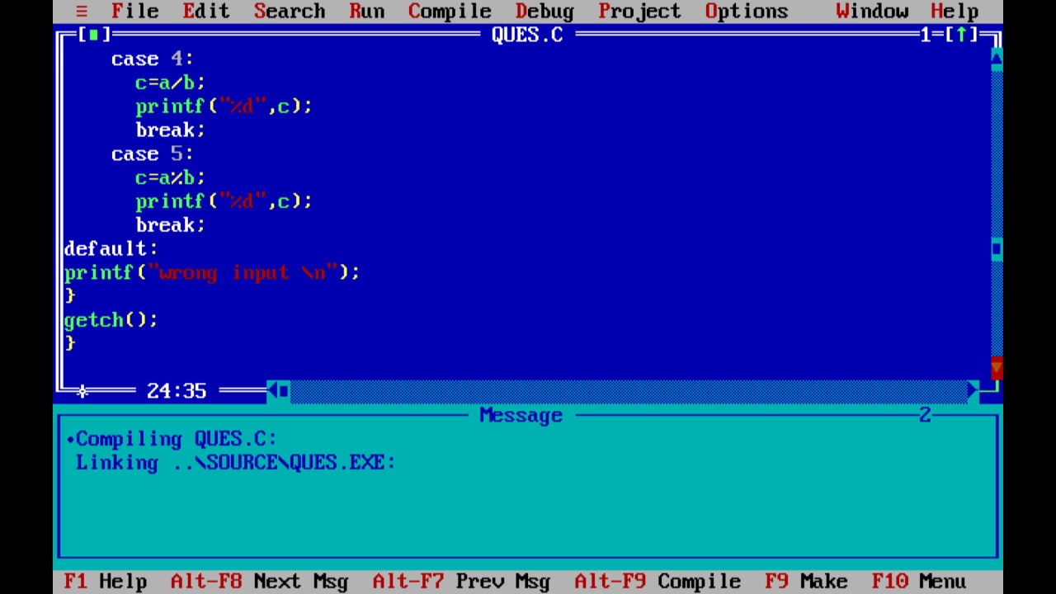

OUTPUT:-

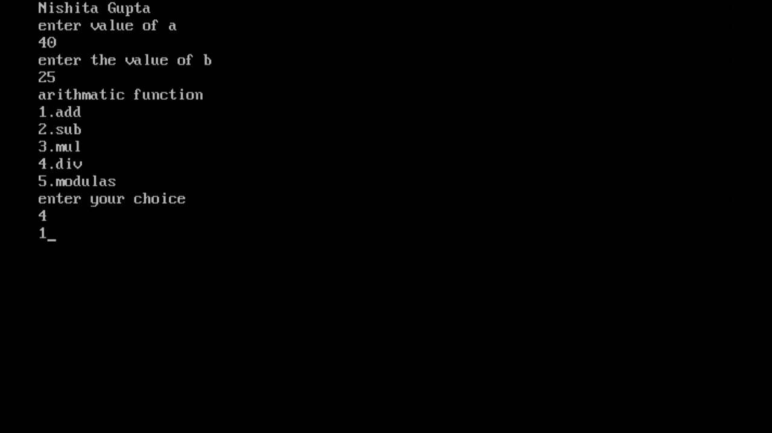

27). Write a programme to calculate salary of medical representative based on the sells bonus and incentive to be offered to him will be based on total sales if the sales exist or equal to of rupees 100000.

Follow the particular of table one otherwise Table 2

Table 1

Basic= 3000 rs.

HRA=20% of basic

DA= 110% of basic

Convenes=500 rs

Inconventive=10% of sales

Bonus = 500 rs

Table 2

Basic= 3000 rs.

HRA=20% of basic

DA= 110% of basic

Convenes=500 rs

Inconventive=10% of sales

Bonus=200 rs.

CODE WITH OUTPUT:-

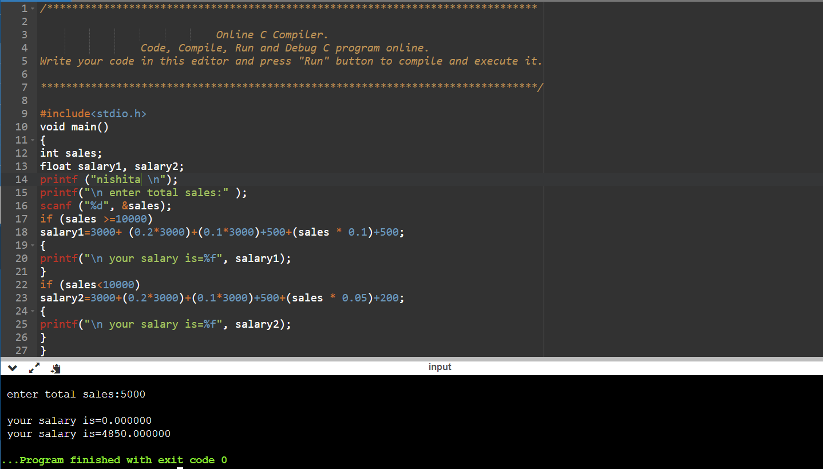

28). Write a program to find SI and CI

CODE WITH OUTPUT:-

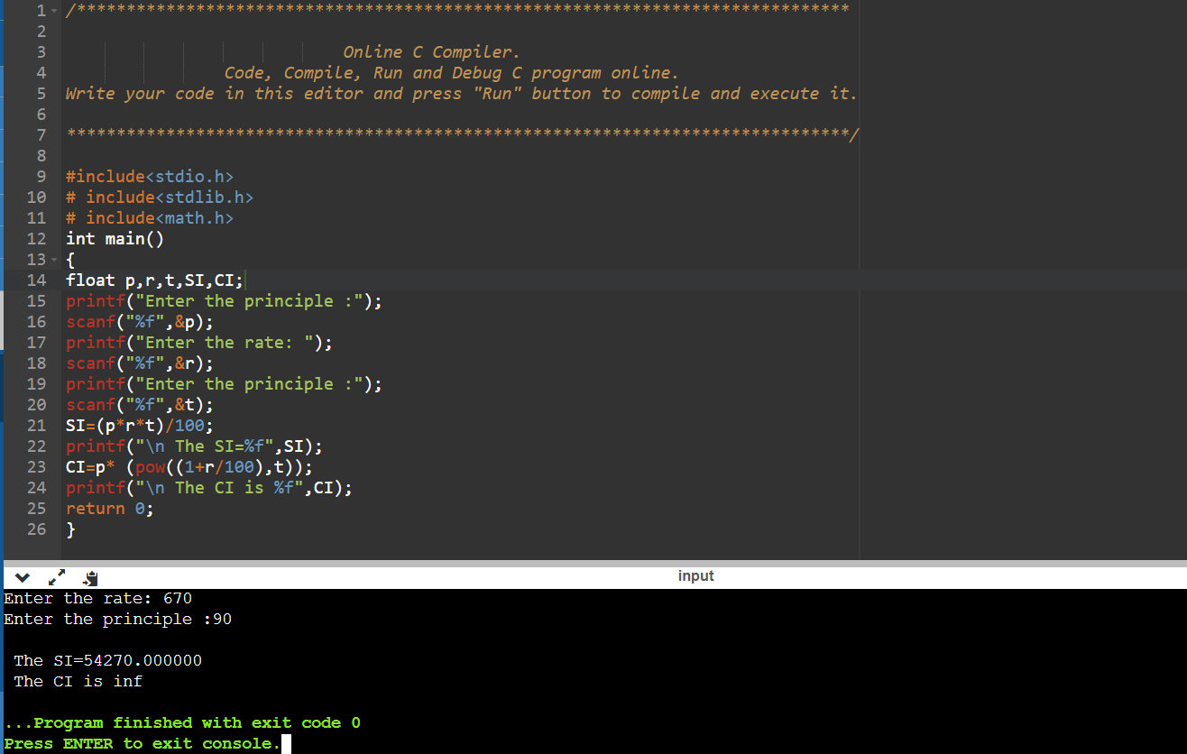

29).write a program for giving space before and after

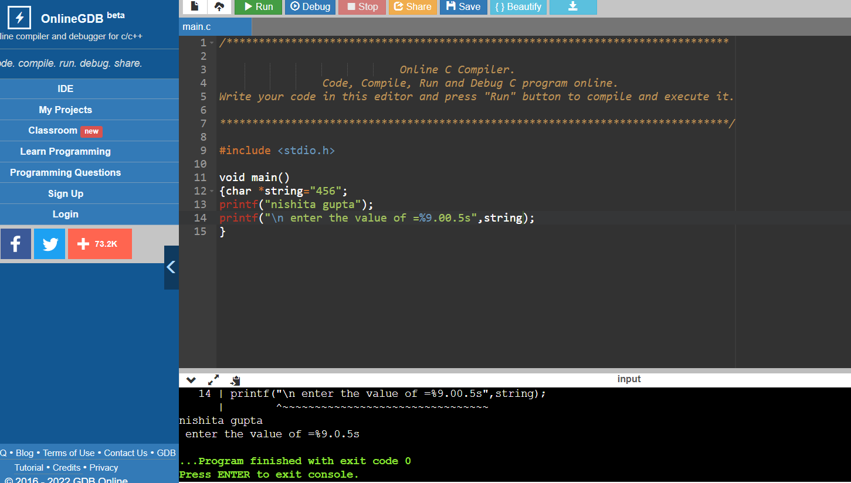

30).print to good morning good afternoon and good evening

CODE:-

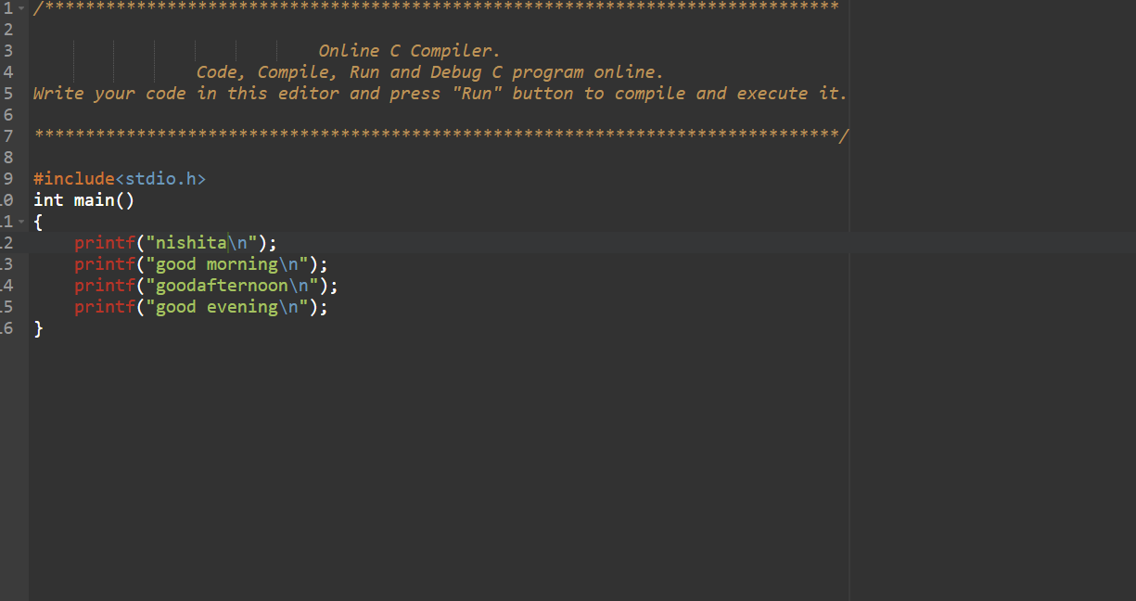

OUTPUT:-

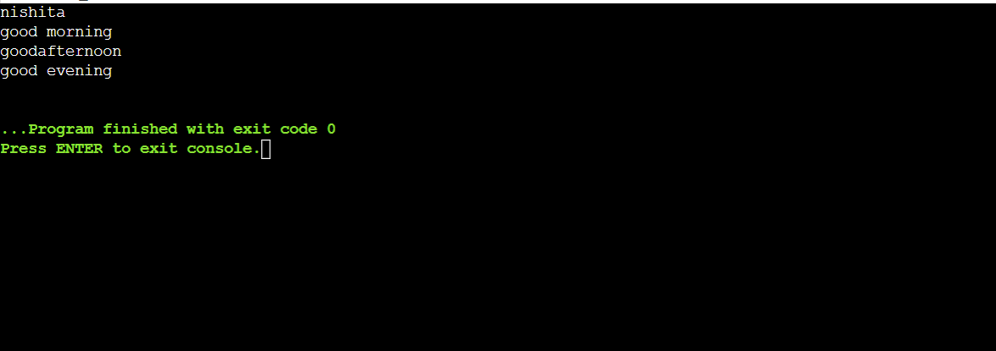

31). Write a program number of times word occur

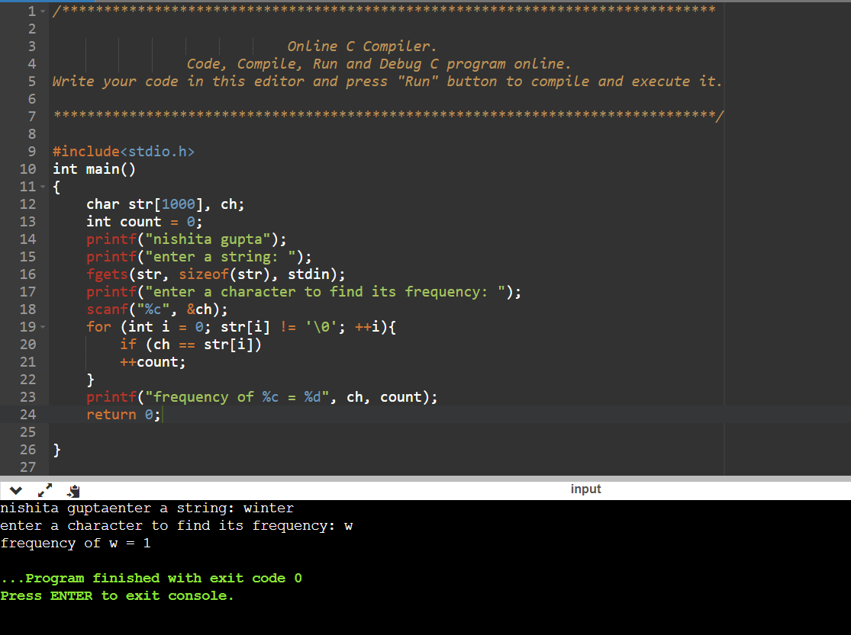

32). Write a program to 2 array

CODE WITH OUTPUT:-

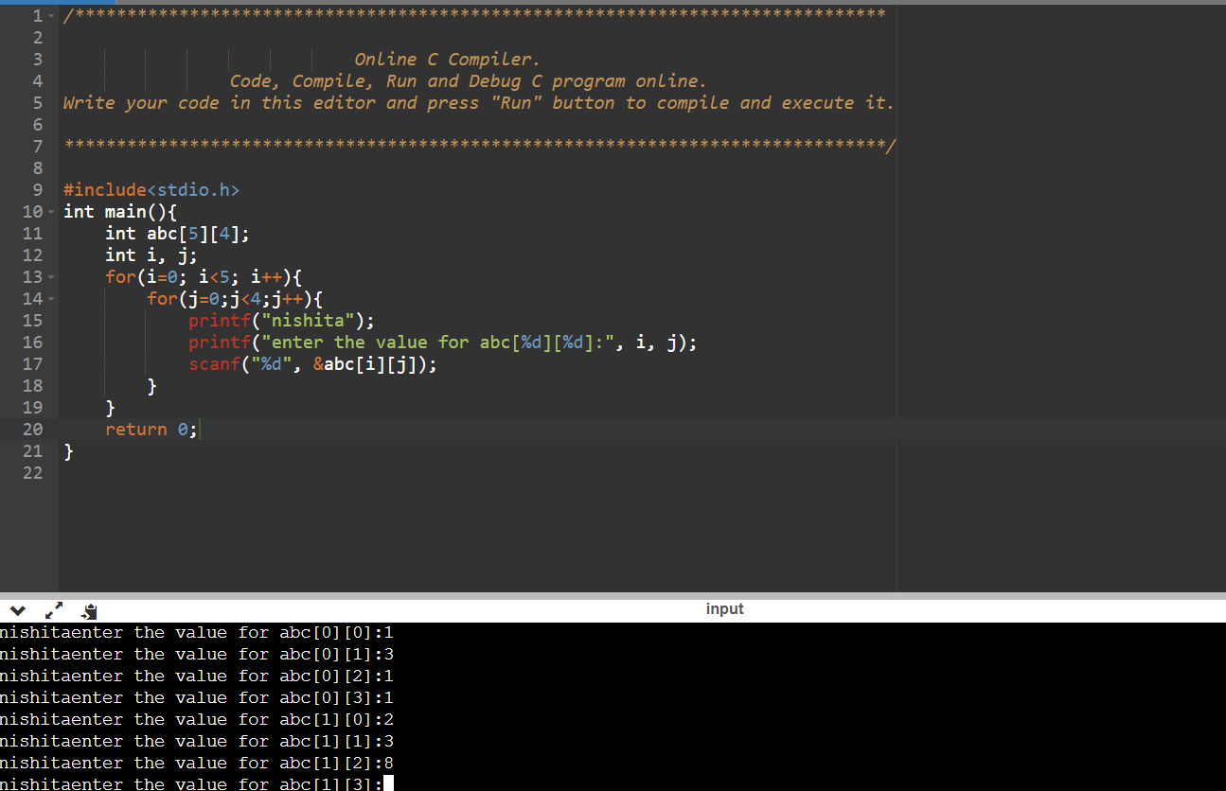

33). Write a programme to demonstrate to size of operators.

CODE:- 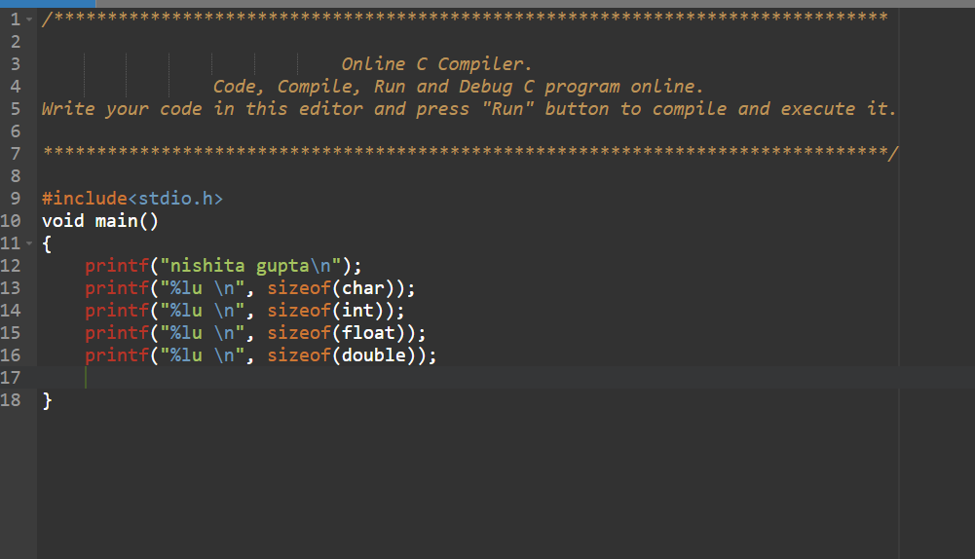

OUTPUT:- 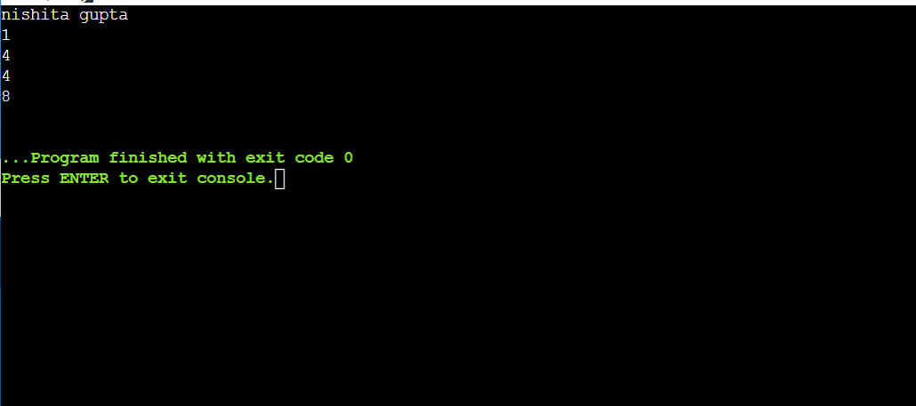

34). Write a programme to pi by value by design:-

Code..

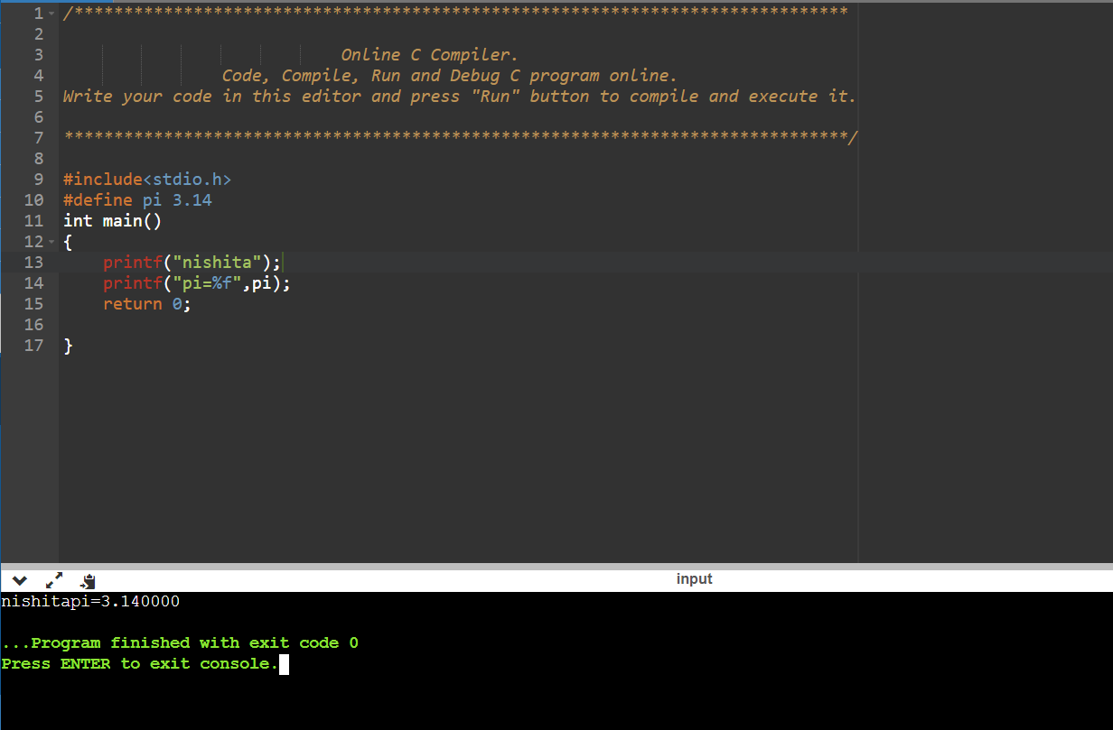

35). Write a program enter the no. and display in ascending order

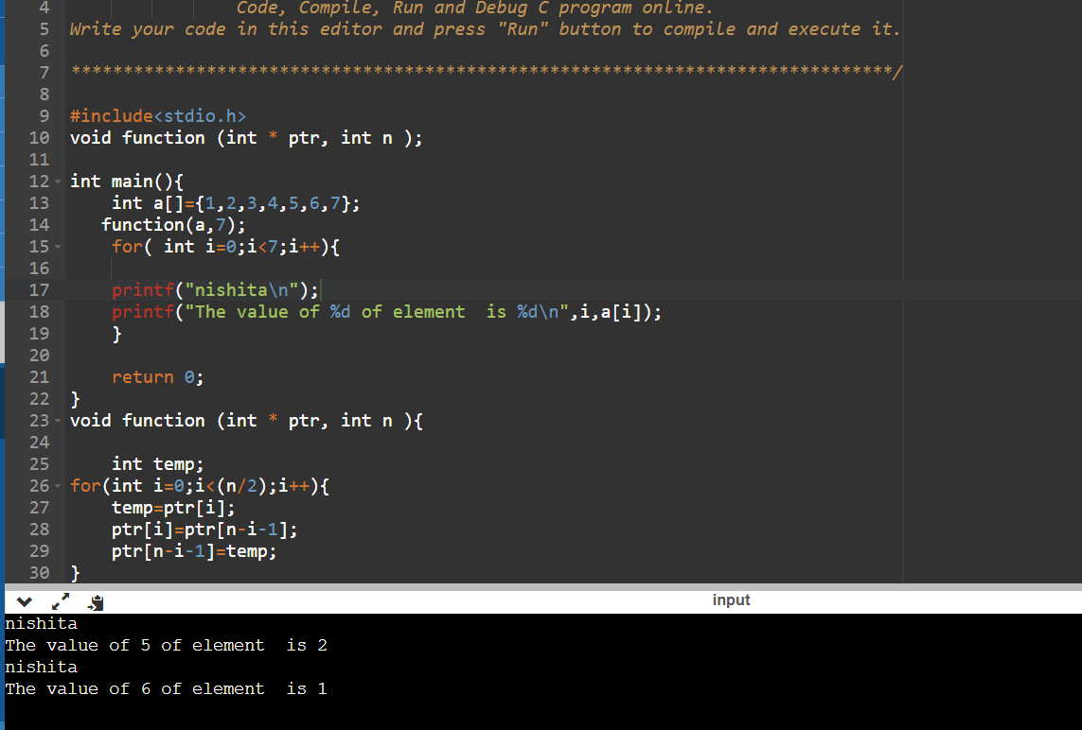

36). Write a program of realloc

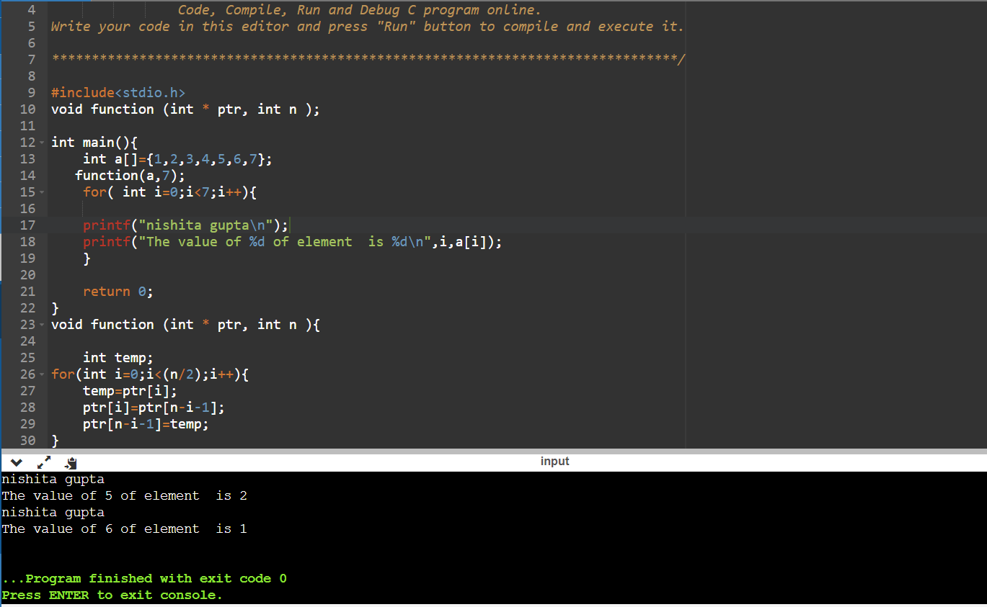

37). Write a program of calloc

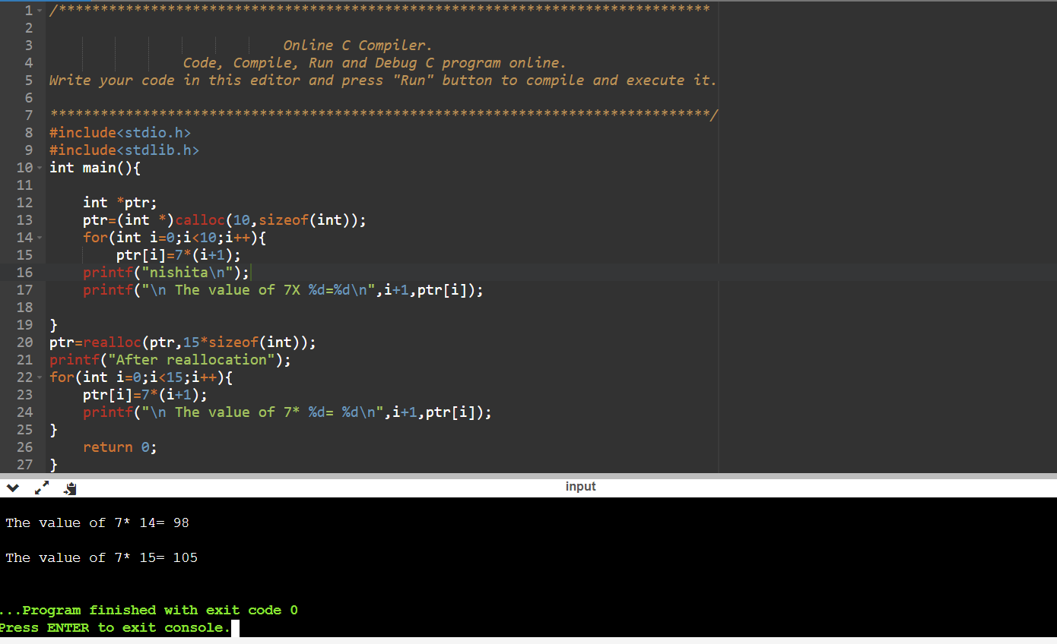

38) write a program of malloc

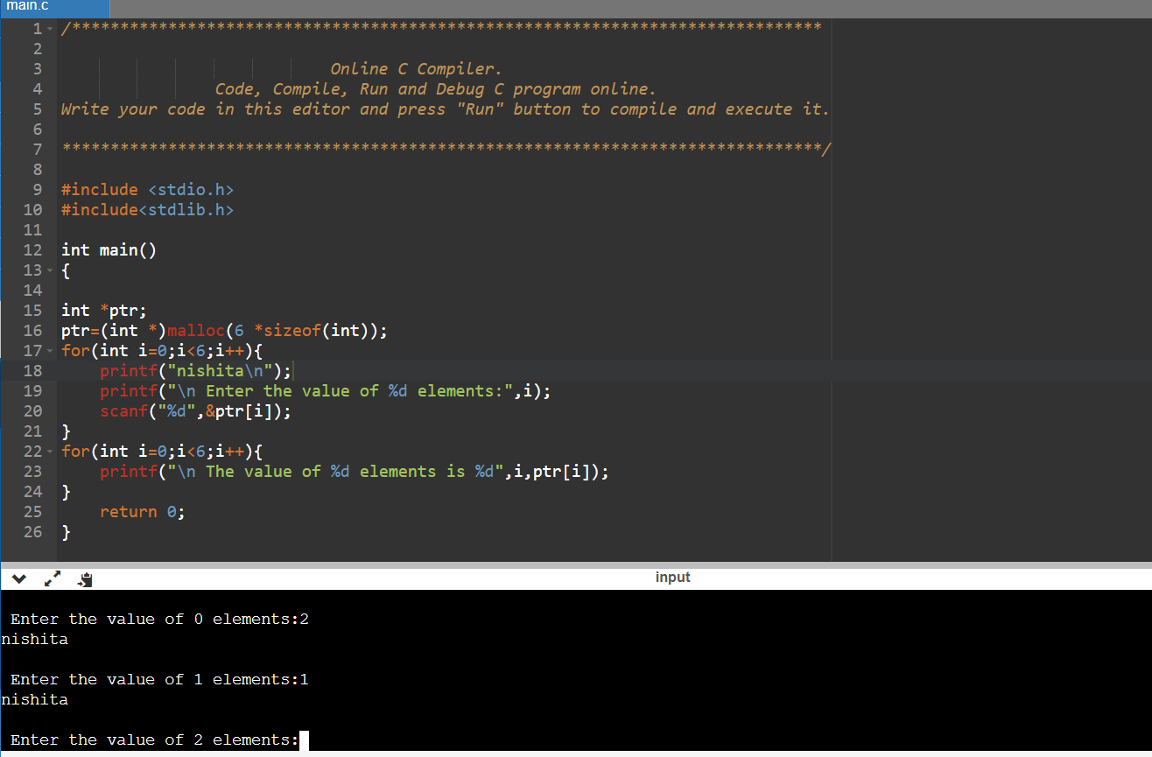

39). Write a program to print a number in continue

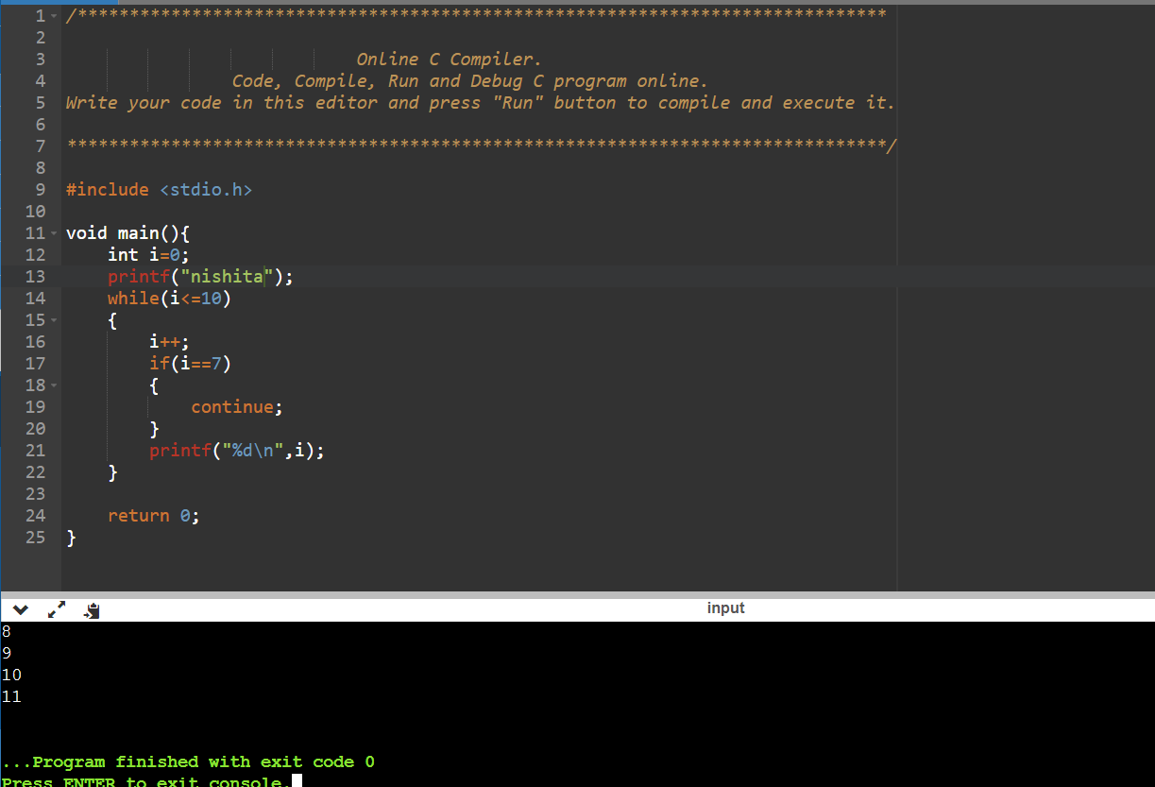

40) write a program of use of break keyword

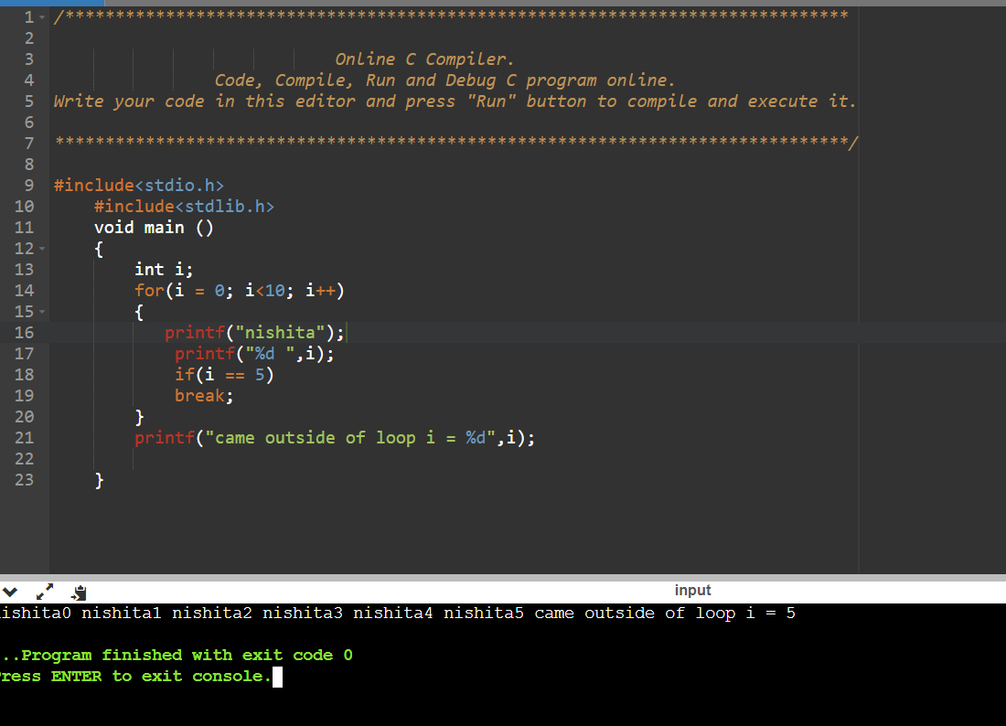

41) write a program of 1d array

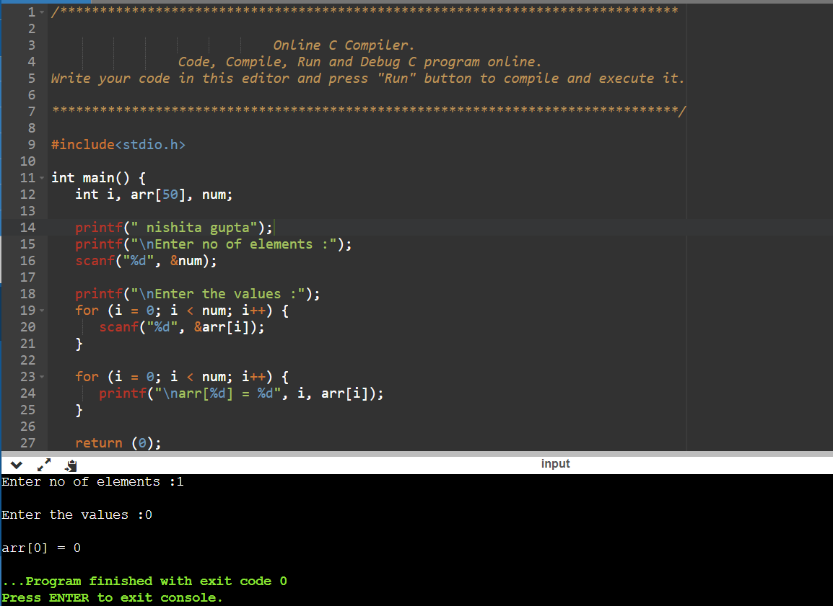

42). Write a program to find square of following

CODE:- 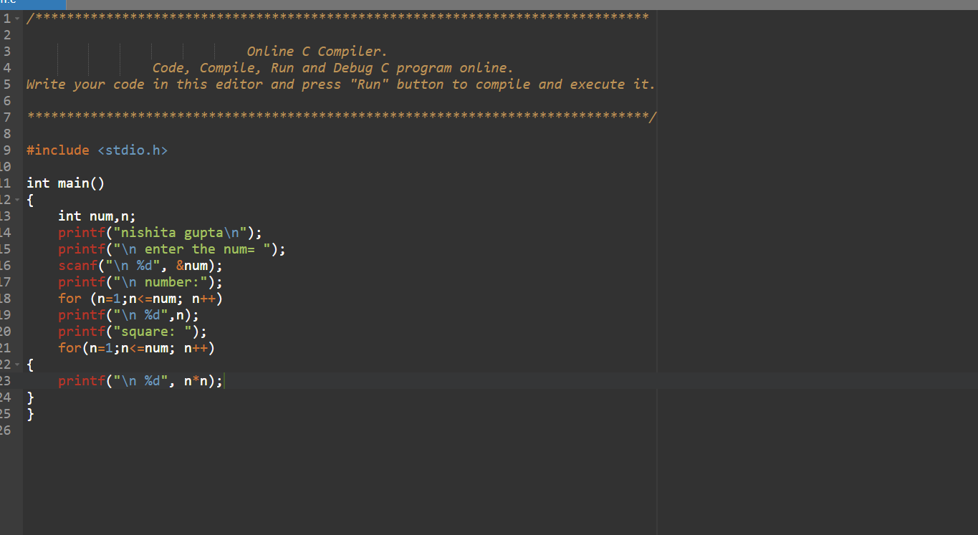

OUTPUT

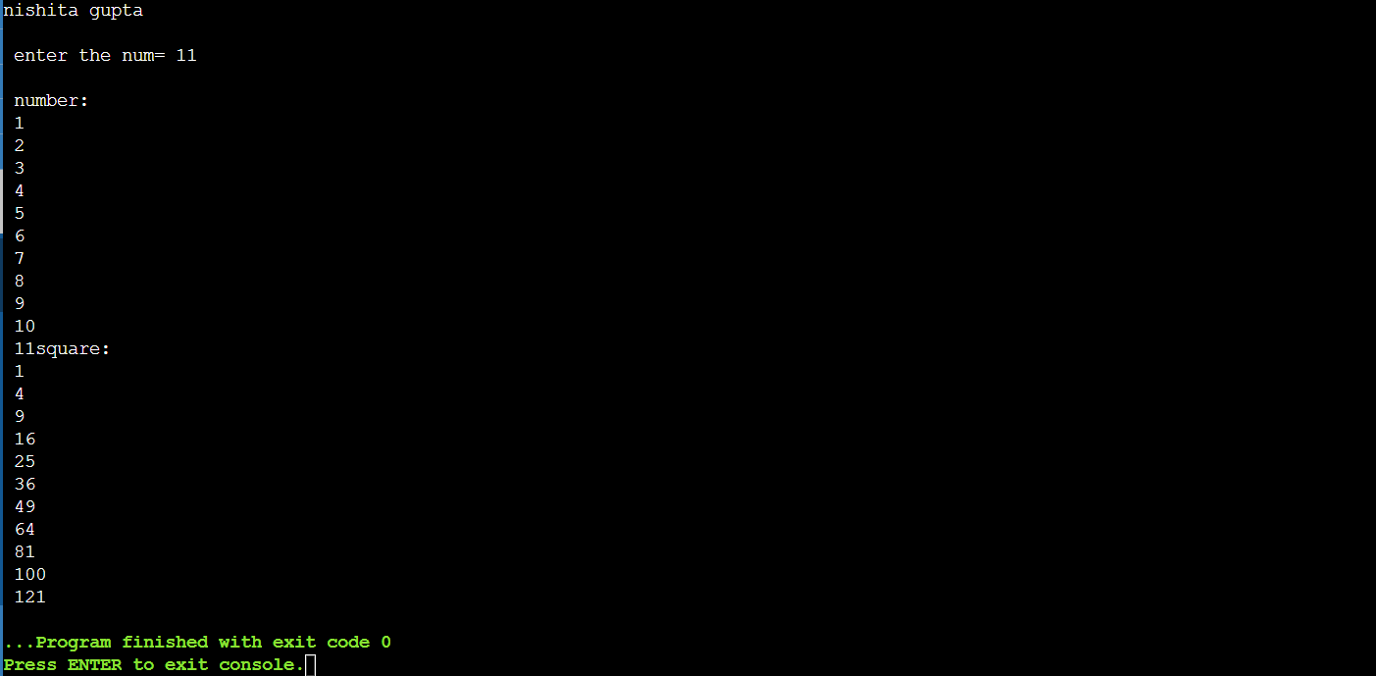

43). Squar of whose significant digit is

5

CODE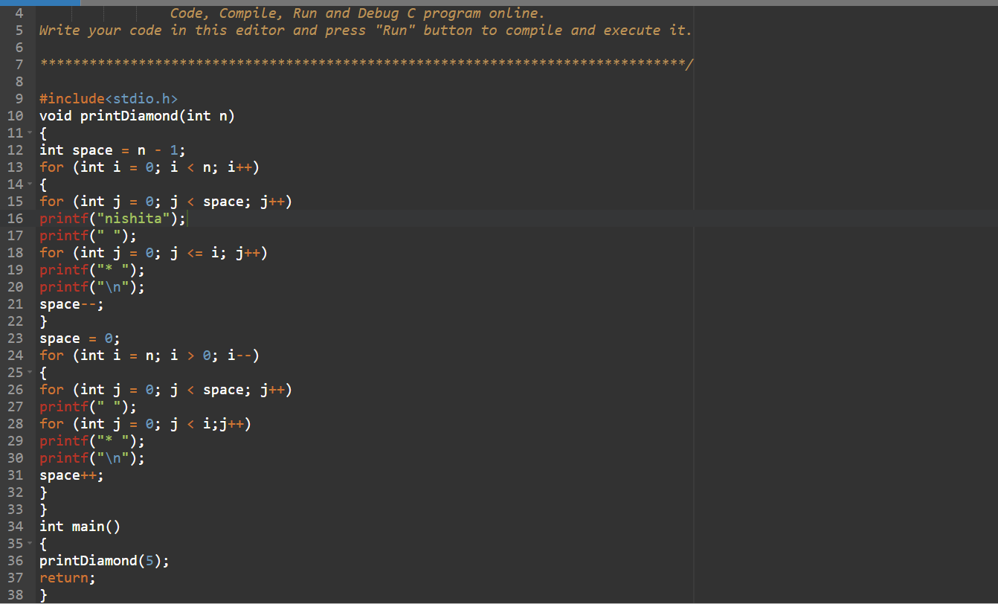

OUTPUT

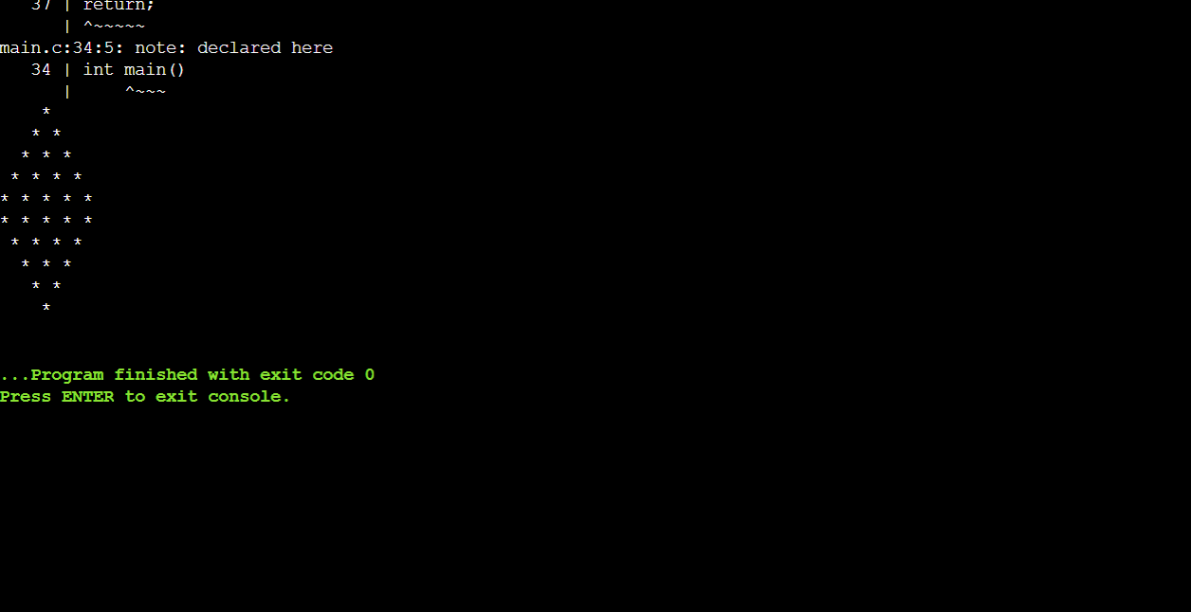

44). Write a program to print reverse series of number 100 to 1?

CODE

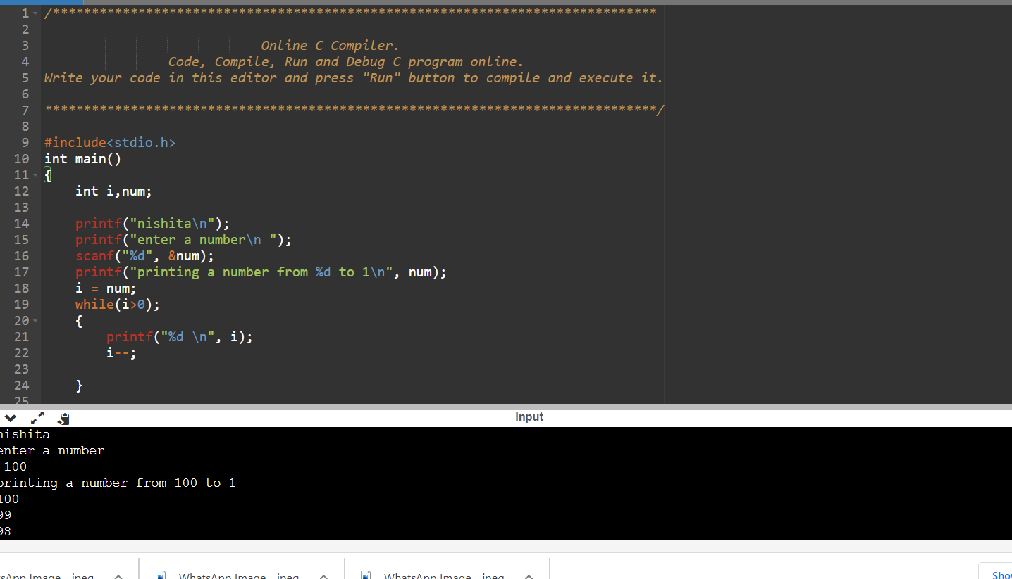

45) write a program to find transpose of a matrix using two dimensional array

Code:-

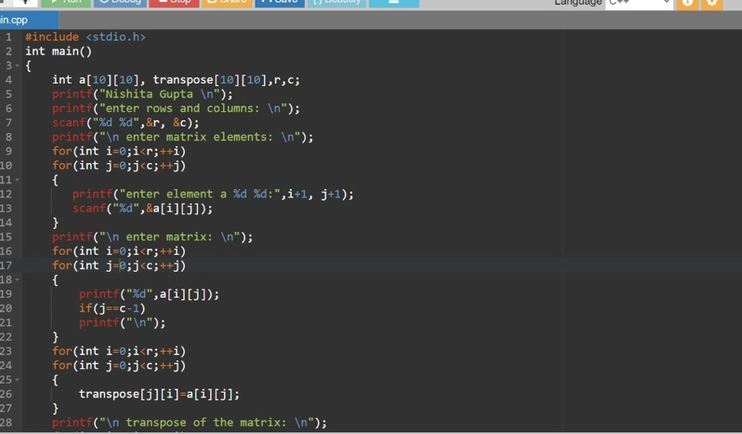

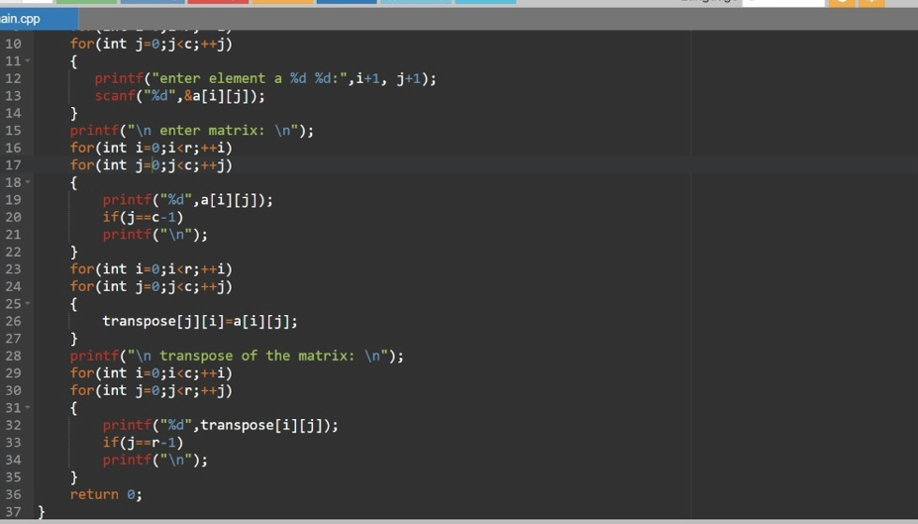

Output:- 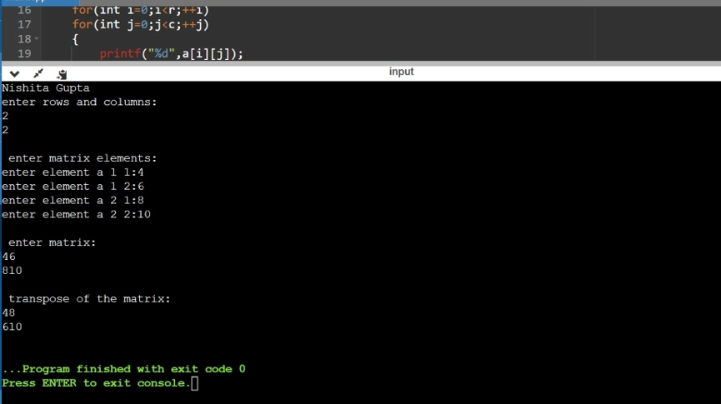

46). Write a programme to print an array row and column wise

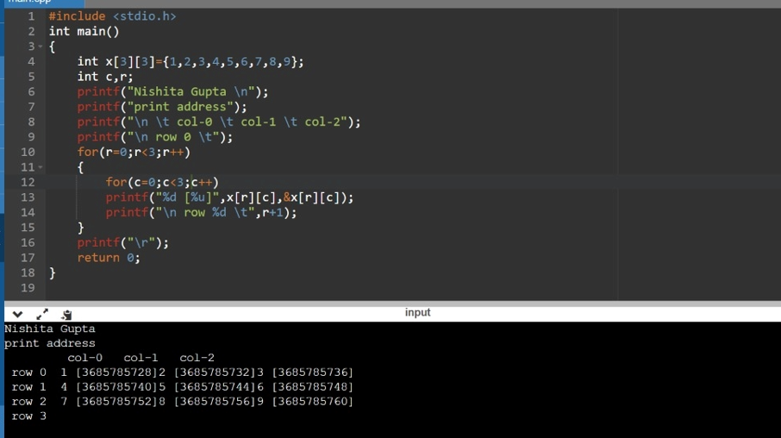

47). Write a program to print alphabetical ladder pattern

CODE:-

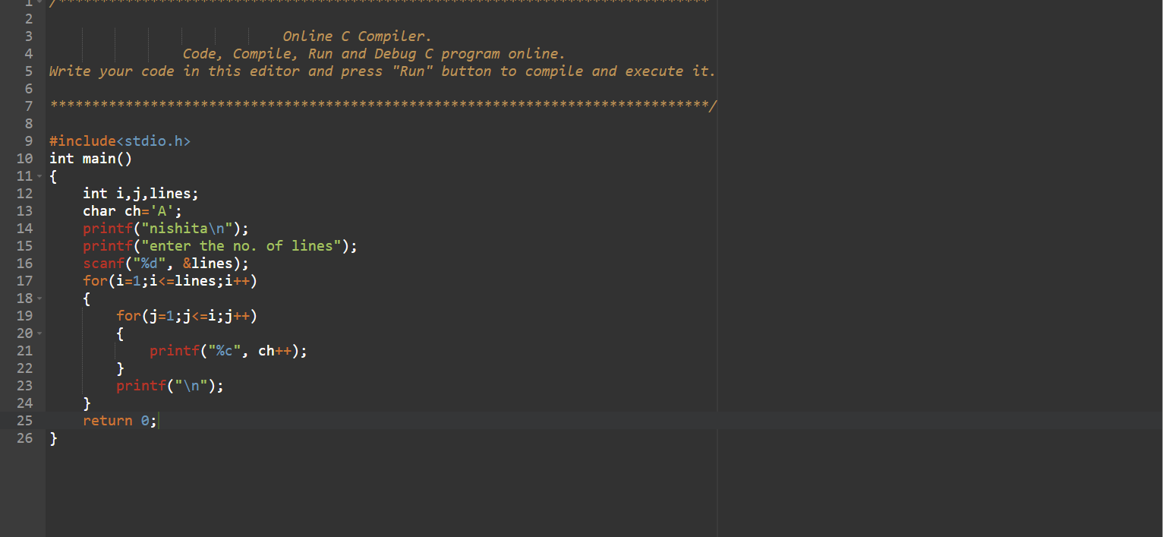

OUTPUT:-

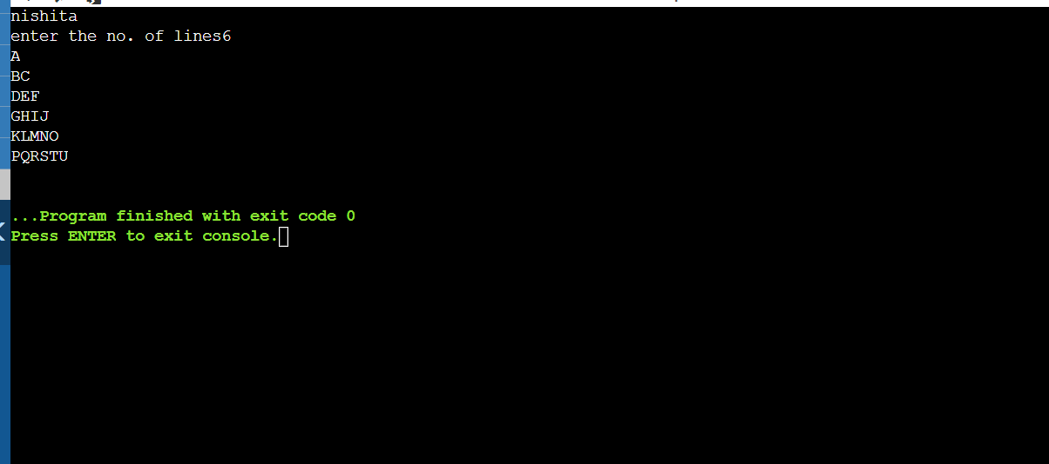

48). Write a program to print number ladder pattern

CODE:- 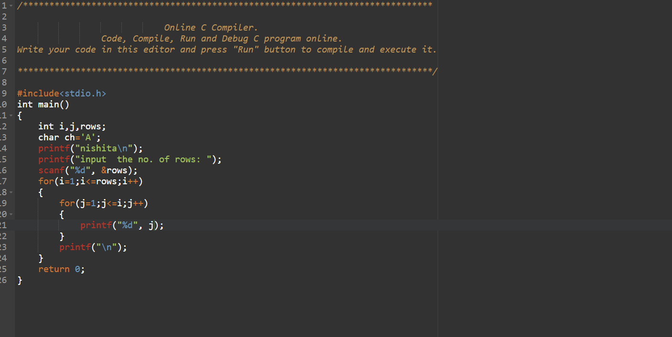

OUTPUT:-

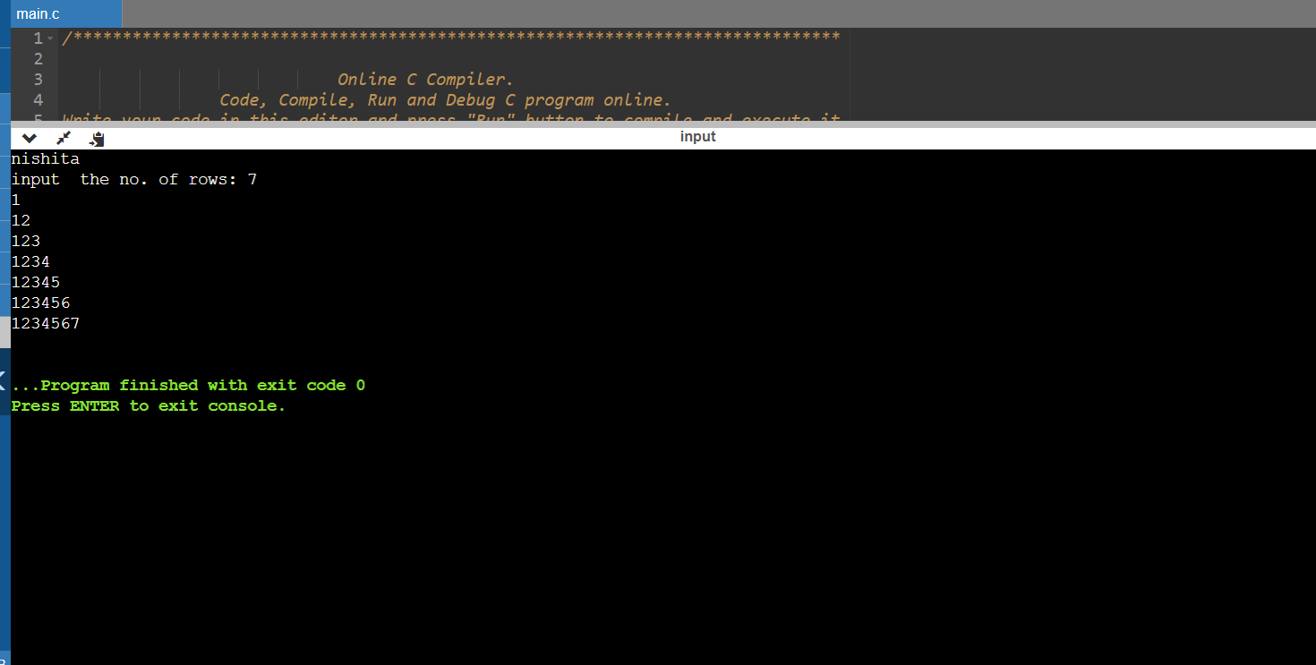

49). Write a program to find min and max number from an array?

CODE:- 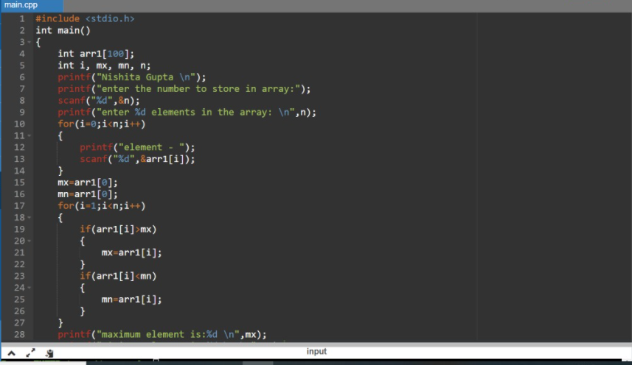

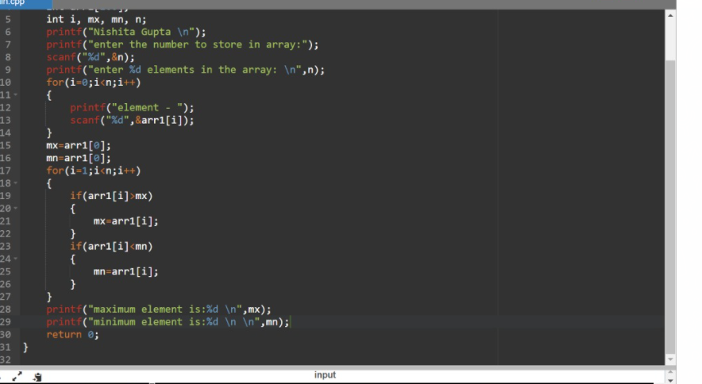

OUTPUT:- 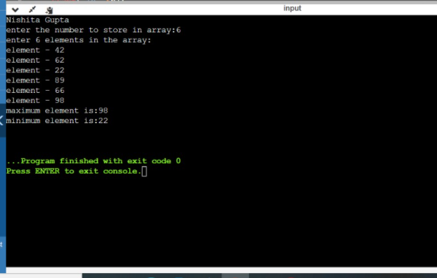

50). Write a program to checkthe occurancy of a character in a string?

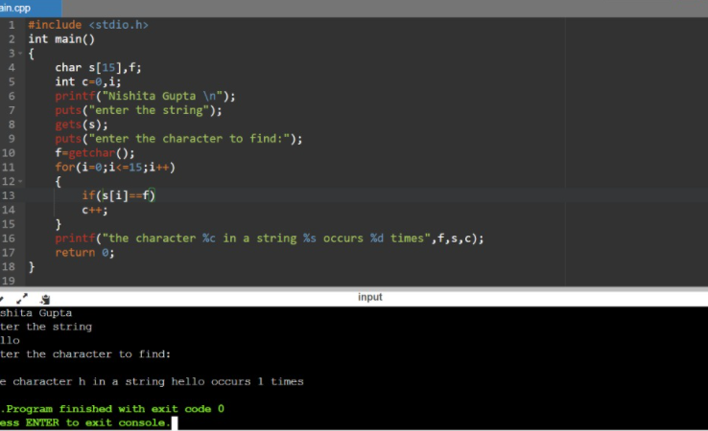

51). Write a program to find largest number among three number using logical and operator?

CODE:- 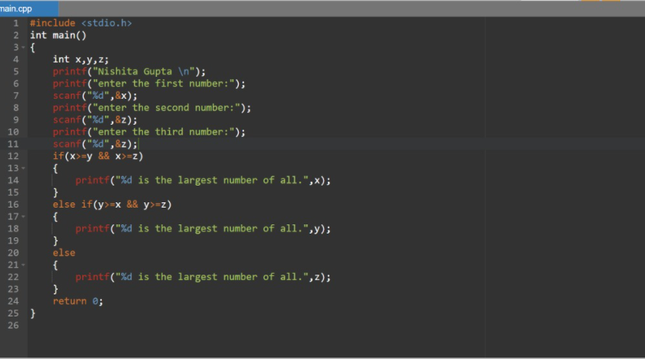

OUTPUT:- 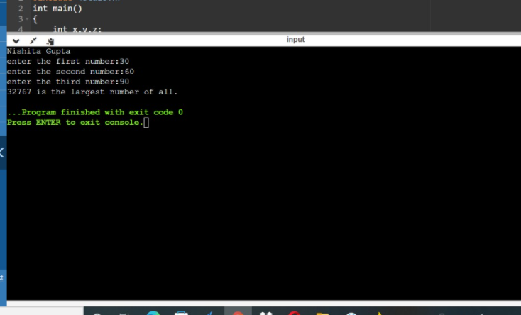

52). Write a program of 1d array.

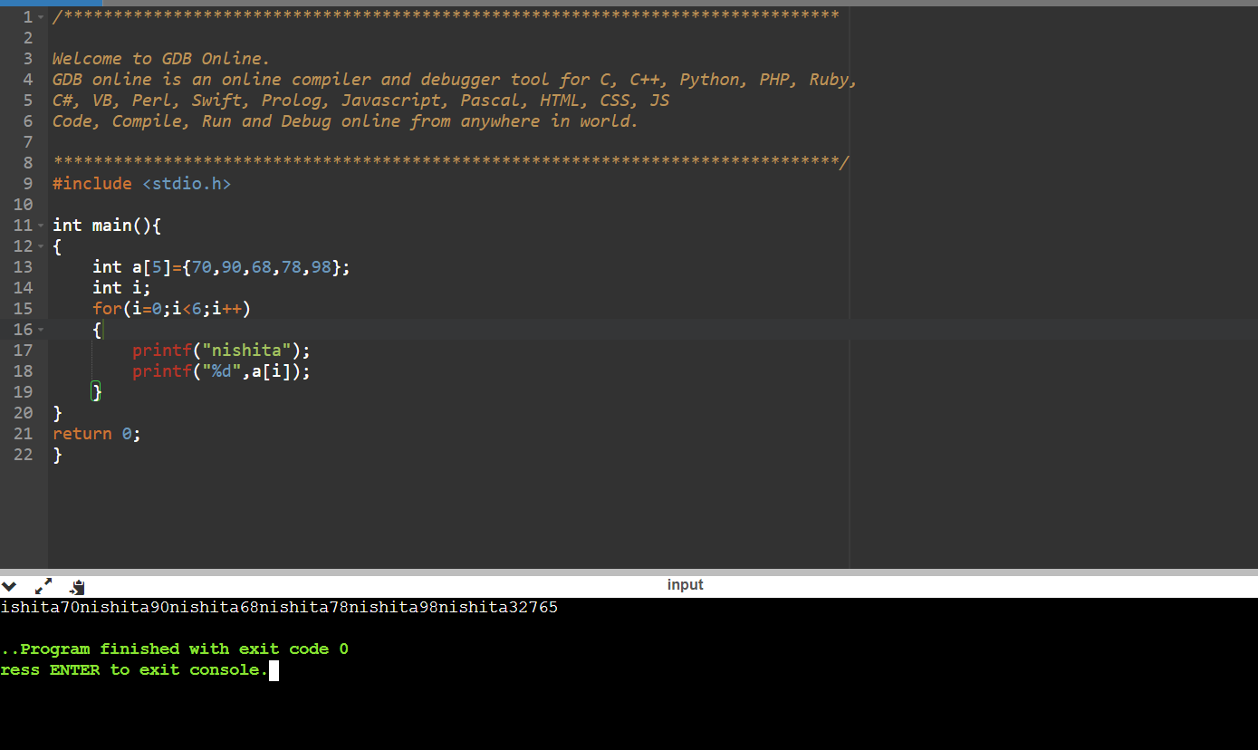

53). Write a program of leap year.

CODE

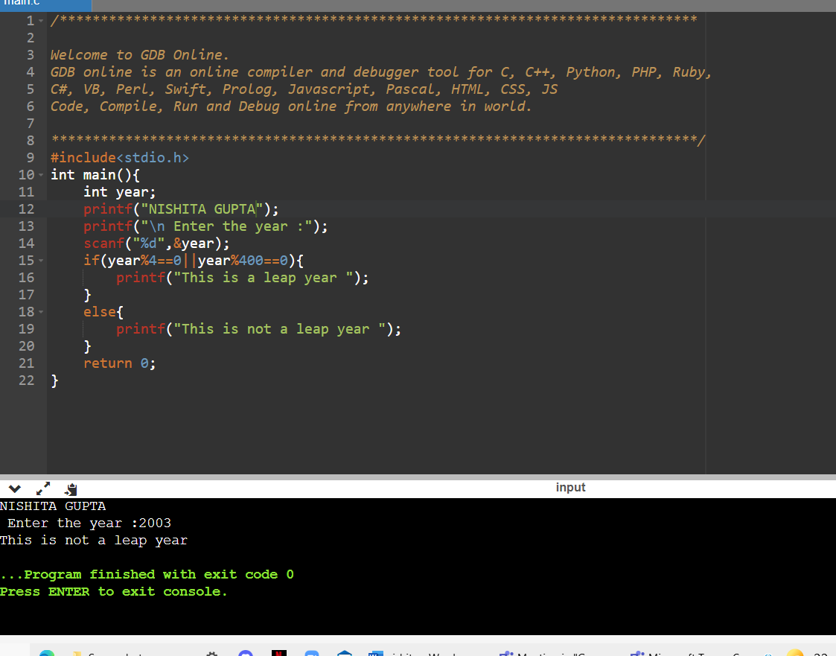

54). WRITE a program of null pointer?

CODE 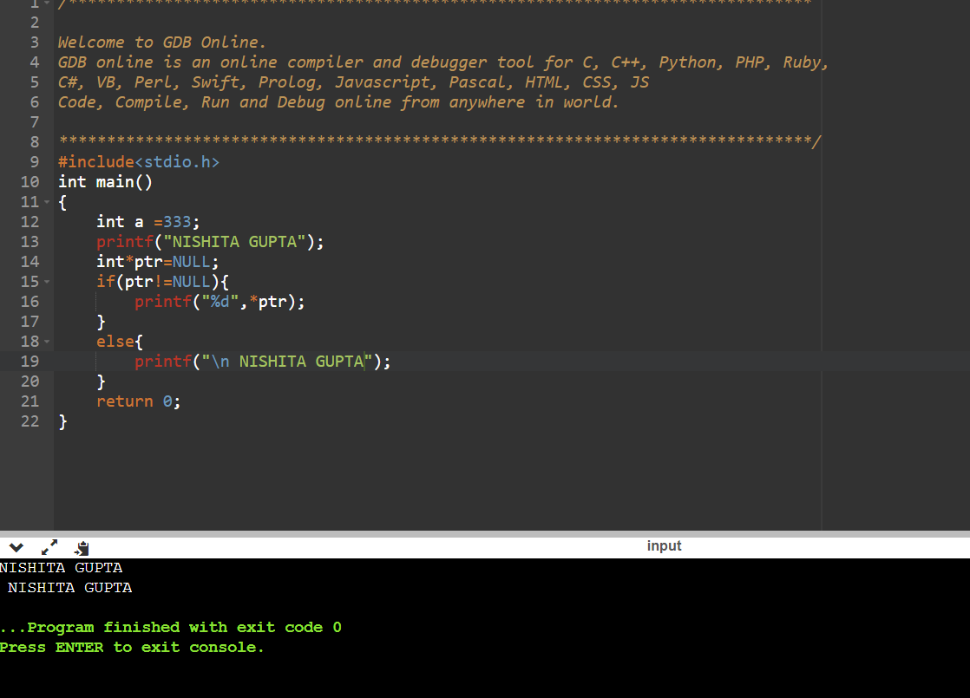

55). Write a program to find increment and decrement of a given number?

CODE:-

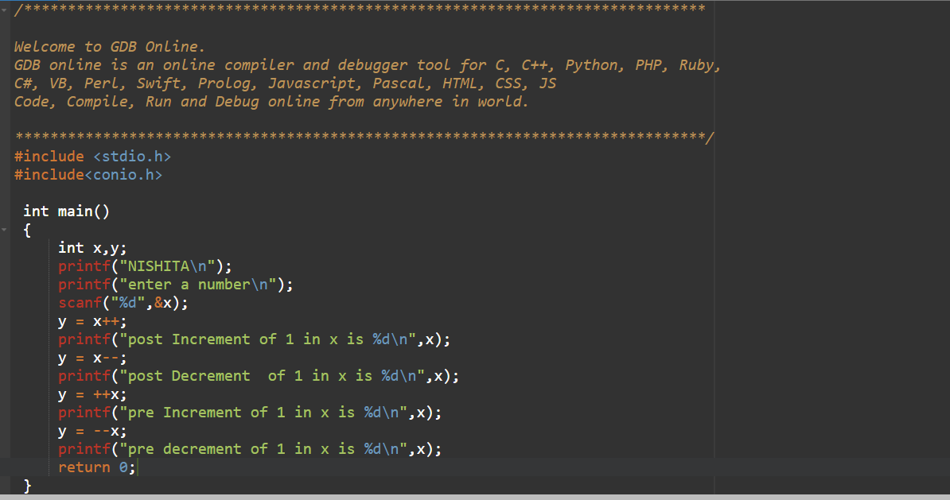

OUTPUT:-

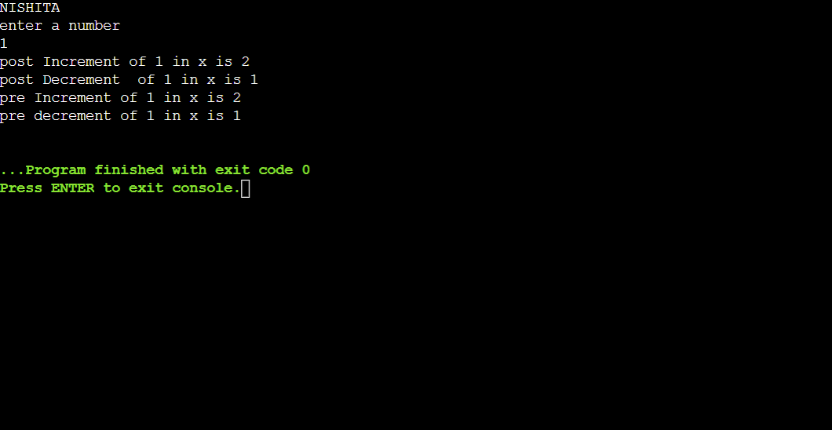

56). Write a program to check number is Armstrong or not?

CODE:-

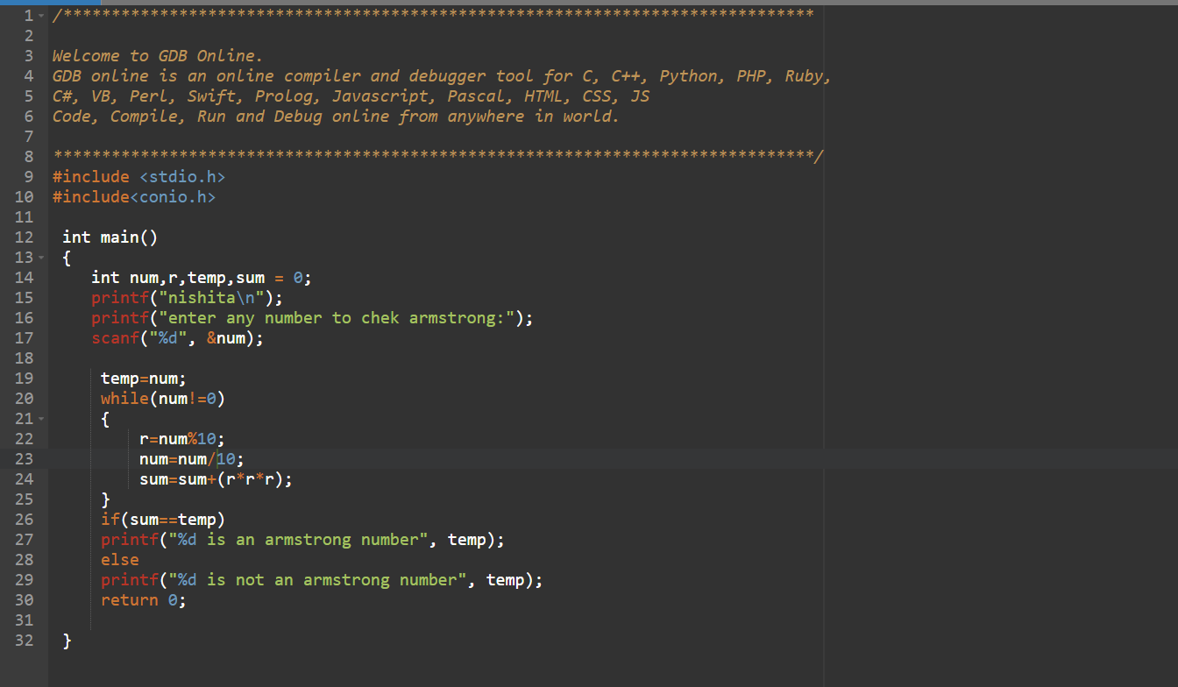

OUTPUT:-

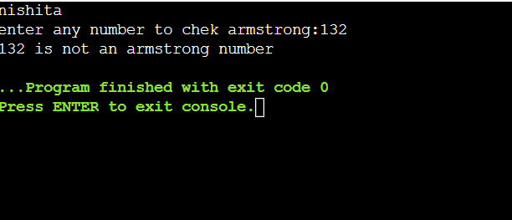

57). Write a program of SI

CODE

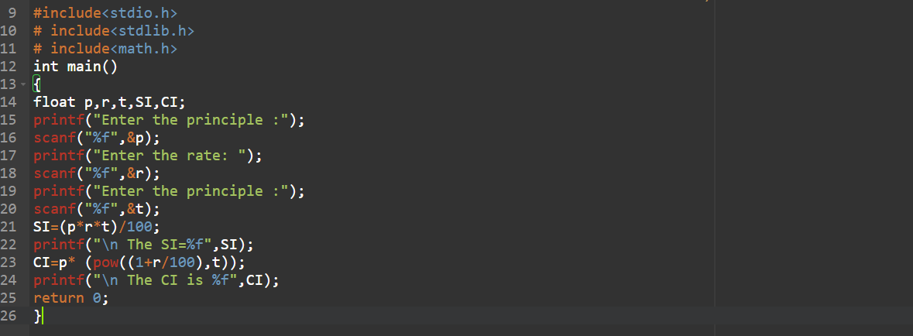

OUTPUT

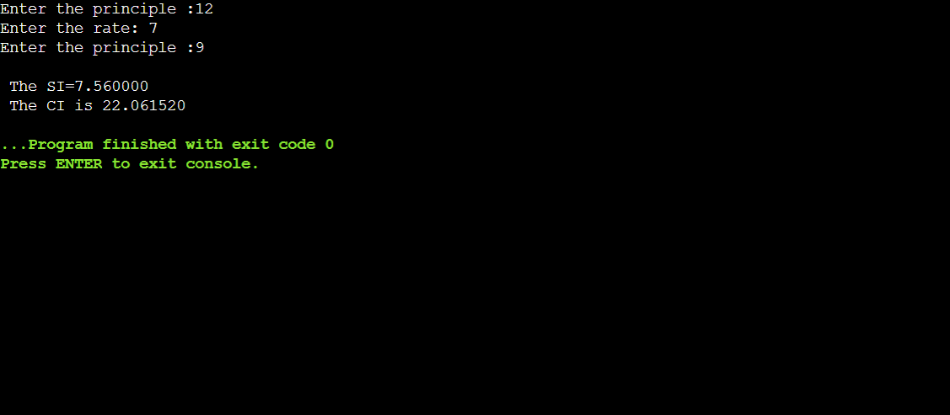

58). Write a program of for loop

CODE

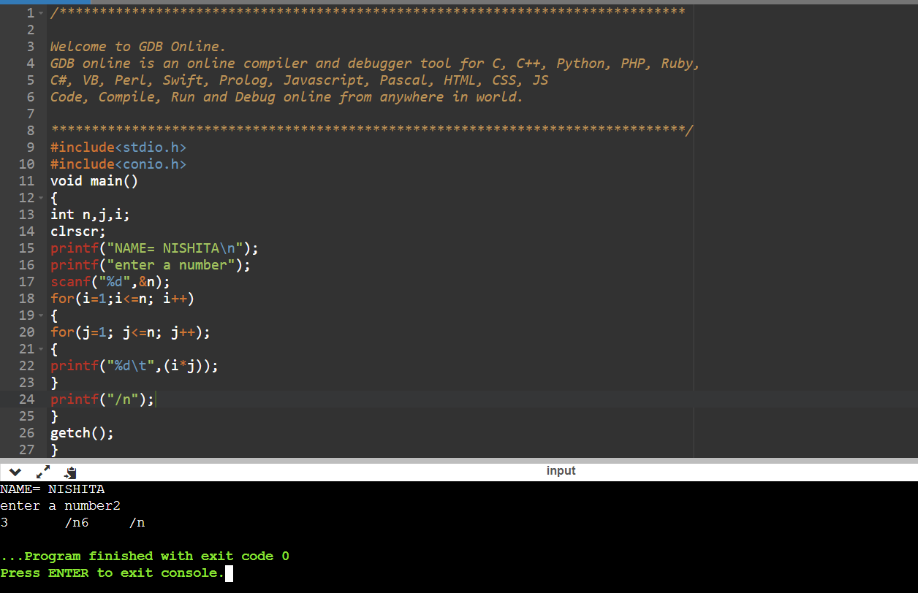

59). Write a program to find number is palindrome or not?

CODE

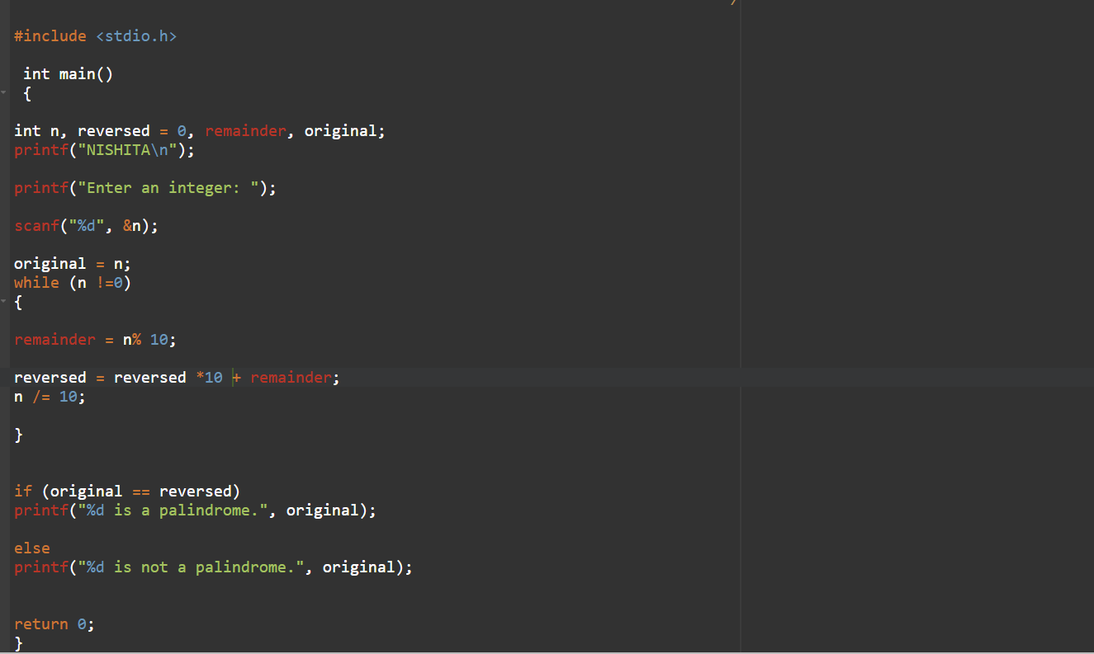

OUTPUT

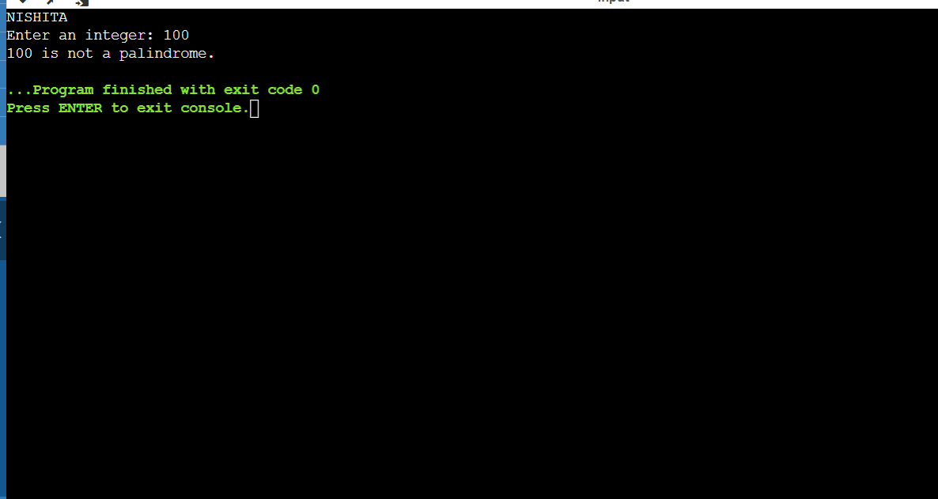

60). Write a program to take data of all five student and count the students who age is less than 25 and weight less than 50KG

CODE

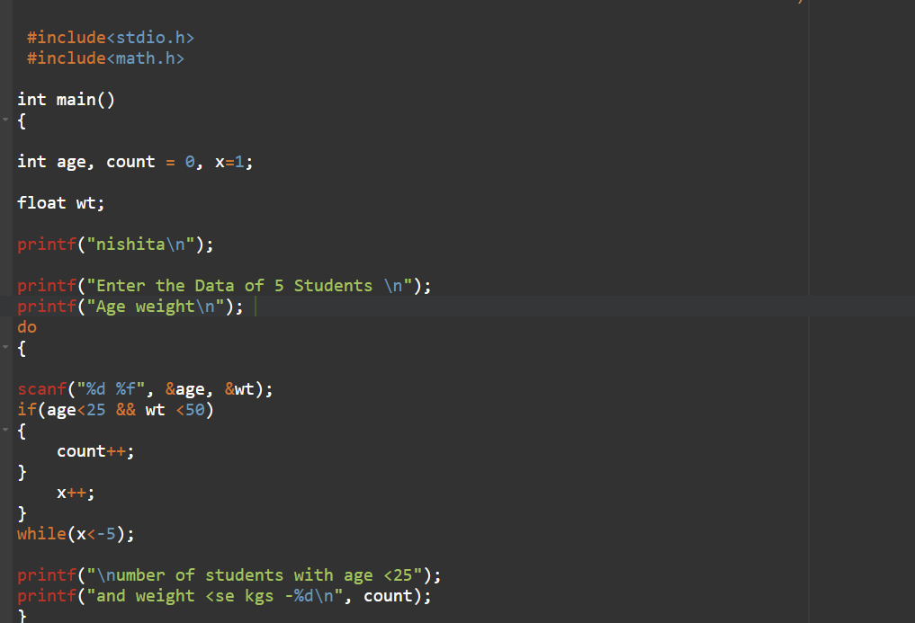

OUTPUT

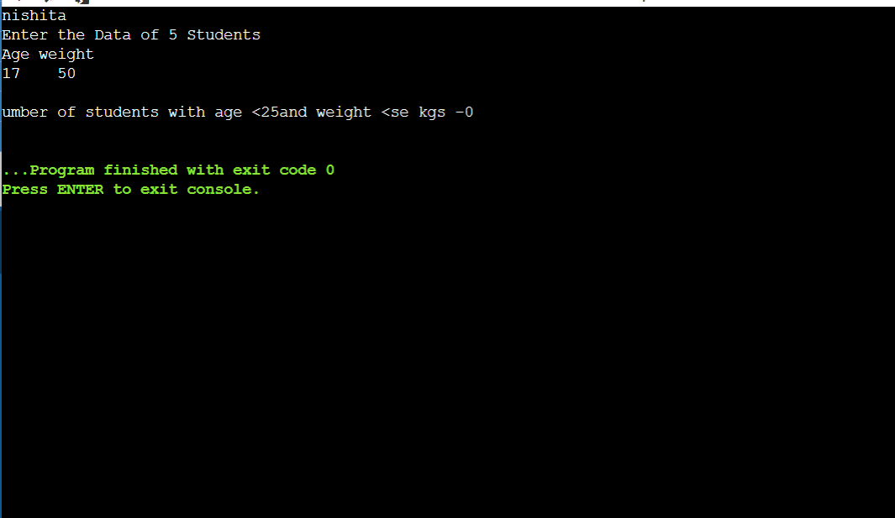

61). Write a programme to find functions without argument and with return value example

CODE

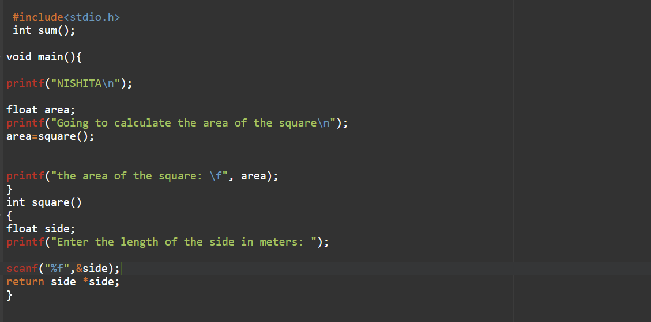

Output:

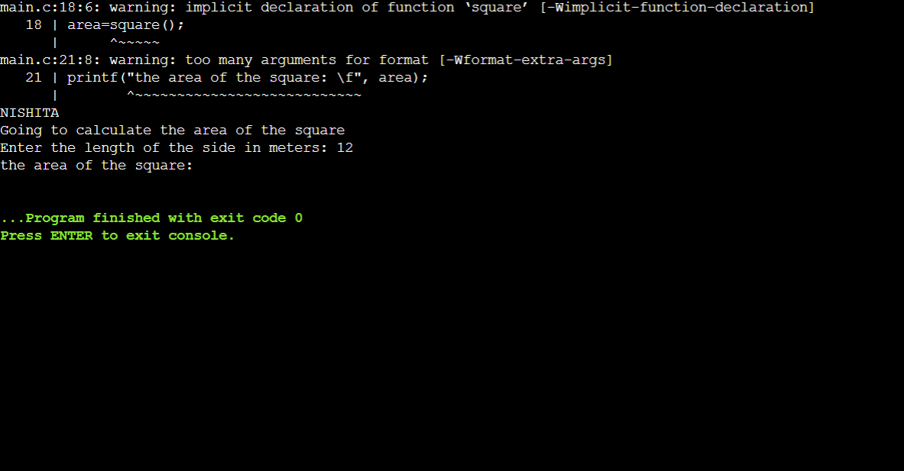

62). Write a program to show extern function.

CODE

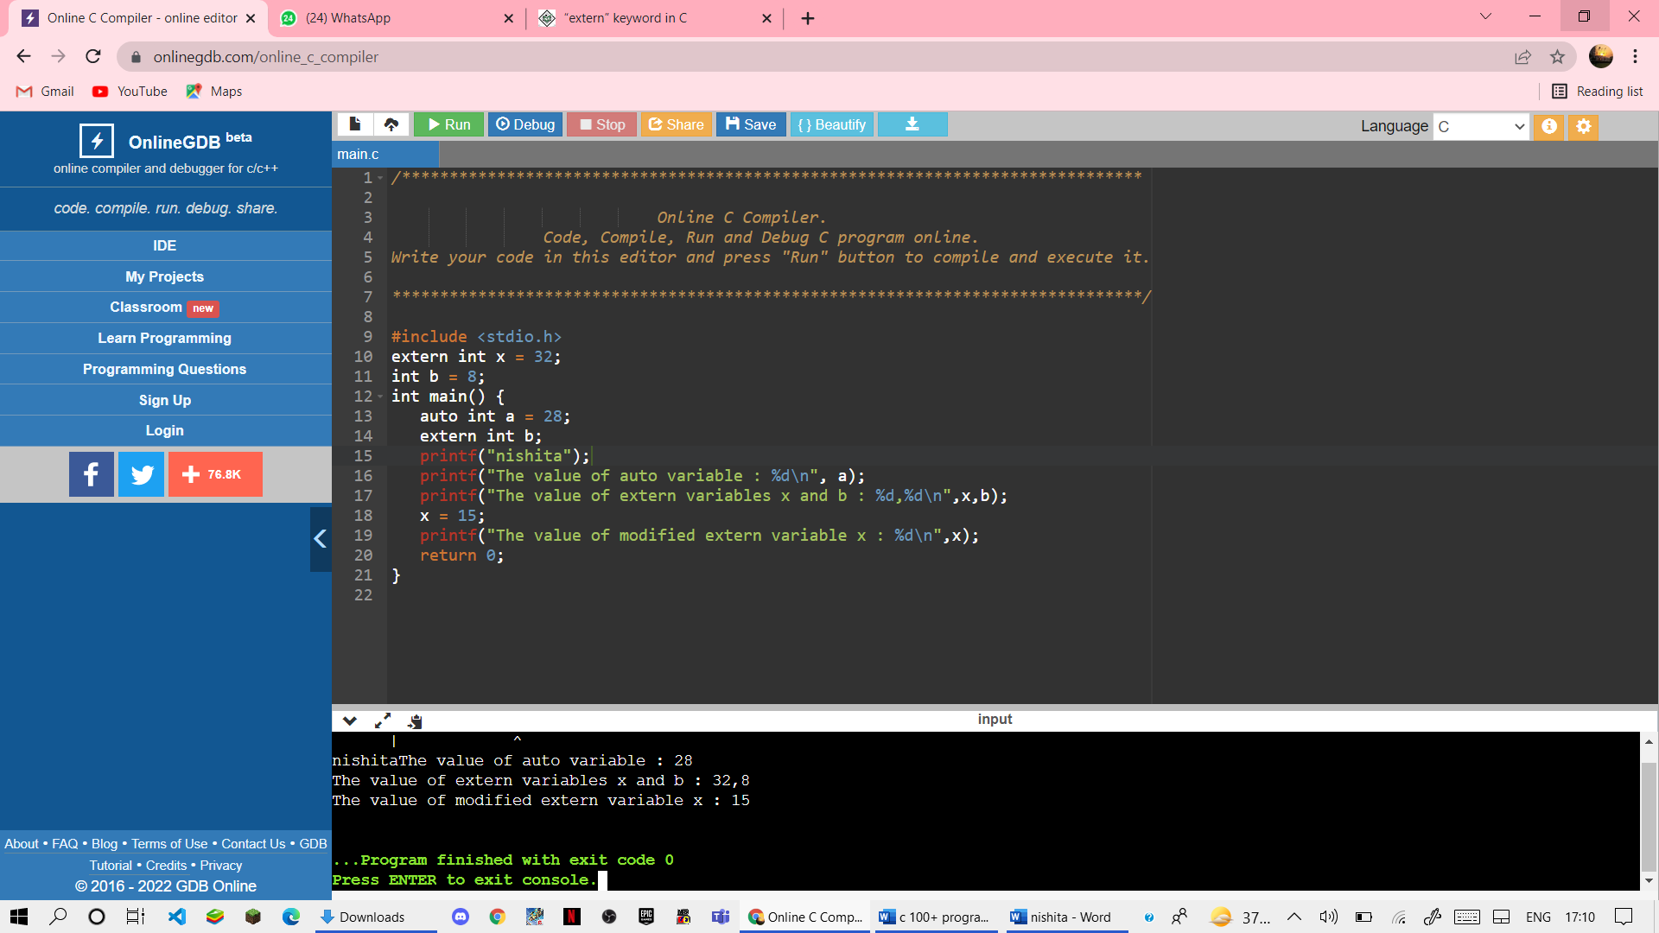

Output



63). Write a program to search for a number enter by the users in a given array and display the array in ascending order

CODE

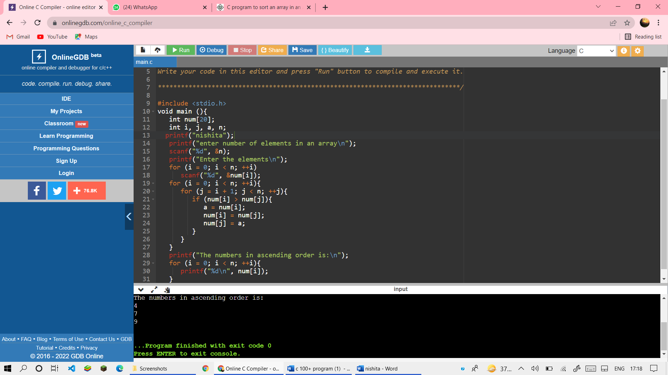

OUTPUT

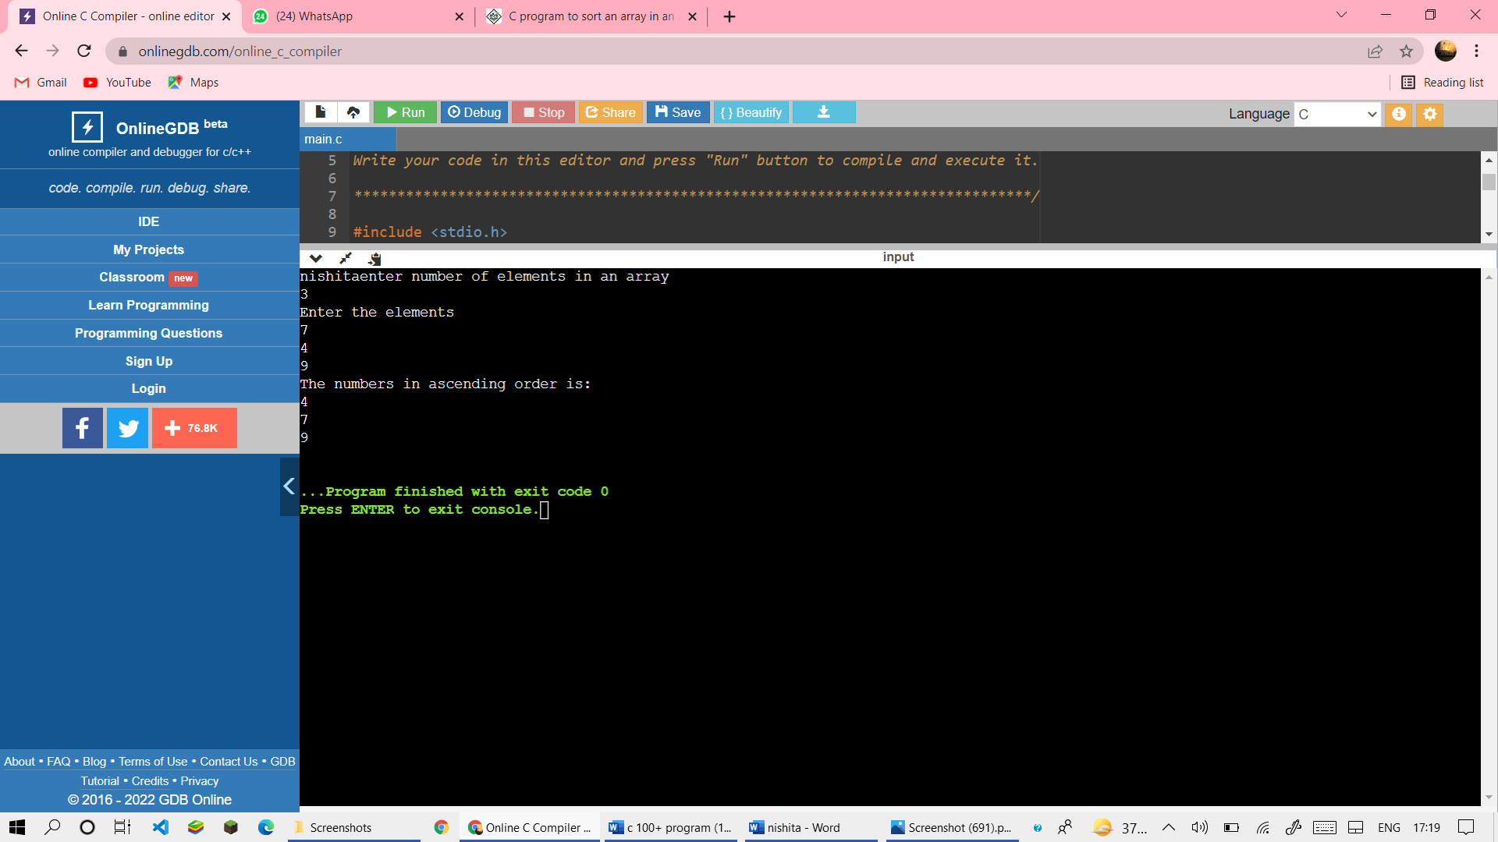

64). Write a programme to display transpose of matrix

CODE

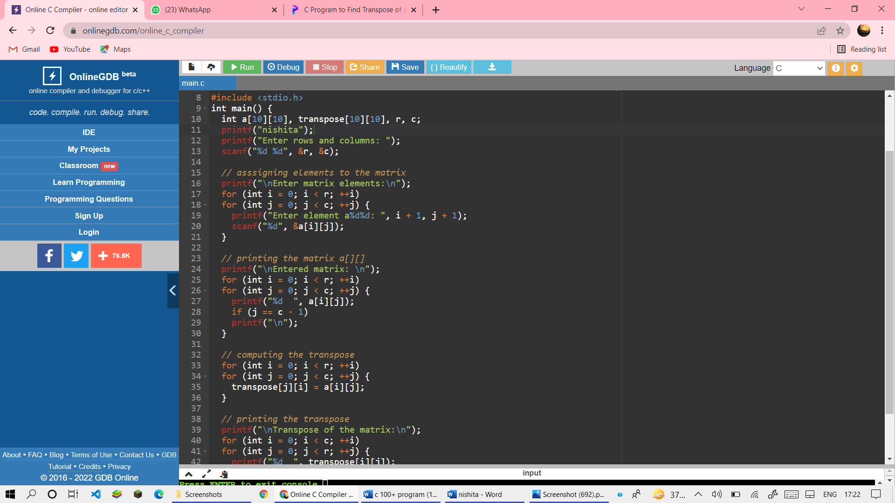

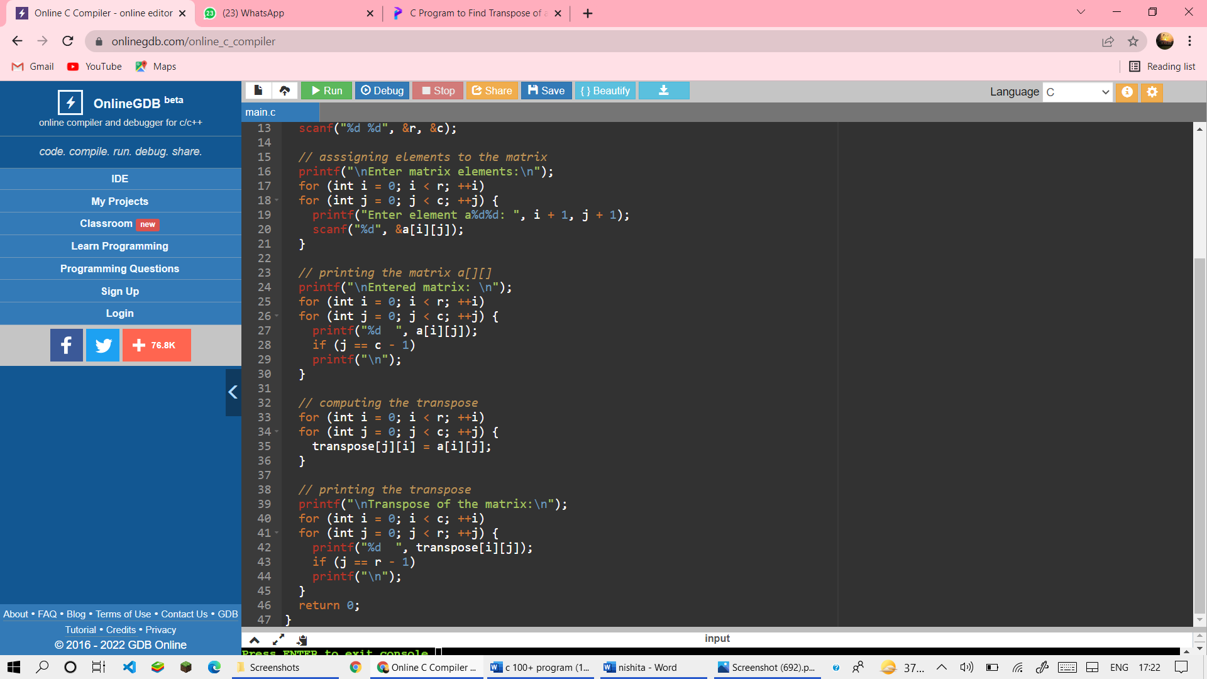

OUTPUT

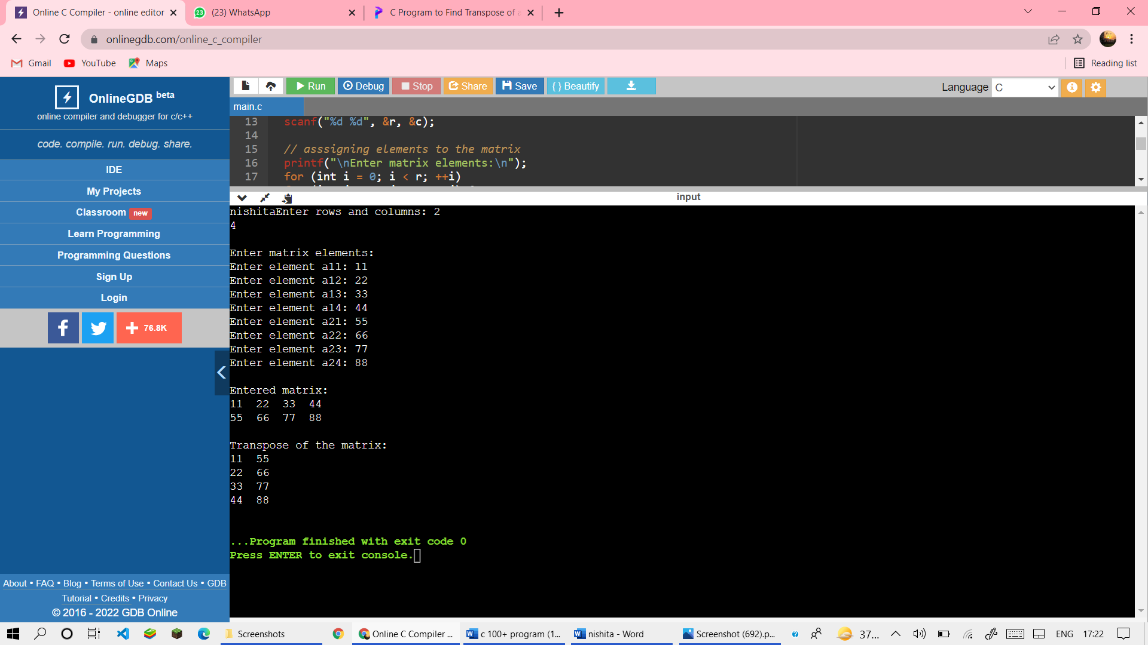

65).Write a program to store even and odd number in seprate list .

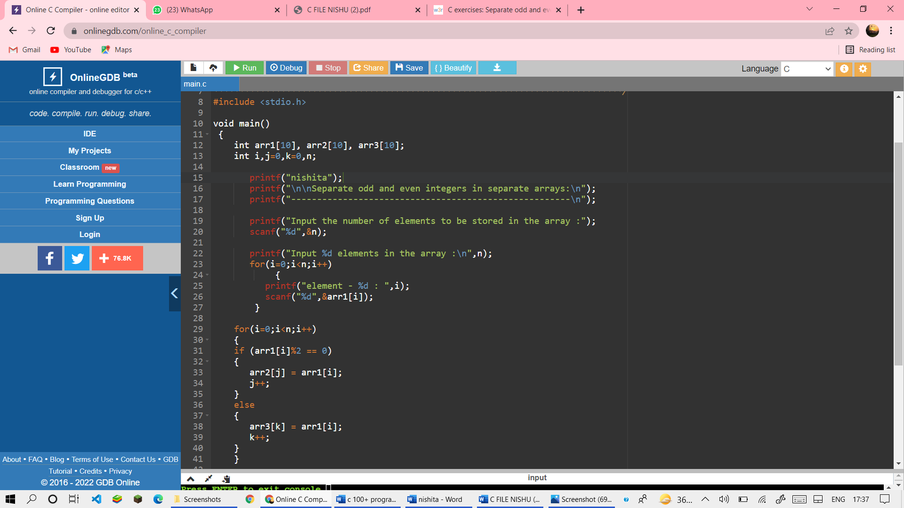

OUTPUT

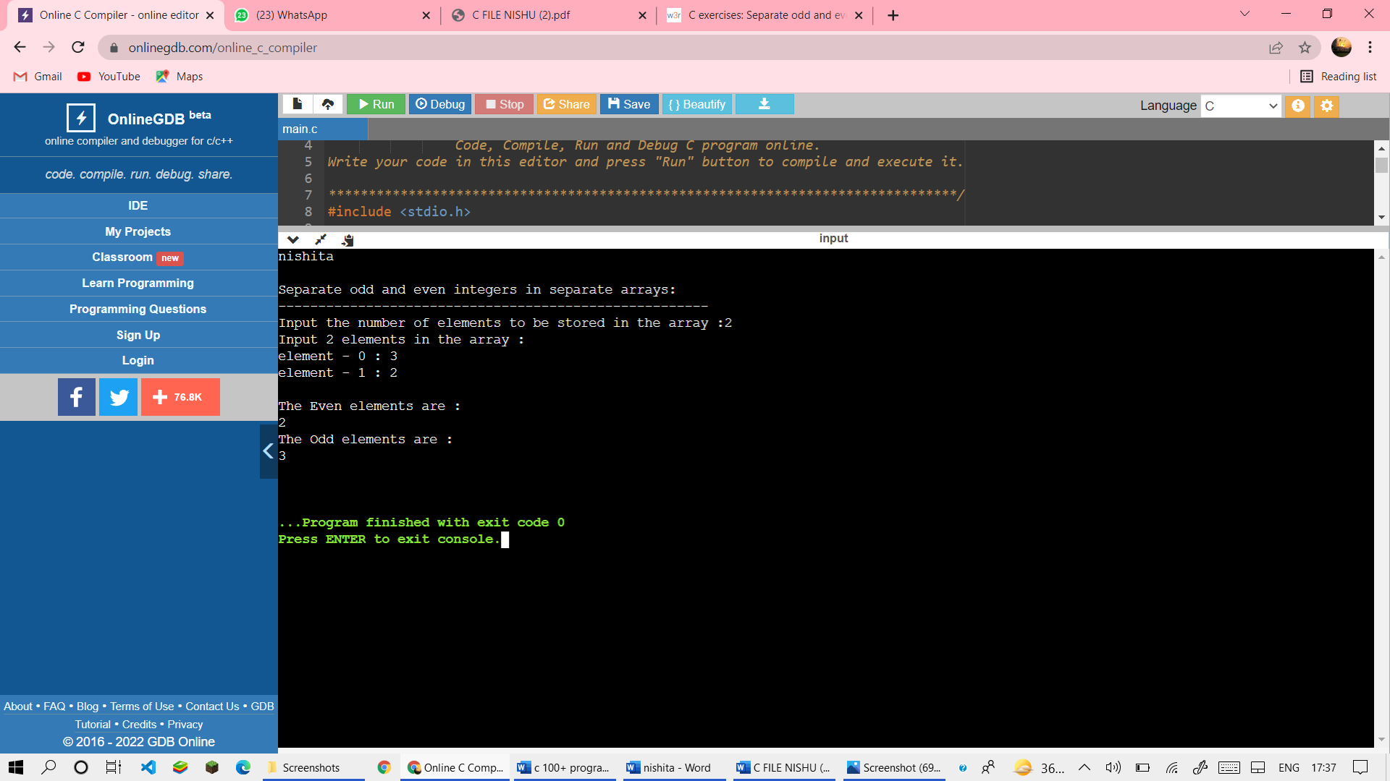

66). Write a program to read time in string format and extract hours, minutes and second also check time validity.

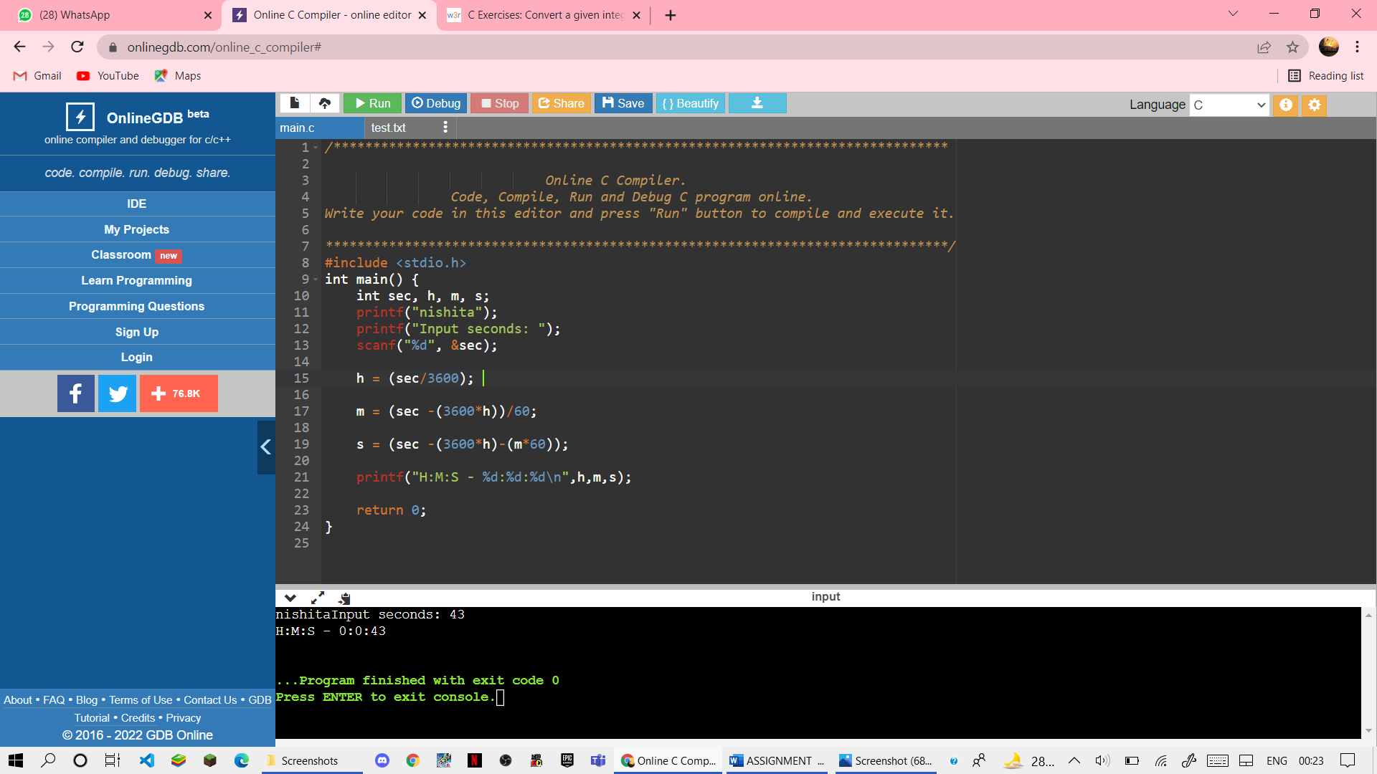

OUTPUT



67) write a program to convert temp from Celsius to fahreint by taking input from user

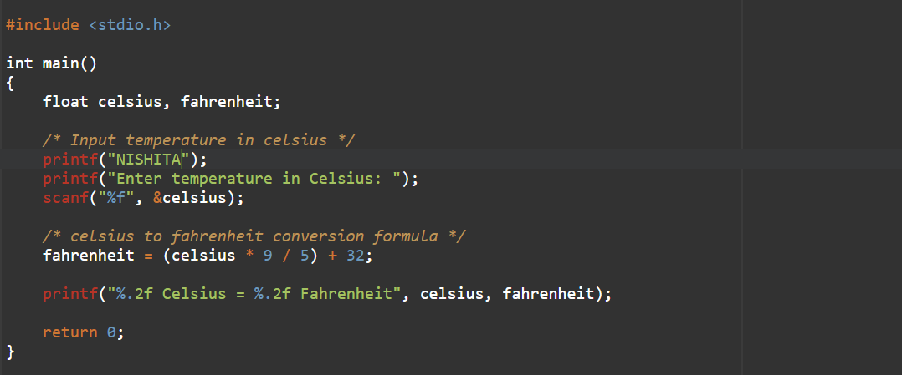

output 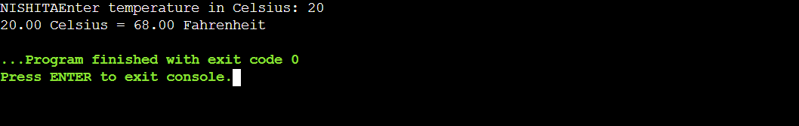

68) Write a program to find the greatest number among 3 numbers given by the user.

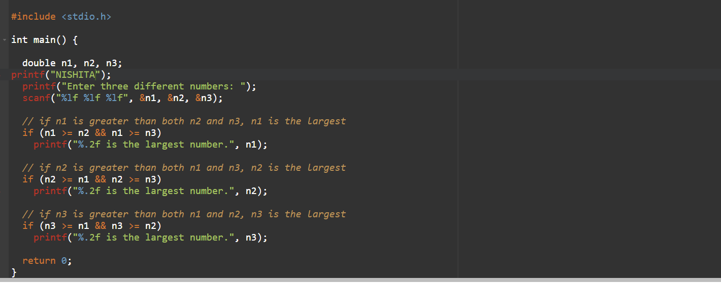

OUTPUT

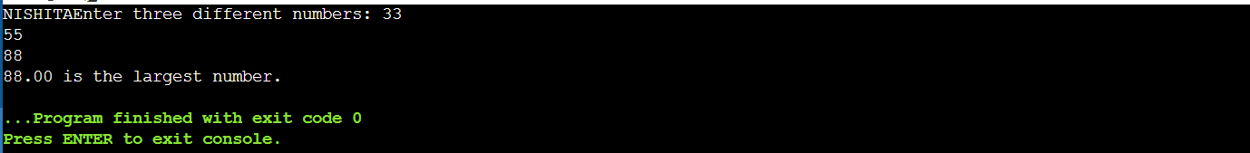

69) Write a program to check if a given number is a prime number or not.

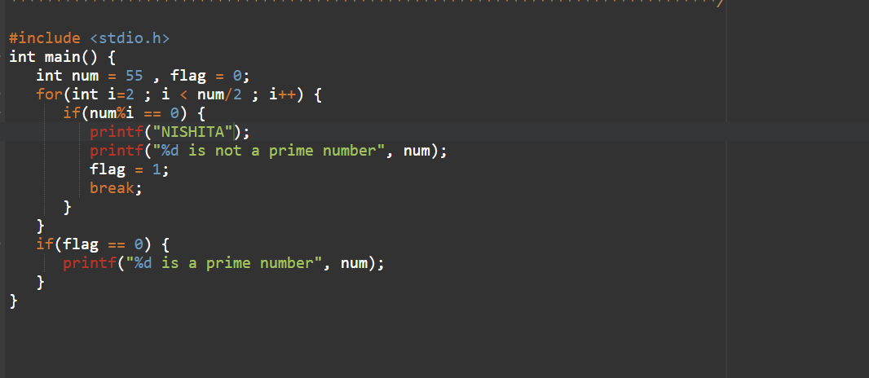

OUTPUT

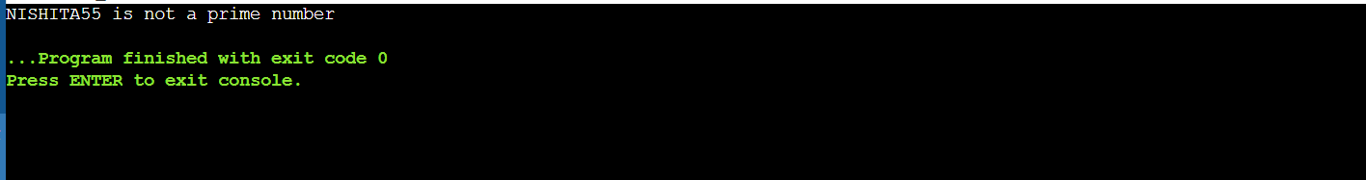

70) Write a program to display the following pattern upto N rows, taking the value of N from the user.

1

2 3

4 5 6

7 8 9 10

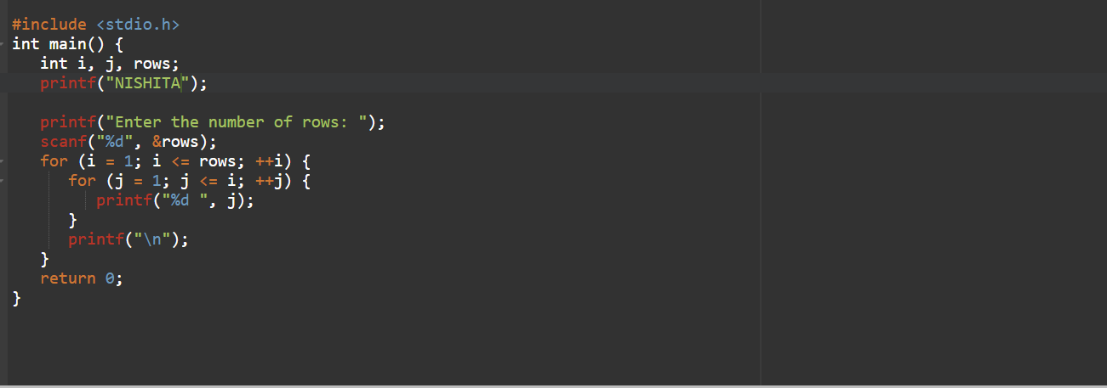

OUTPUT 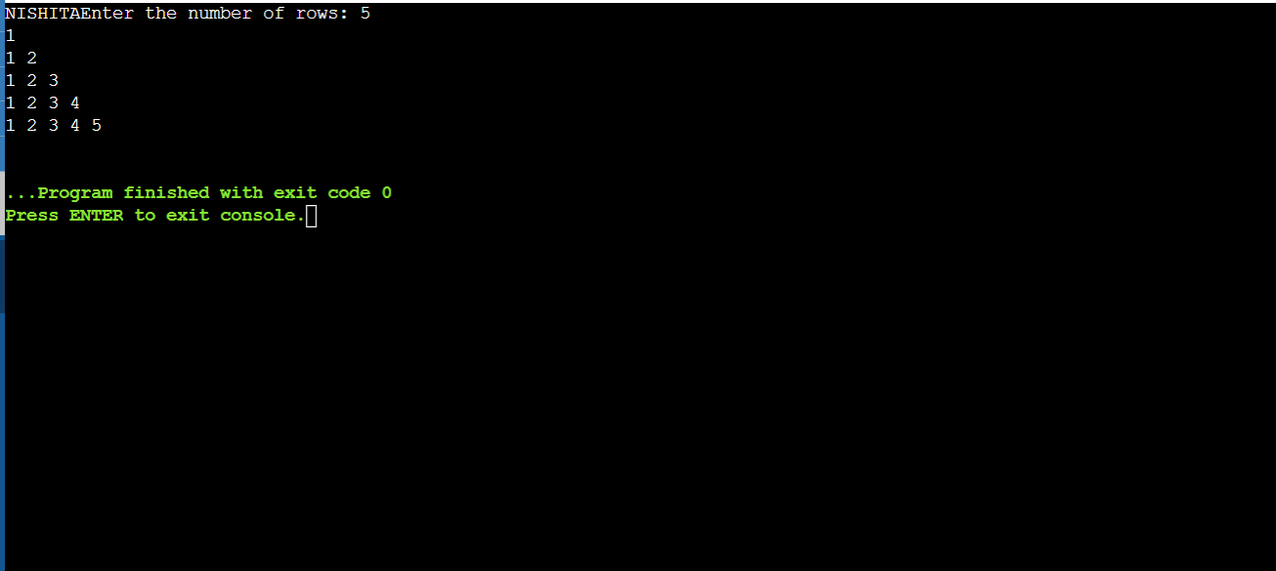

71) Write a program to input marks of 50 students using an array and display the average marks of the class.

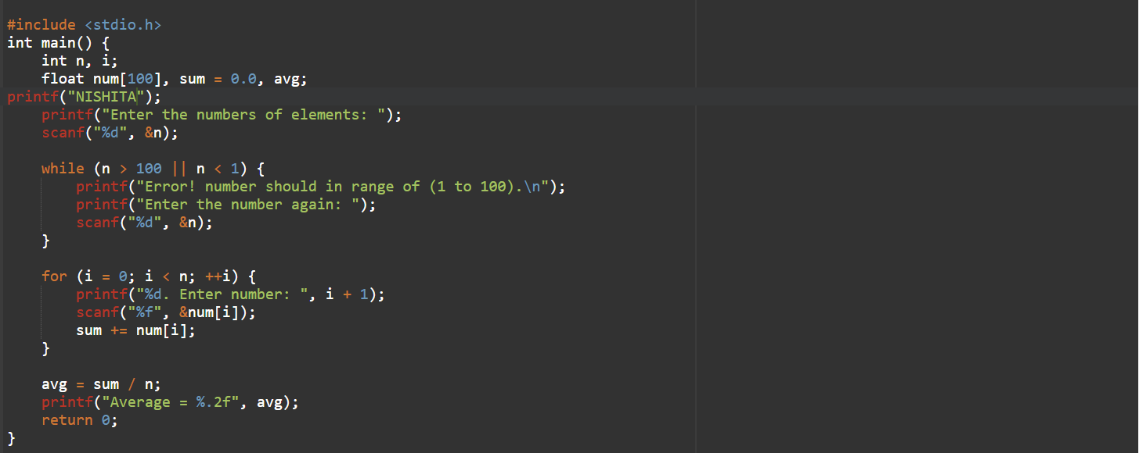

OUTPUT 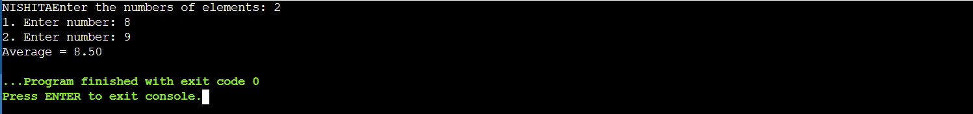

72) Write a program to search for a number entered by the user in a given array and display the array in ascending order.

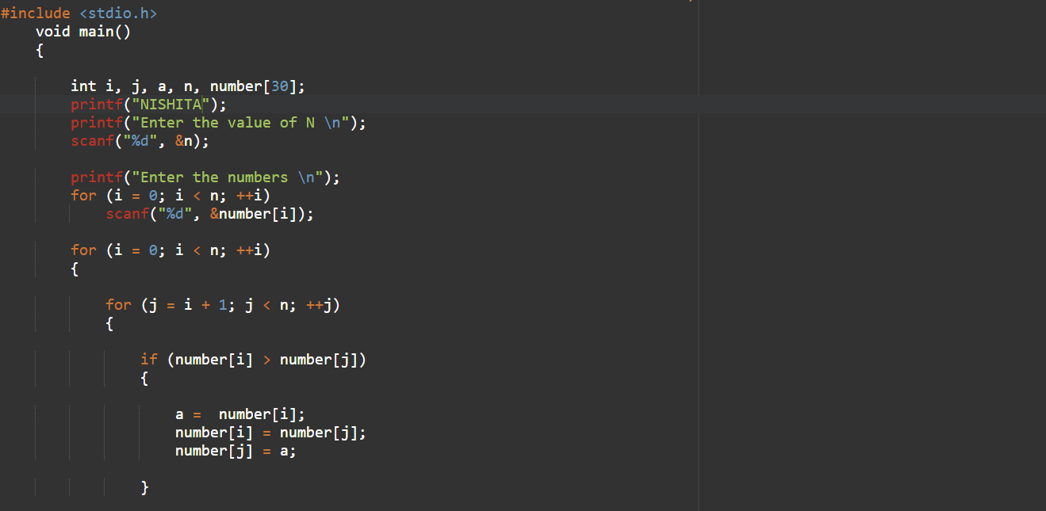

OUTPUT

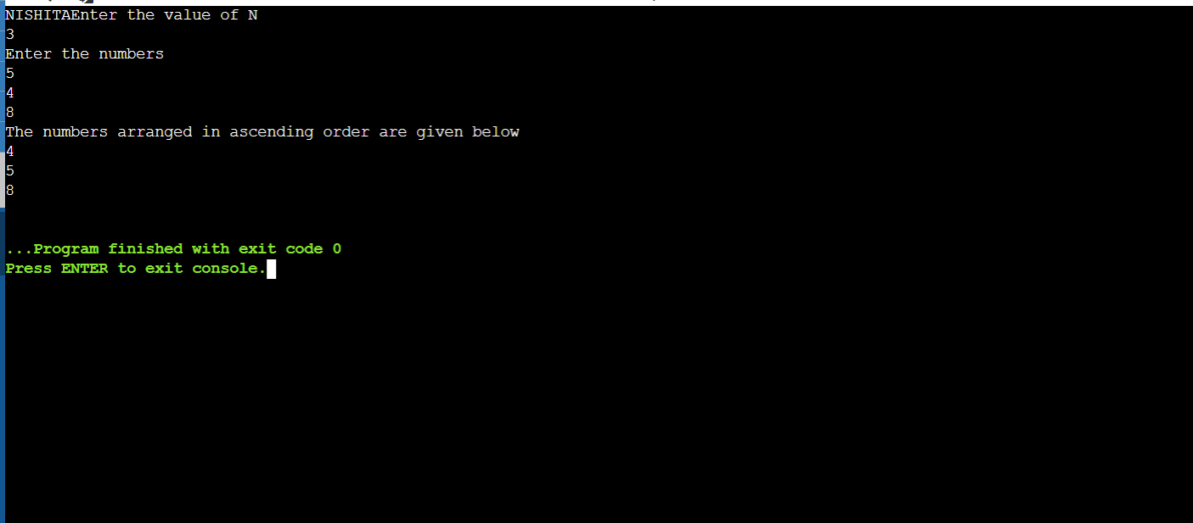

73) Write a program to check if a string is palindrome or not.

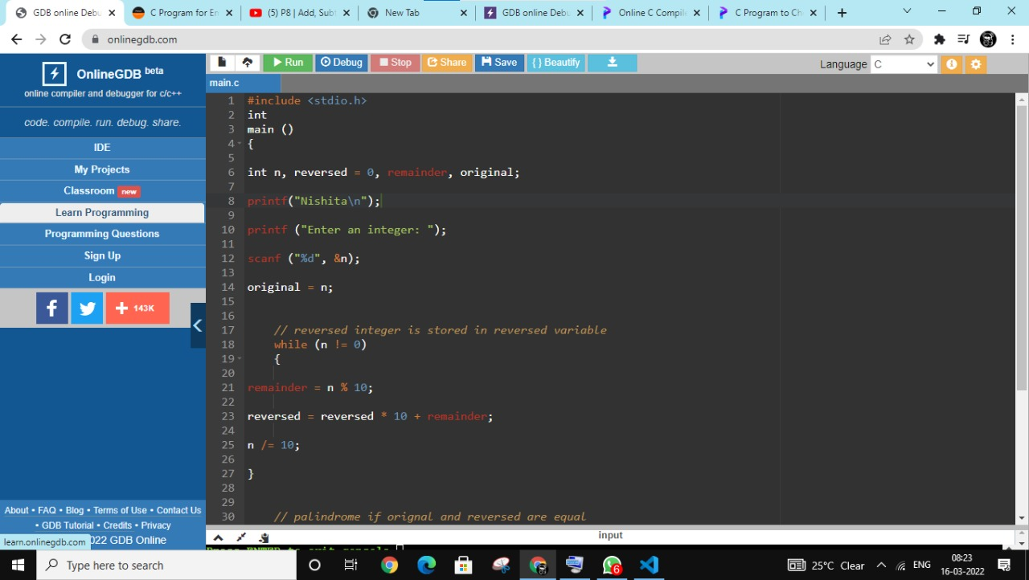

OUTPUT

74) Write a program to add, subtract, multiply and divide two numbers using pointers

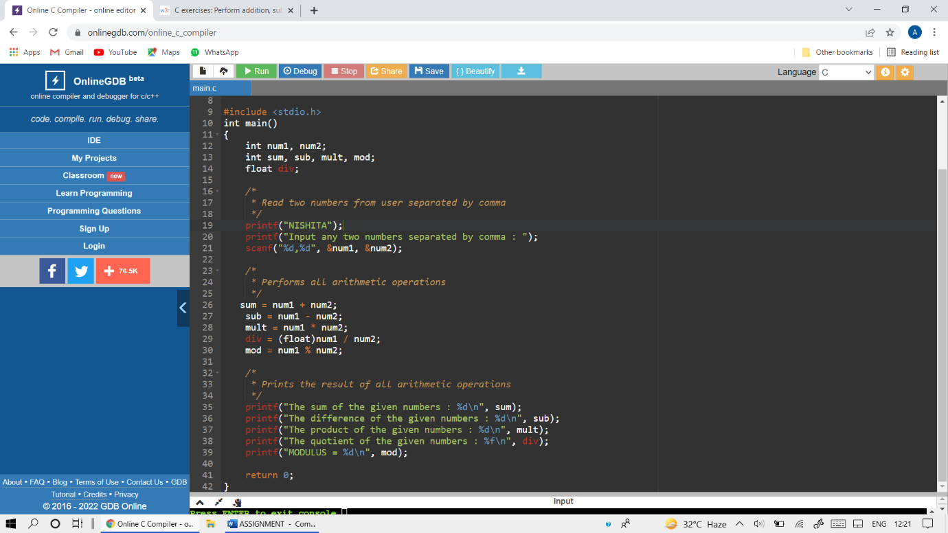

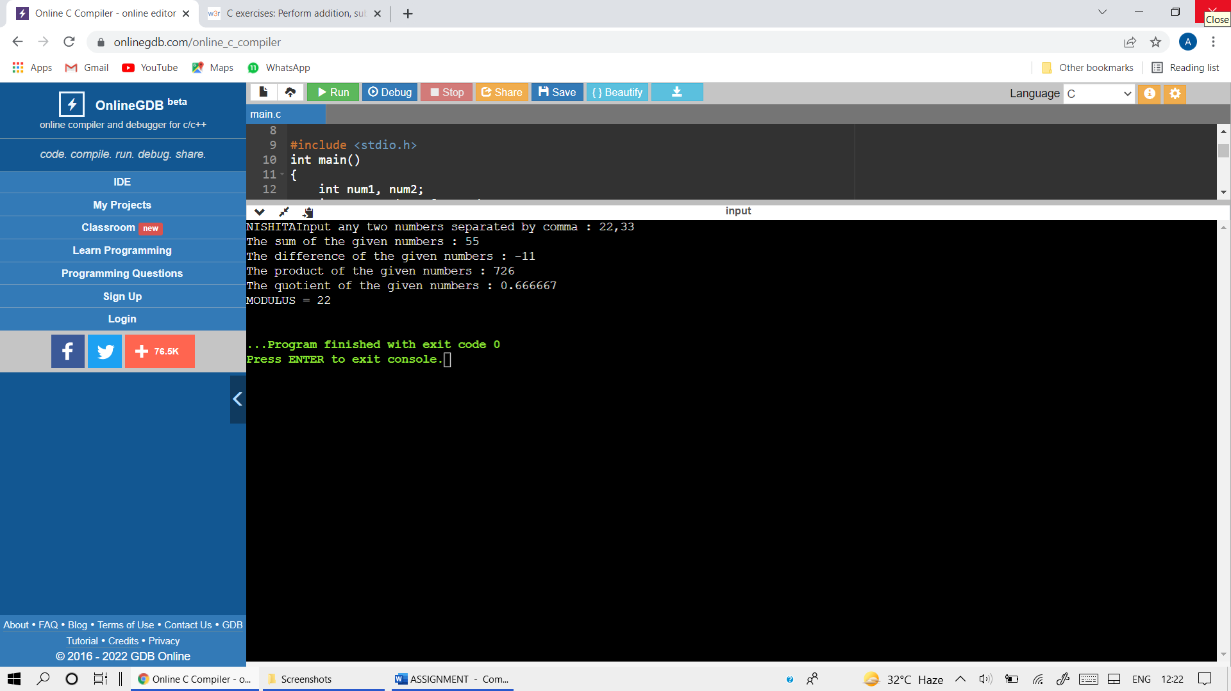

75) Write a program to create a structure for employees containing the following data members: Employee ID, Employee Name, Age, Address, Department and Salary. CO3 Input data for 10 employees and display the de tails of the employee from the employee ID given by the user.

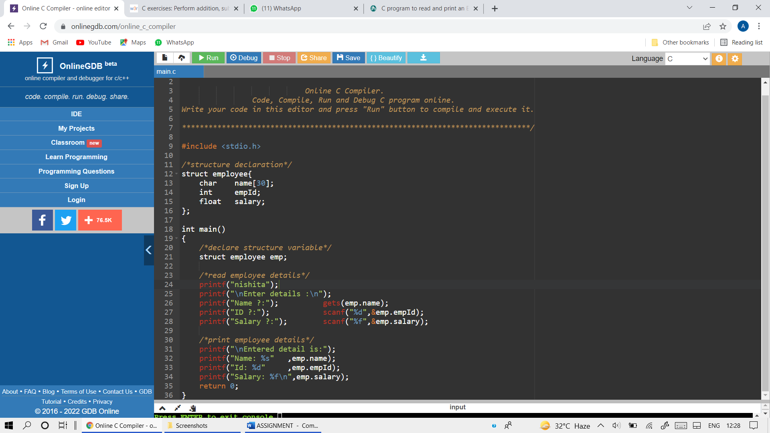

OUTPUT

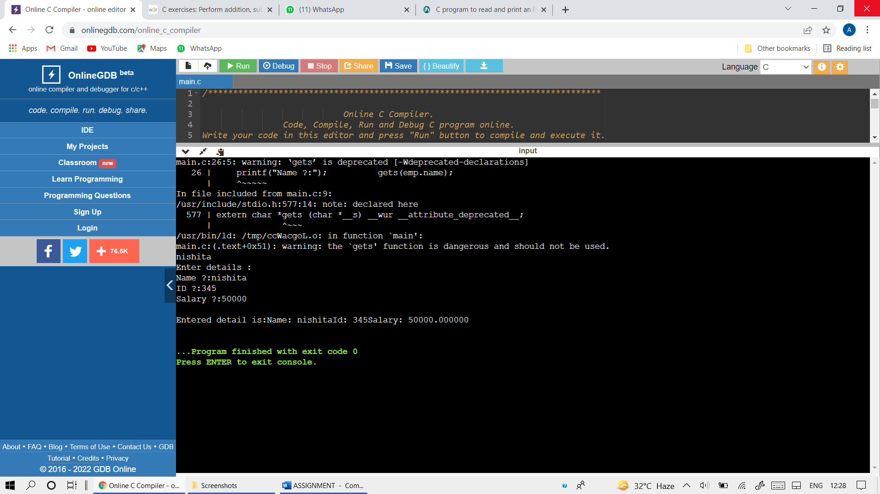

76) Write a program to create two files with names EvenFile and OddFile. Input 20 numbers from the user and save even numbers in EvenFile and odd numbers in ODD FILE

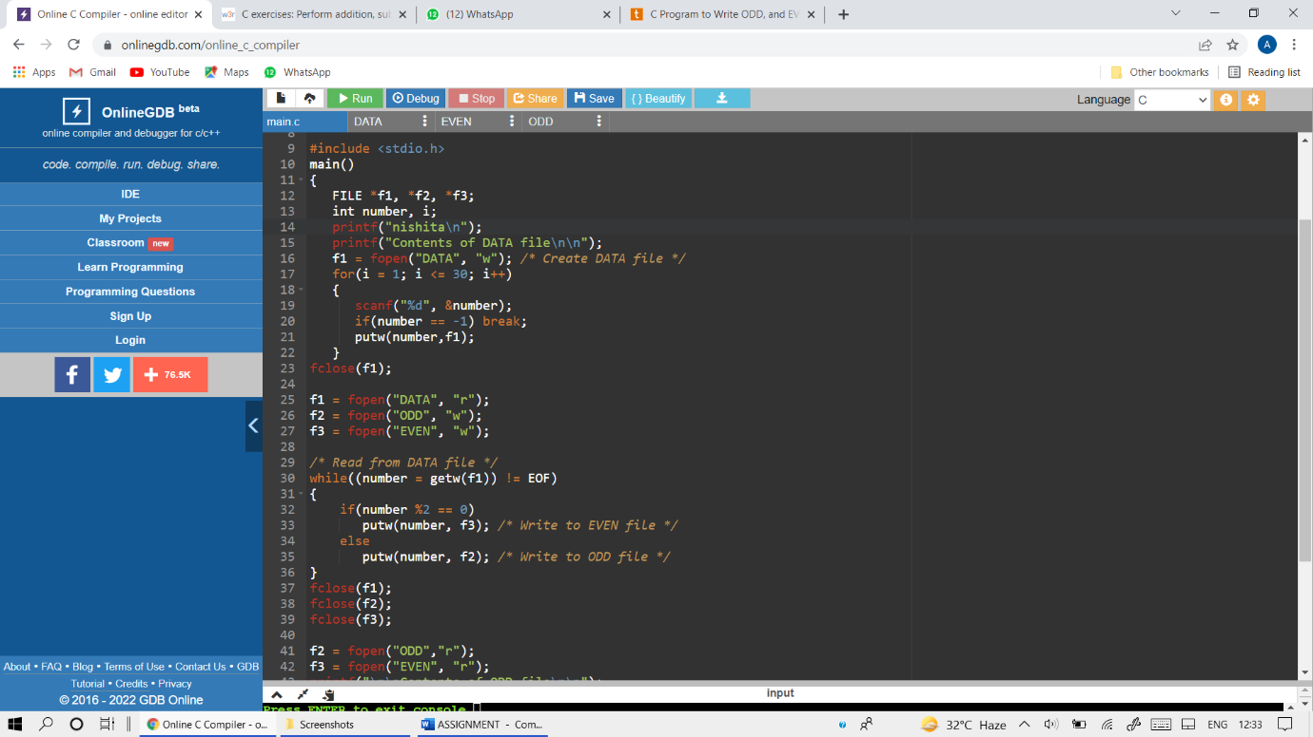

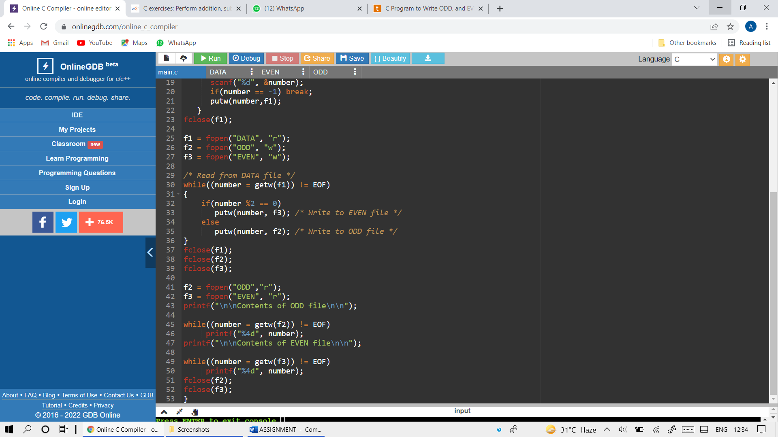

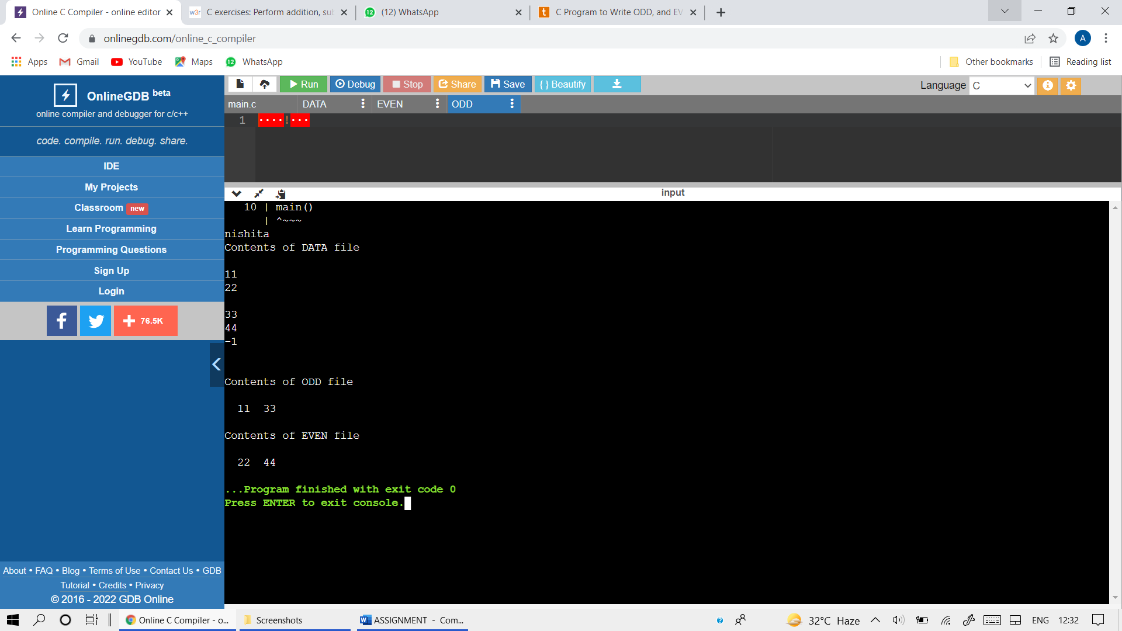

77) Write a menu driven program to construct a calculator for following arithmetic operations: addition, subtraction, multiplication, division, average and

percentage

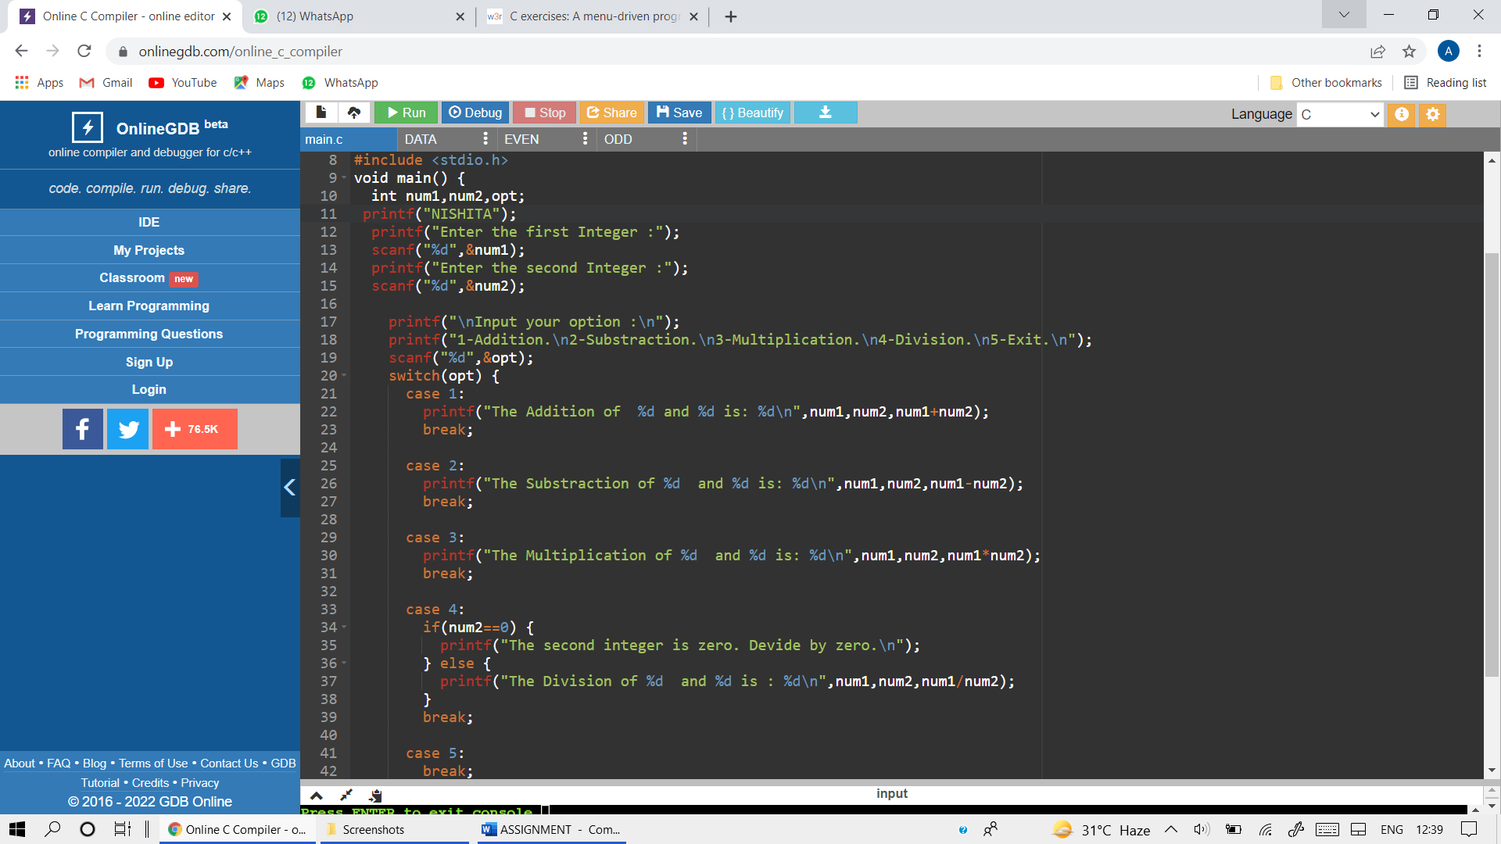

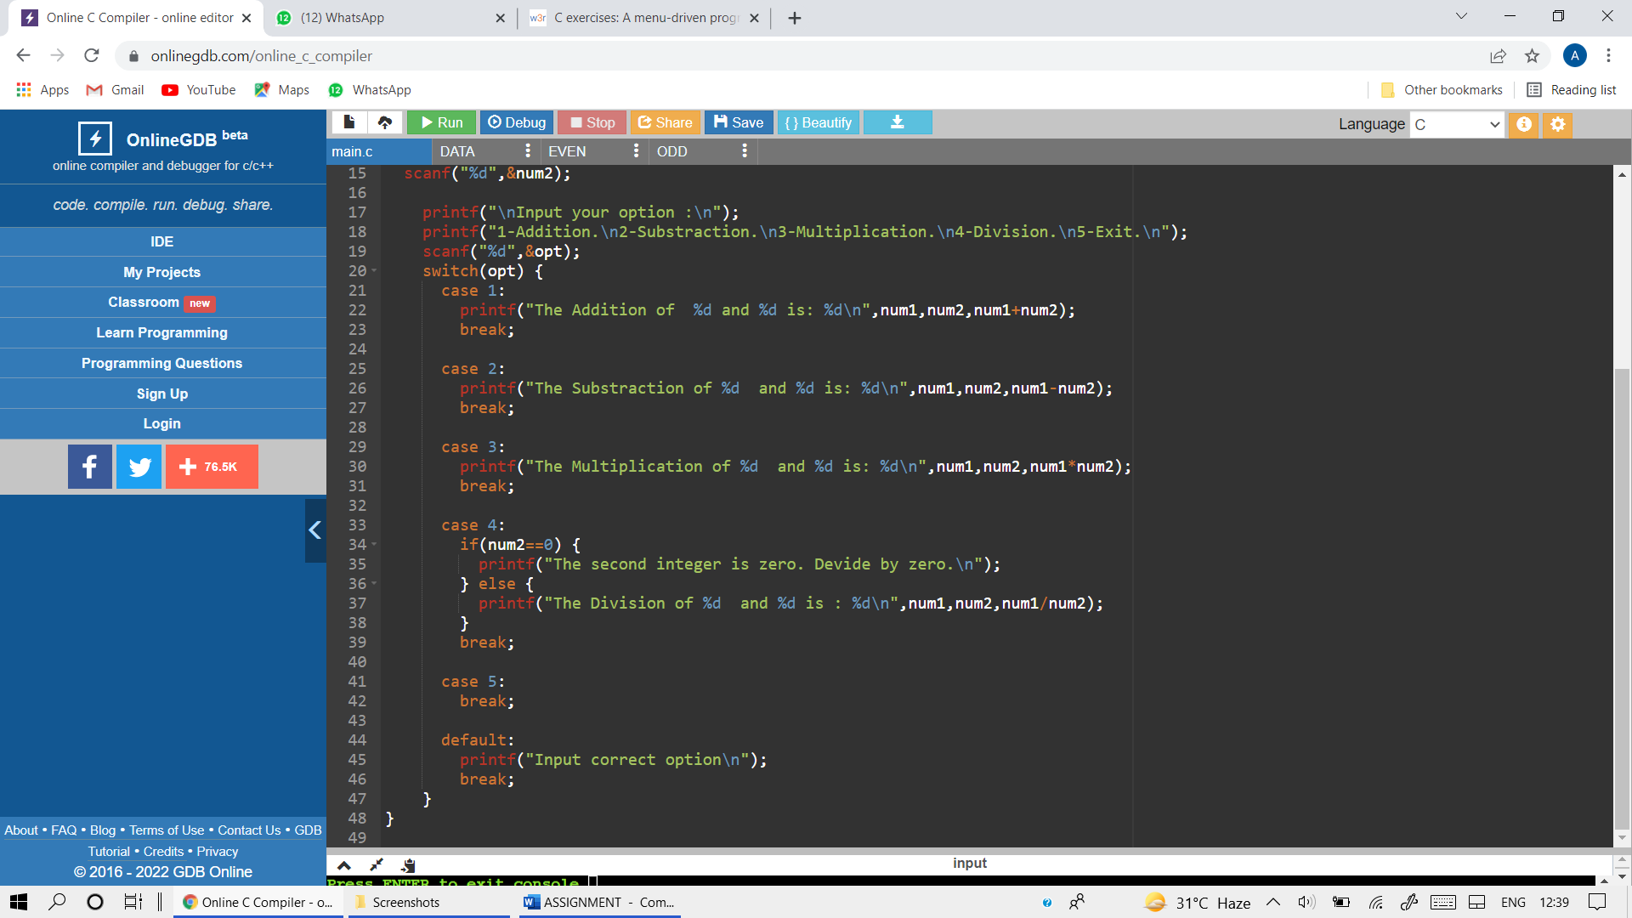

OUTPUT

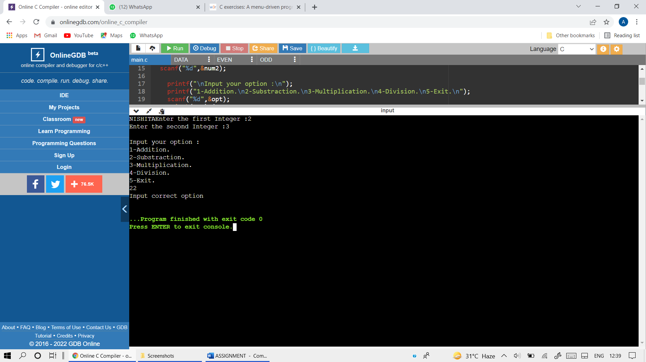

78) Write a menu driven program to perform the following operations: (i) prime Armstrong number upto N (ii) display prime number between 1 toN (iii) reverse of an integer

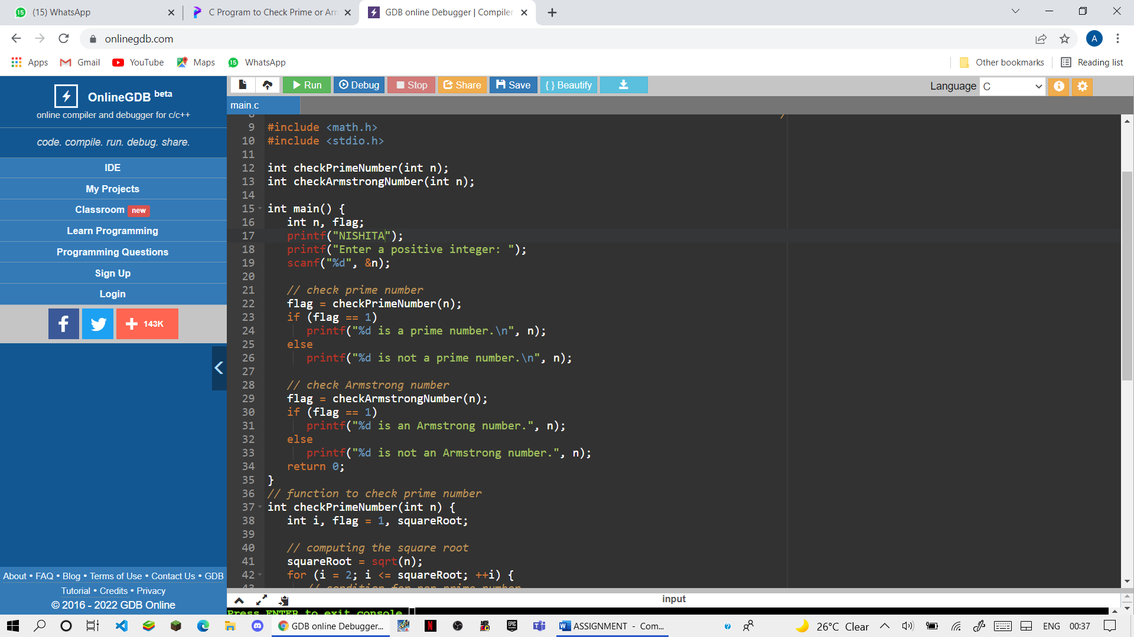

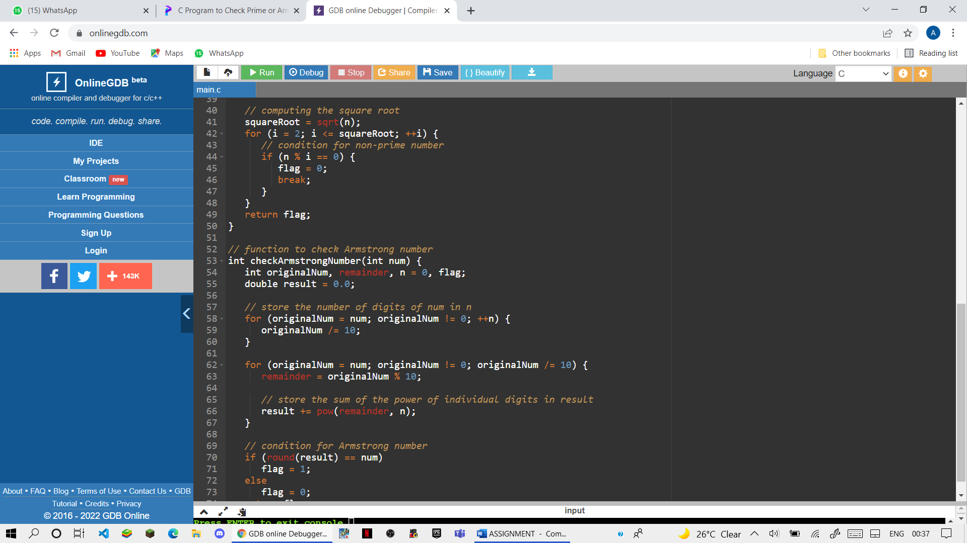

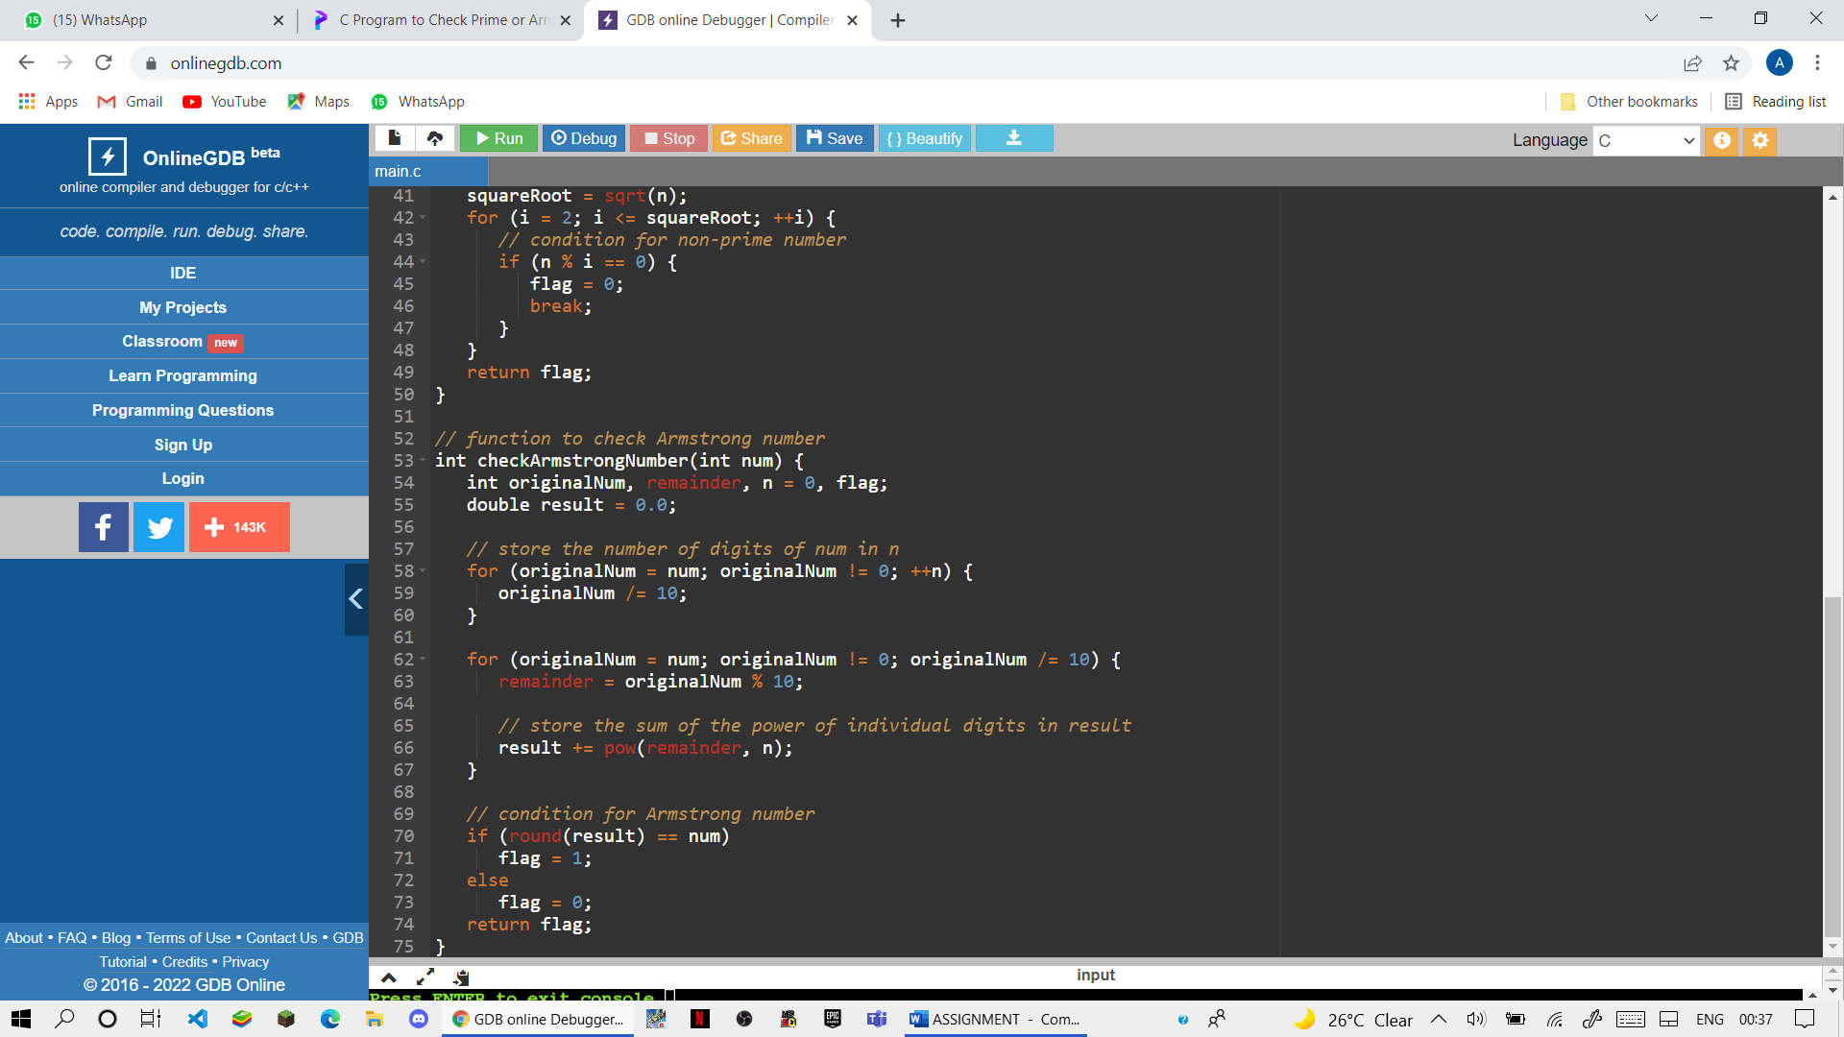

OUTPUT:

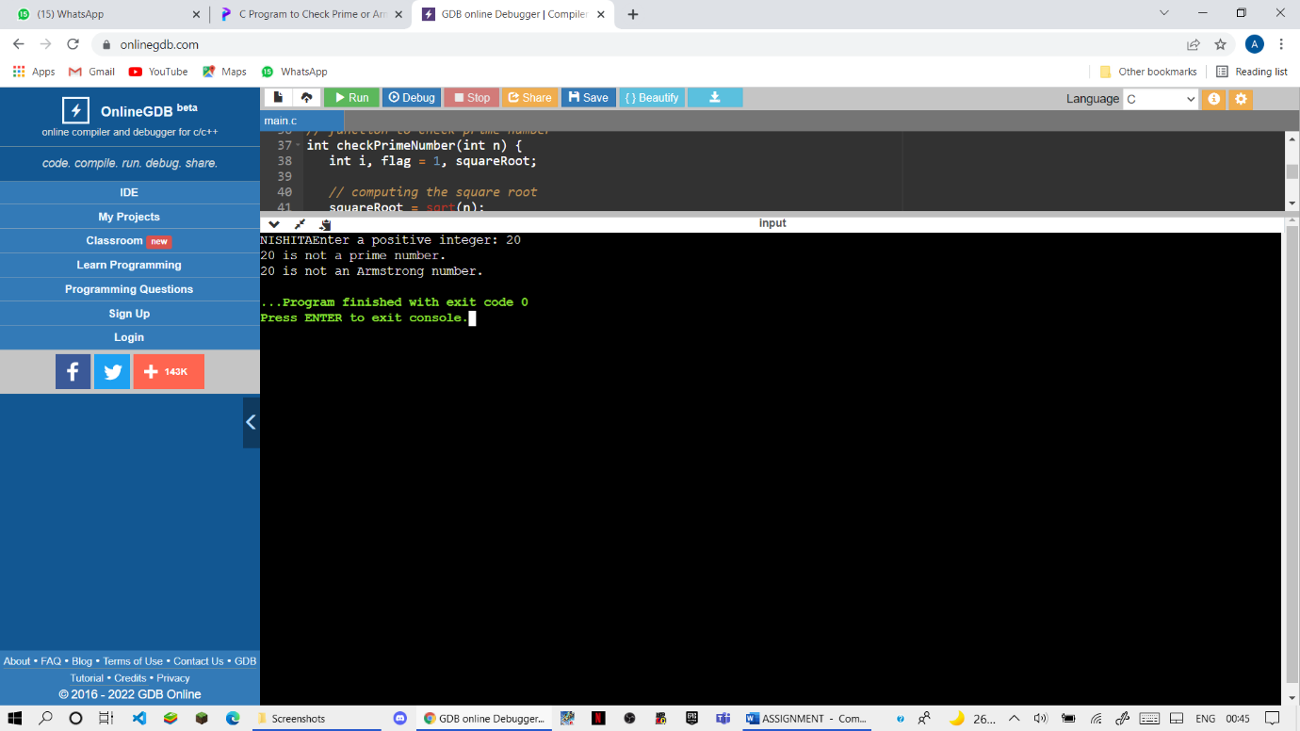

(II)

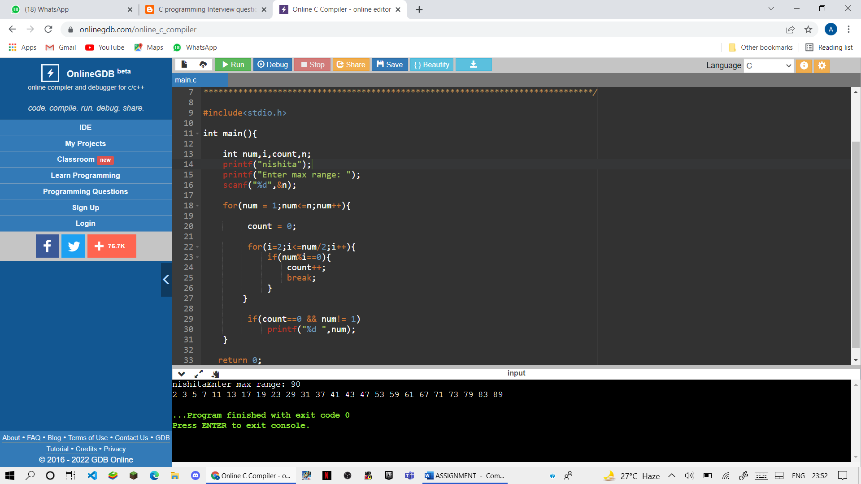

(III)

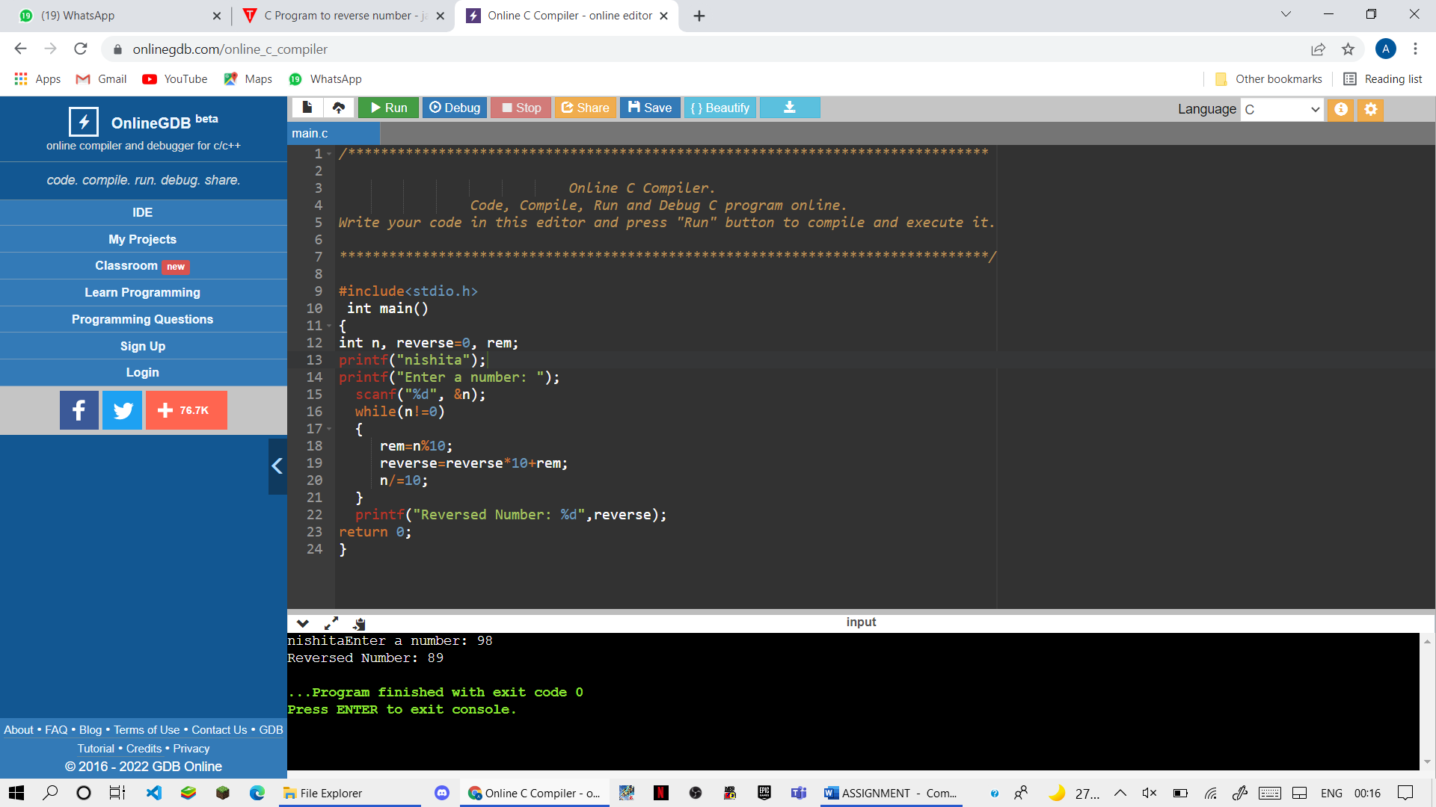

79) Write a program to convert a hexadecimal number into binary number

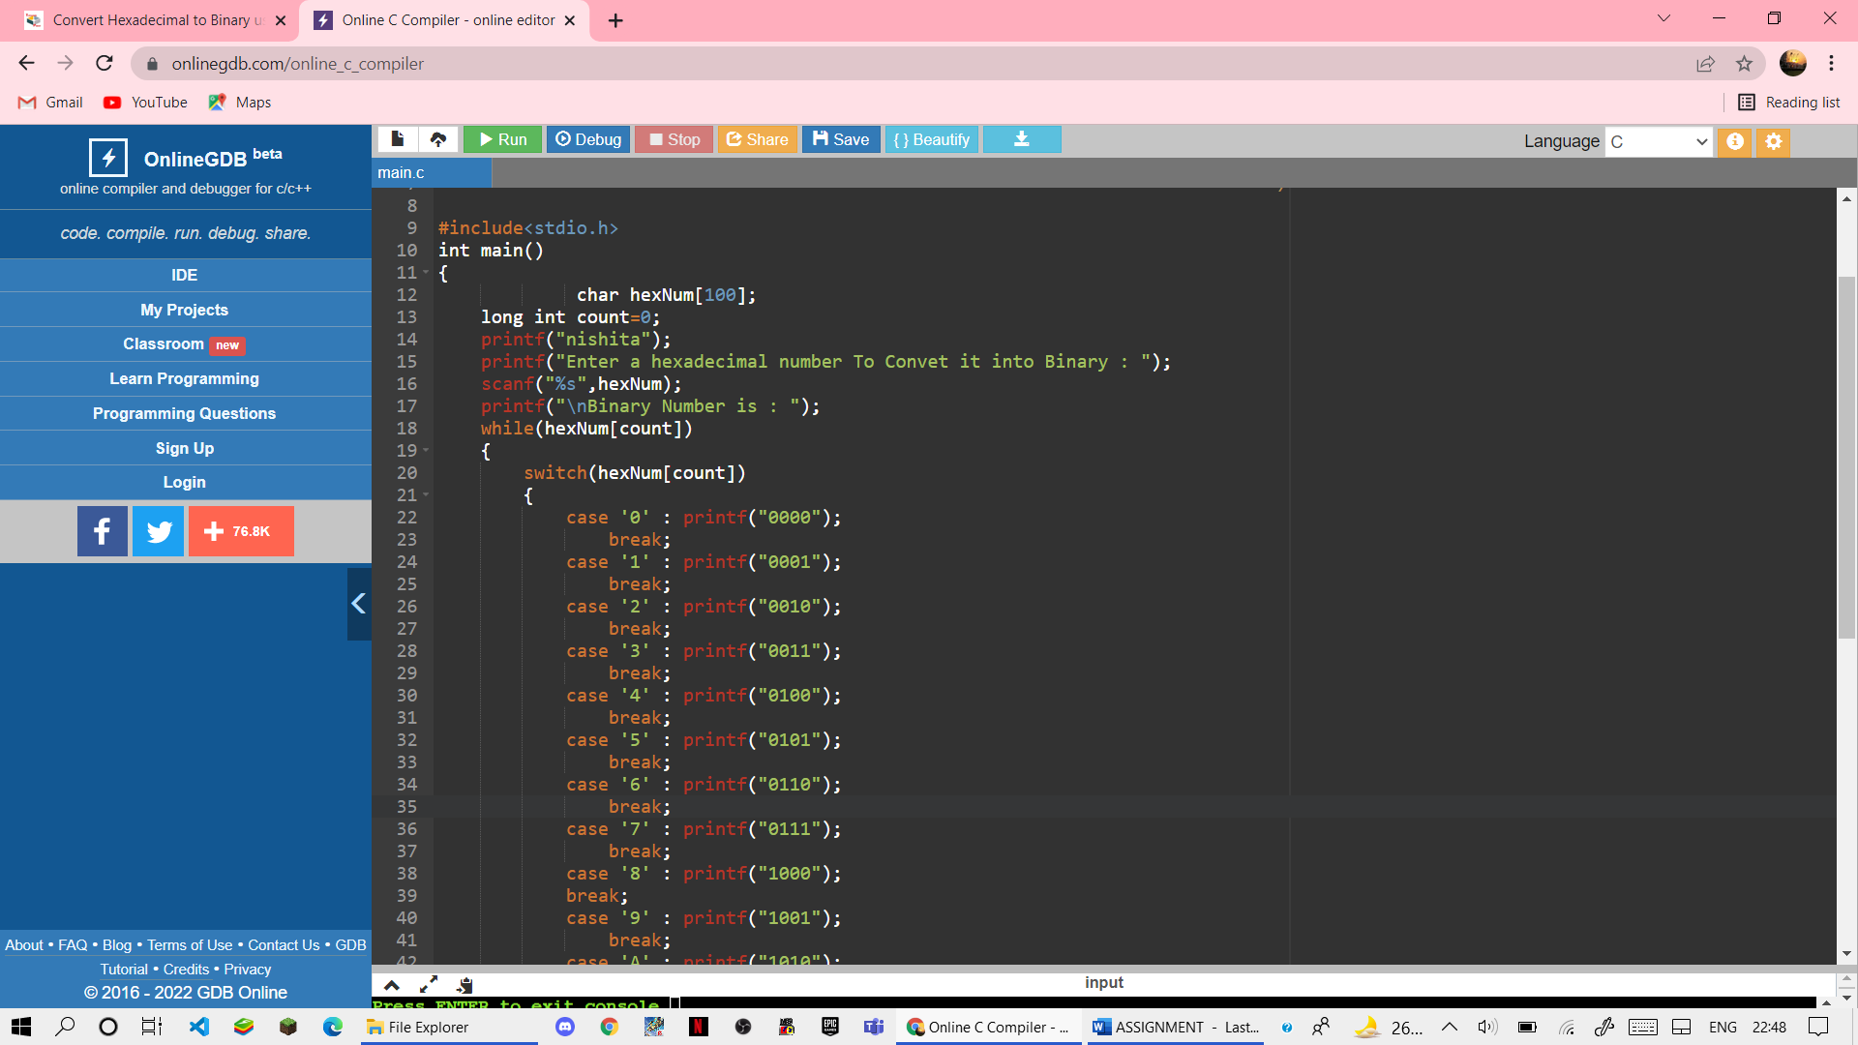

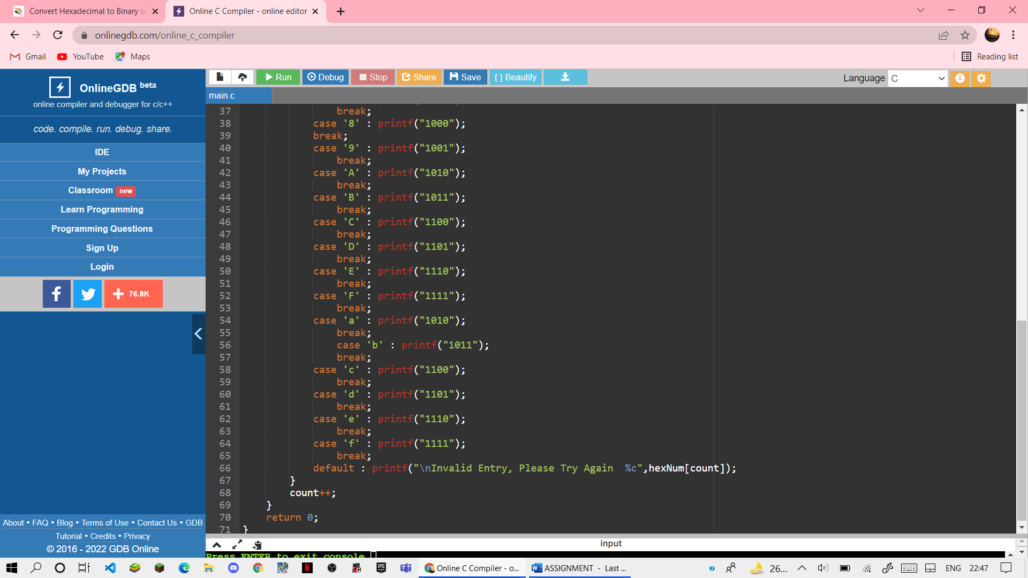

OUTPUT:-

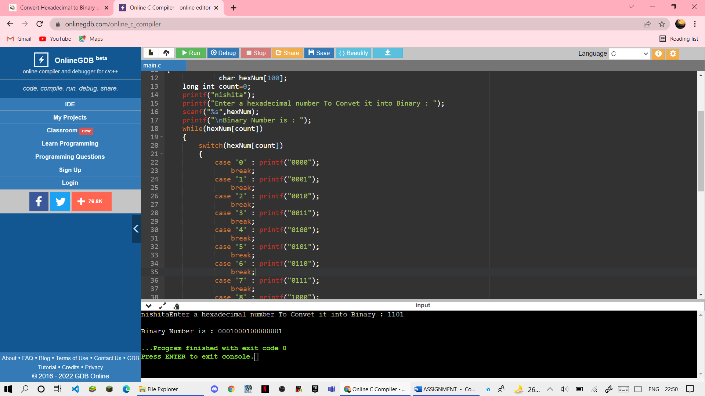

80) Write a program to calculate factorial of a number and display Fibonacci series upto N terms using recursive functions.

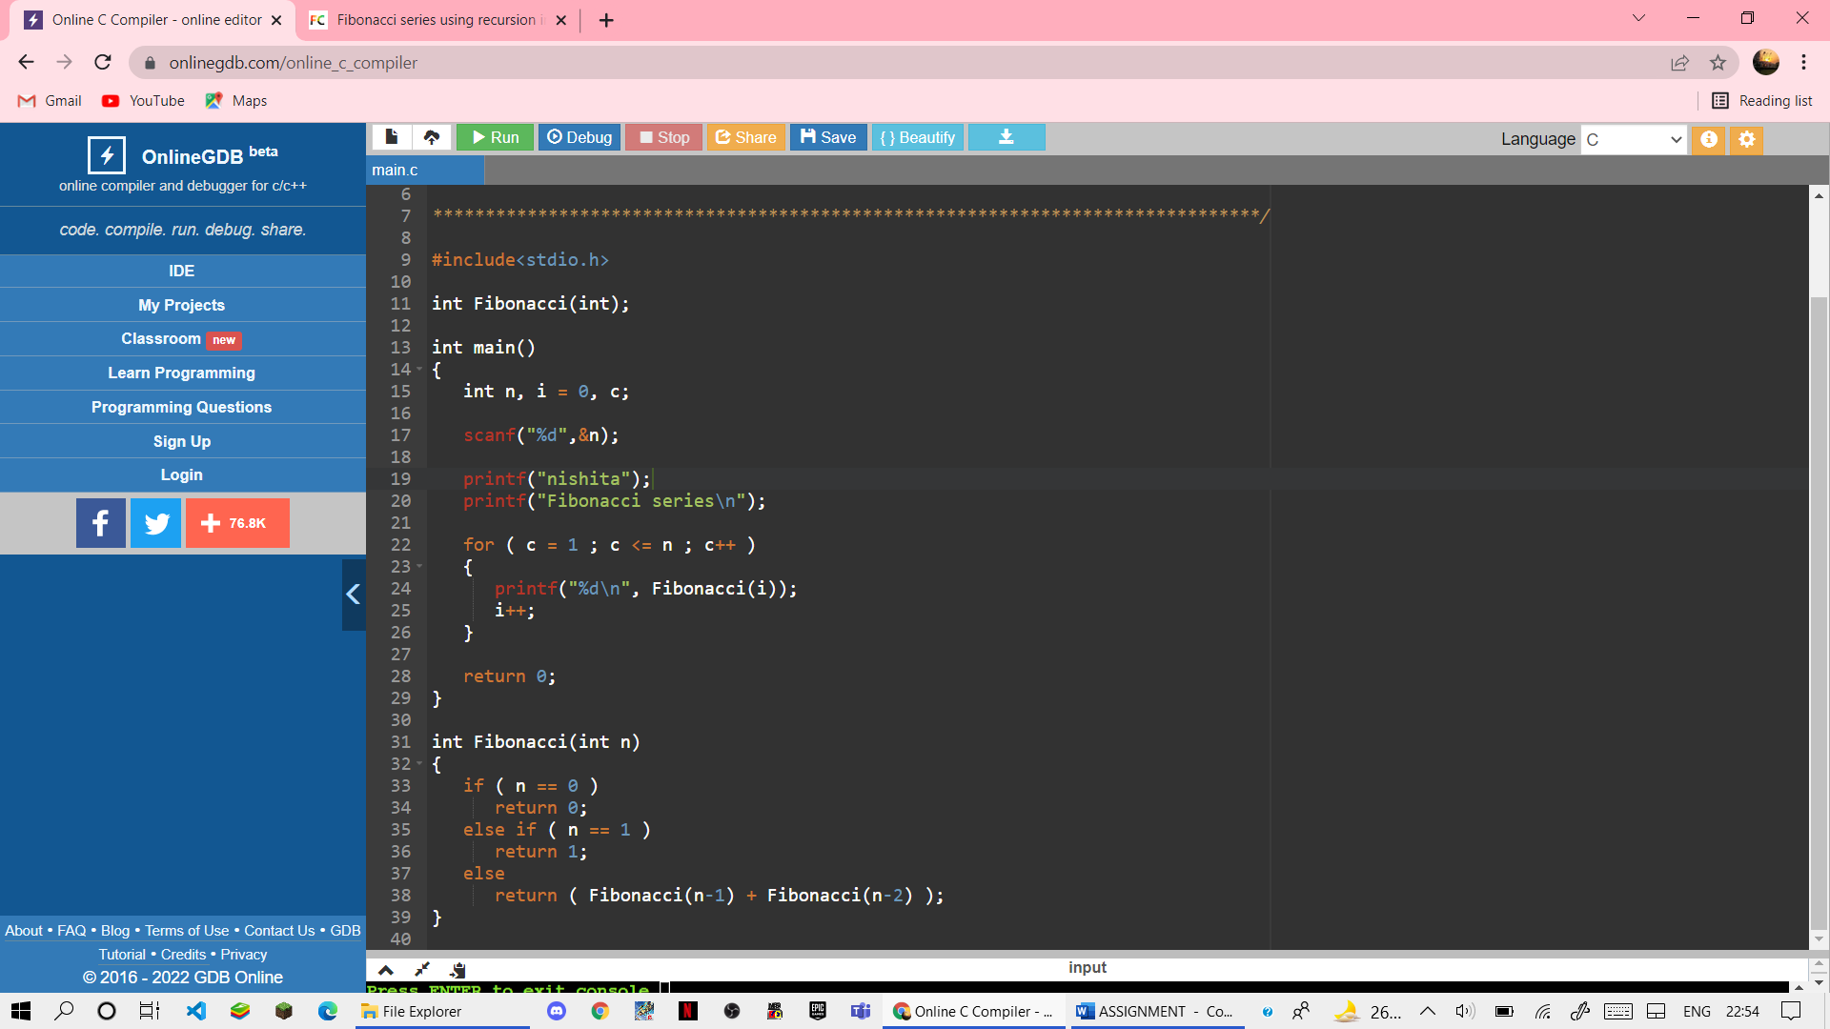

OUTPUT:-

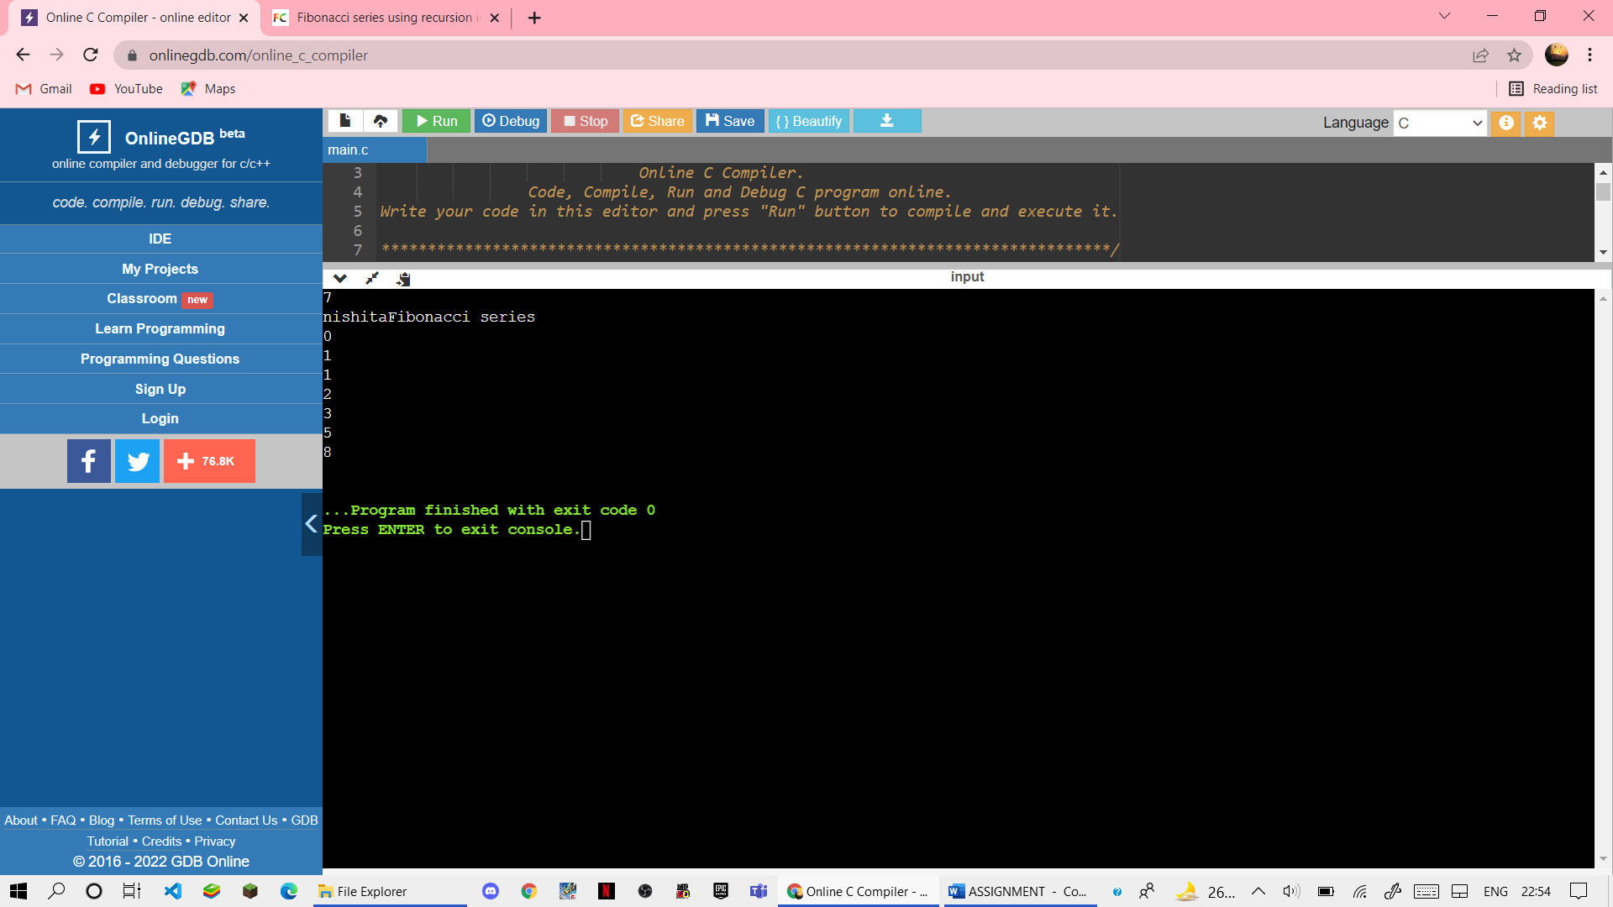

81) Write a program to perform matrix addition, multiplication, transpose on 2D arrays.

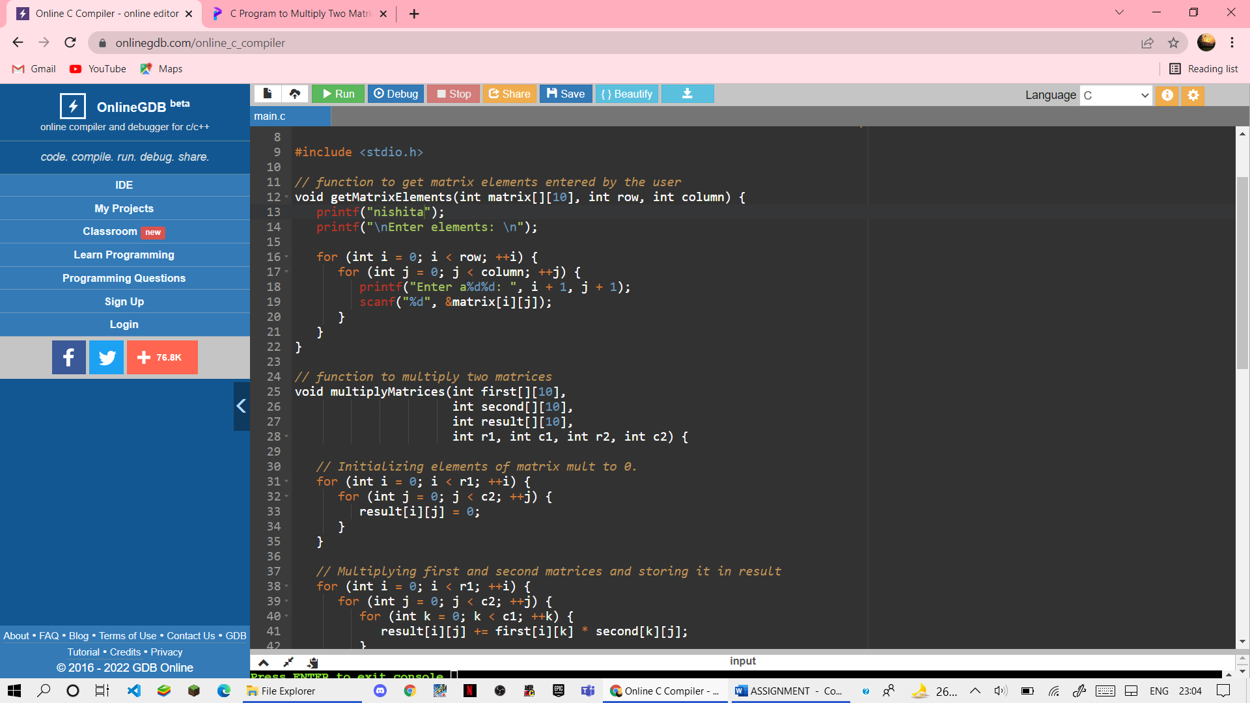

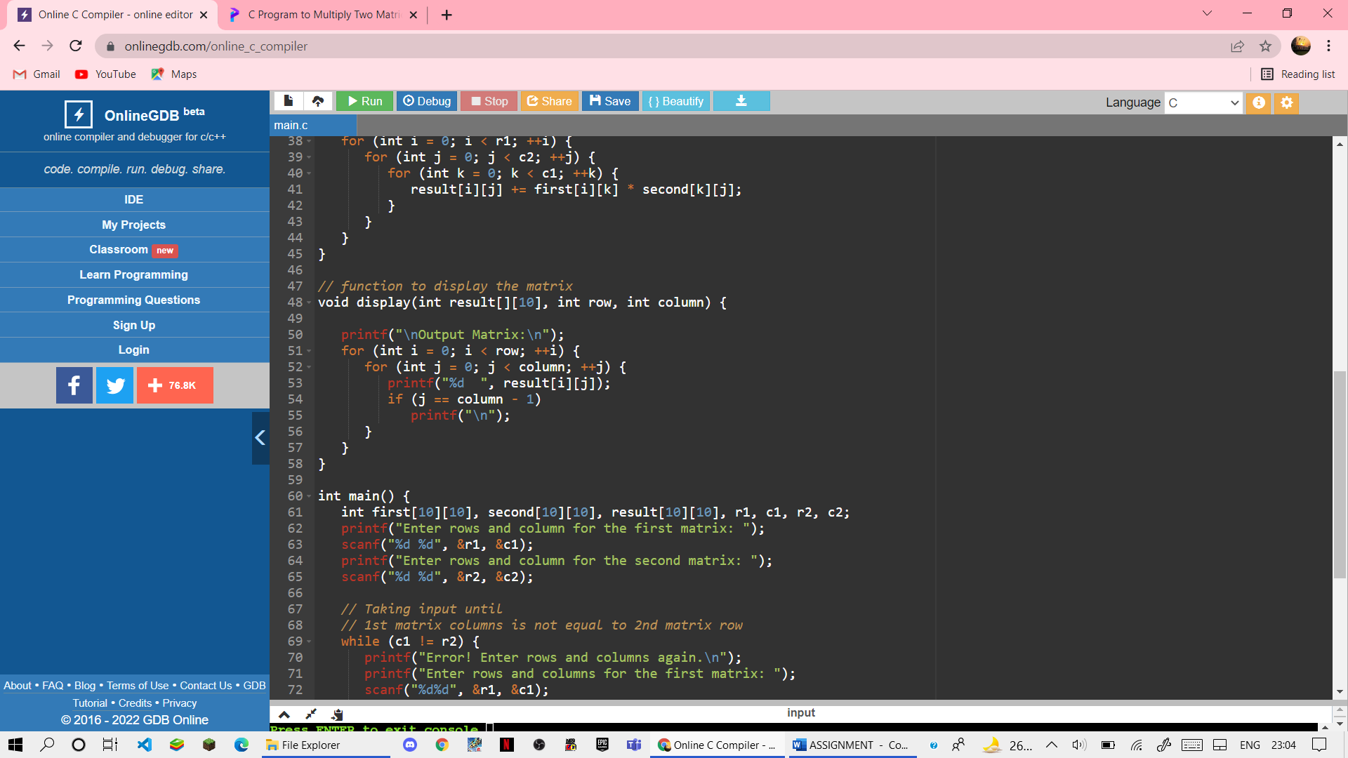

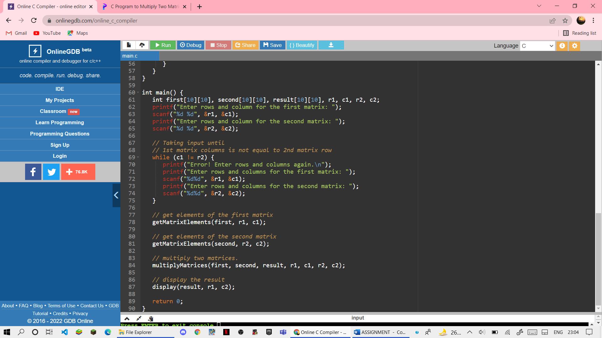

OUTPUT:-

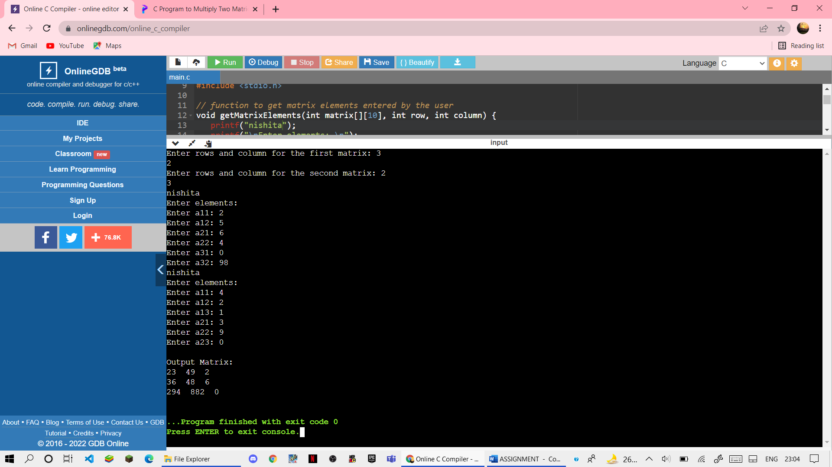

82) Write a program to make use of arrays with structures in the following ways:

1.Use array as a structure data member

2.Create array of structure variables

(I)

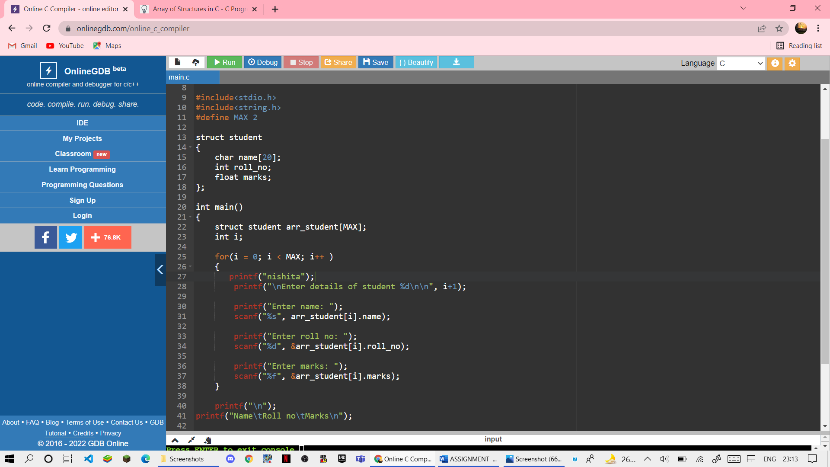

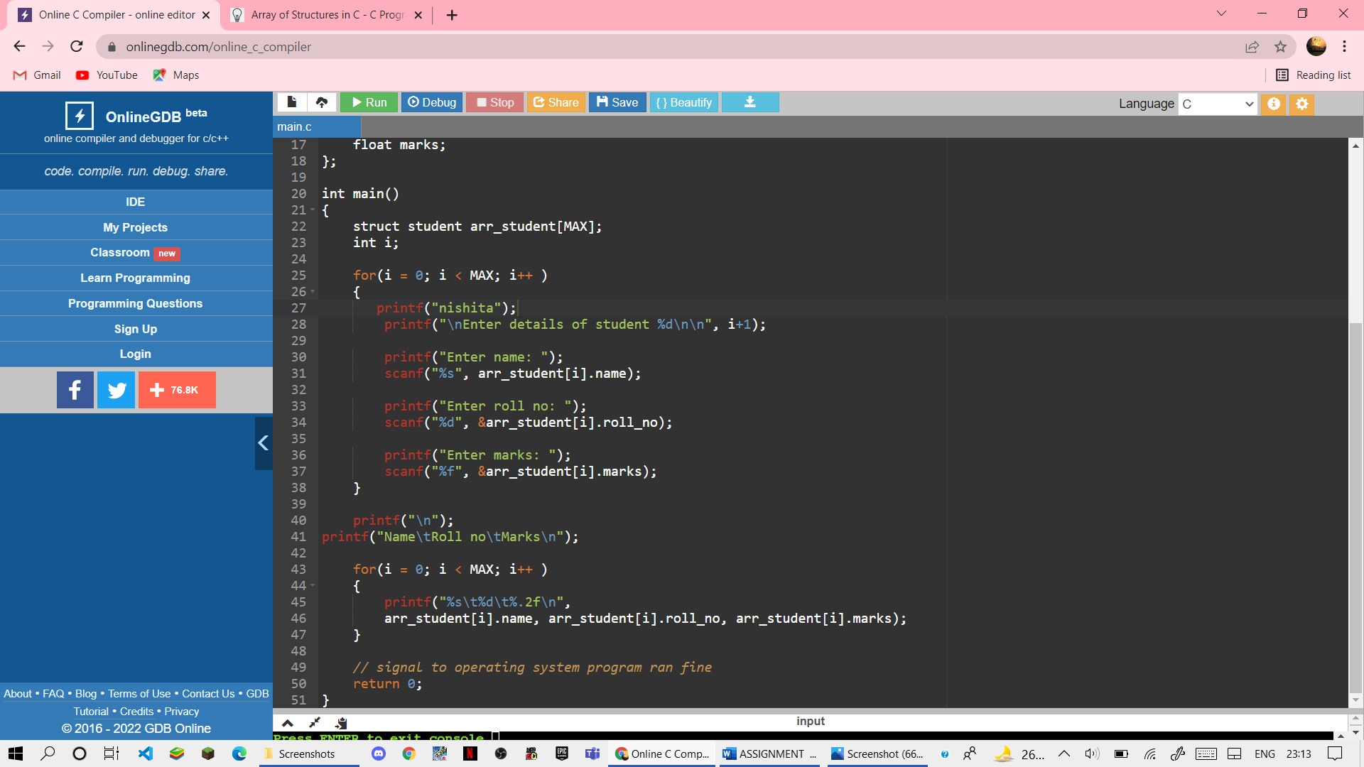

OUTPUT

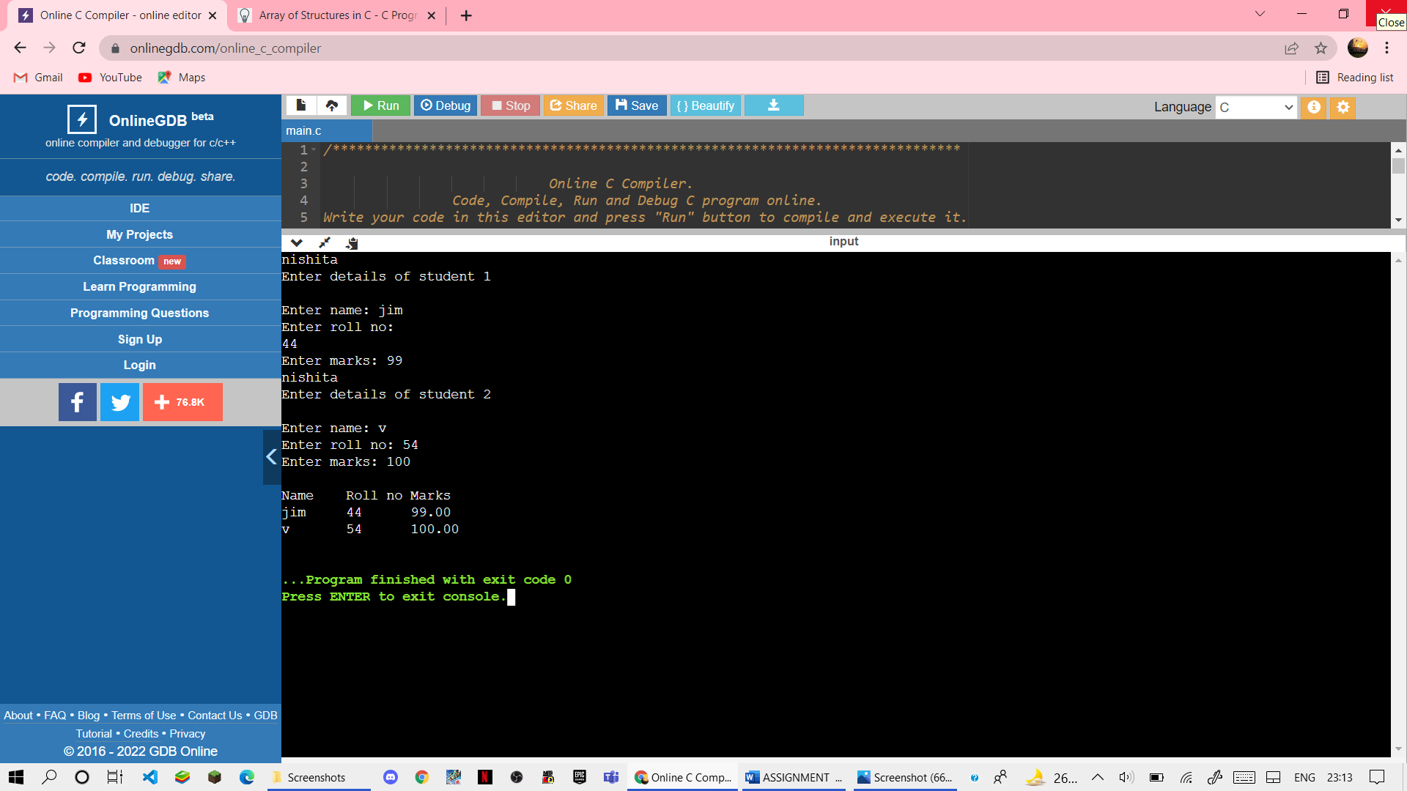

(II)

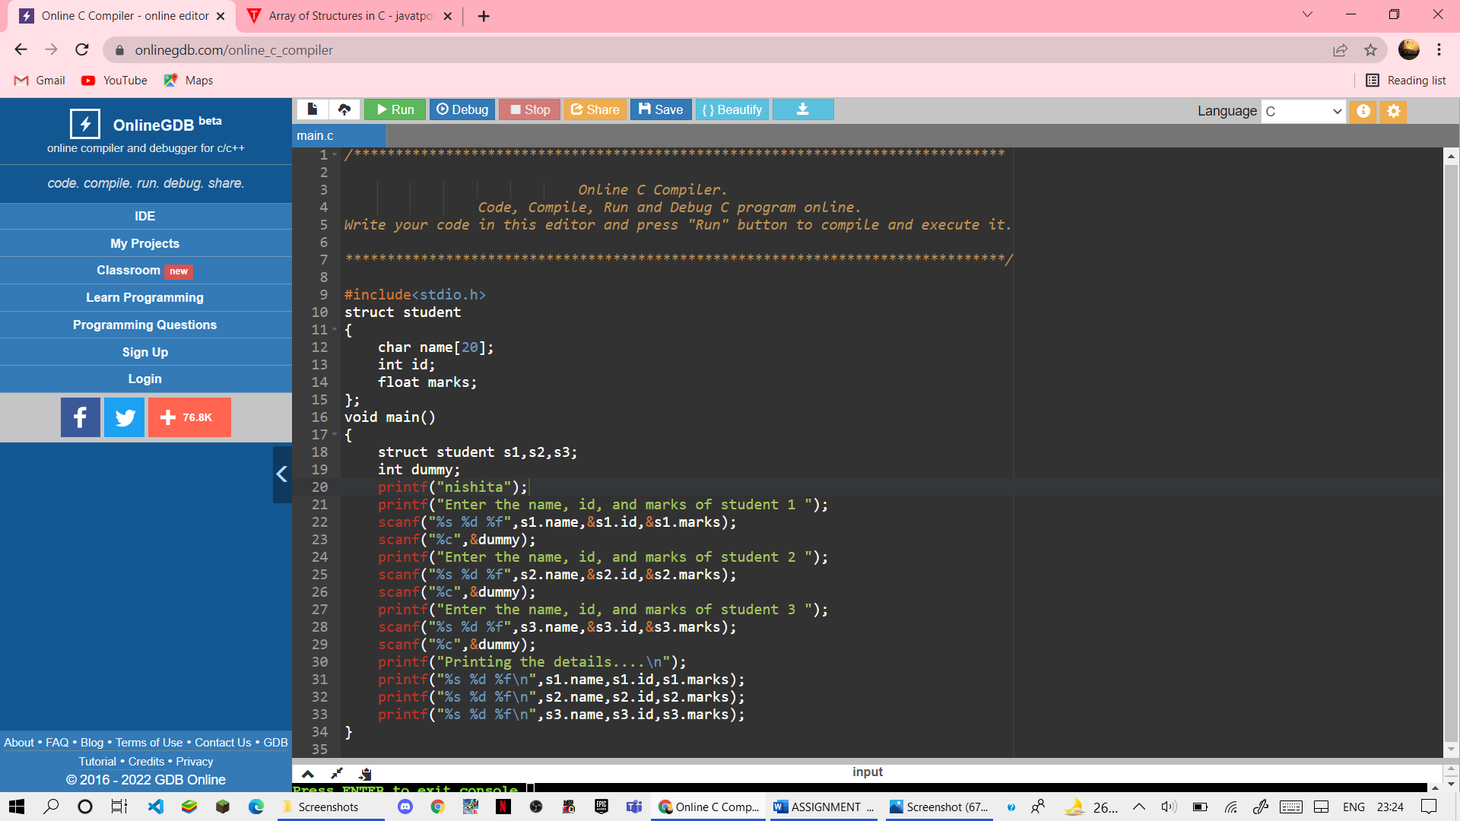

OUTPUT

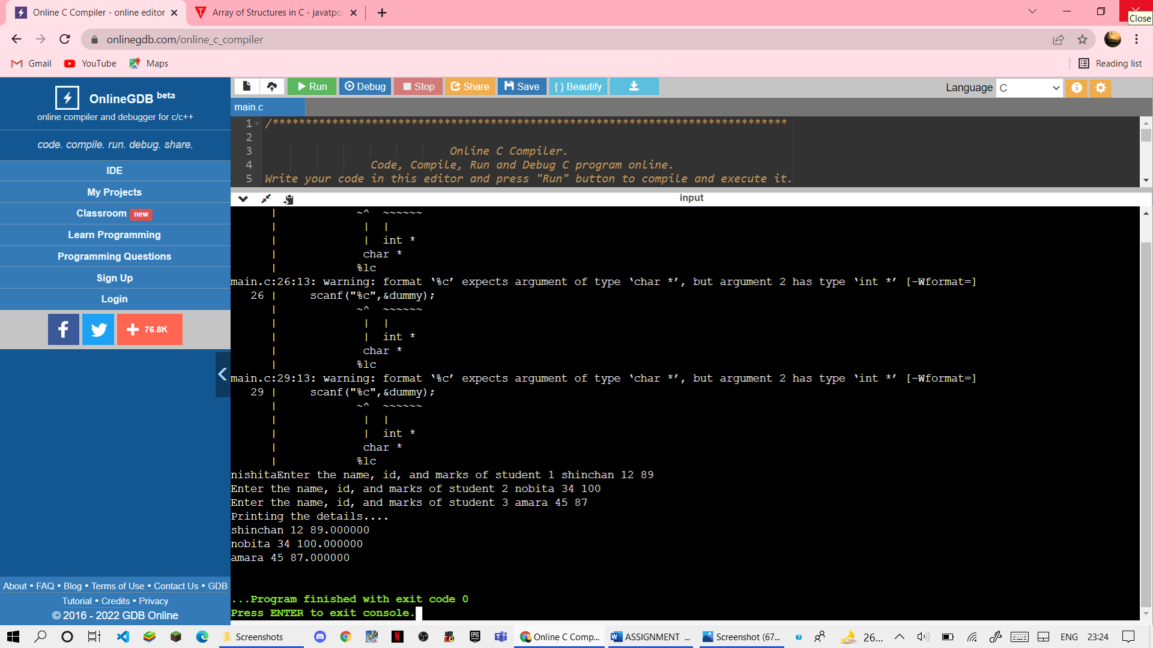

83) Write a program to compare the contents of two files by taking names of the files through command line arguments.

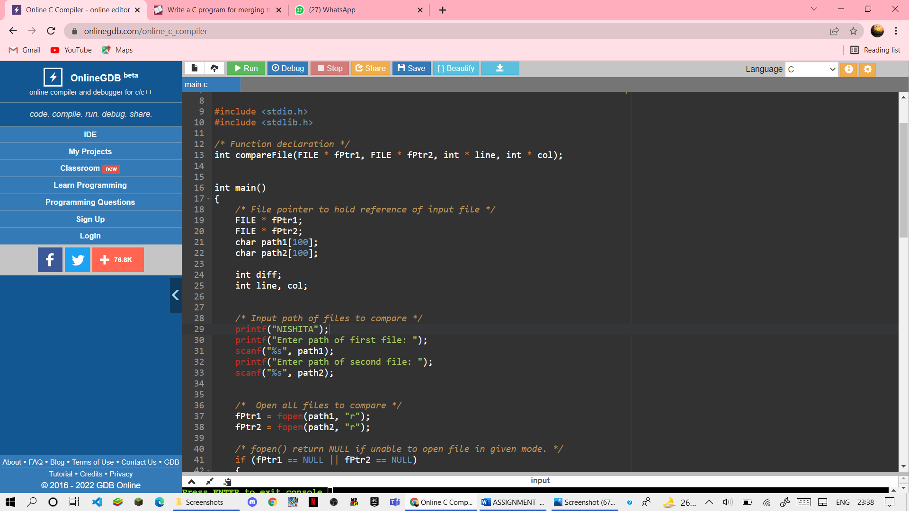

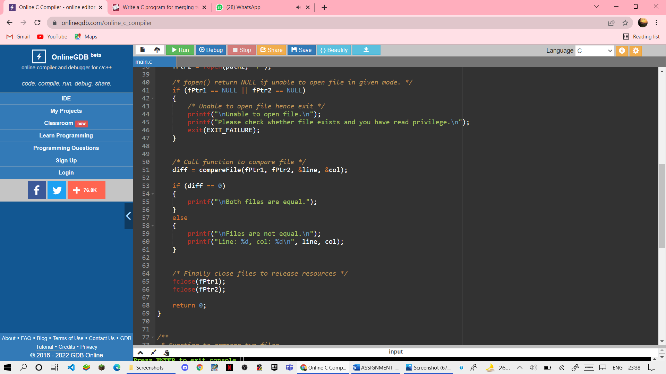

OUTPUT:-

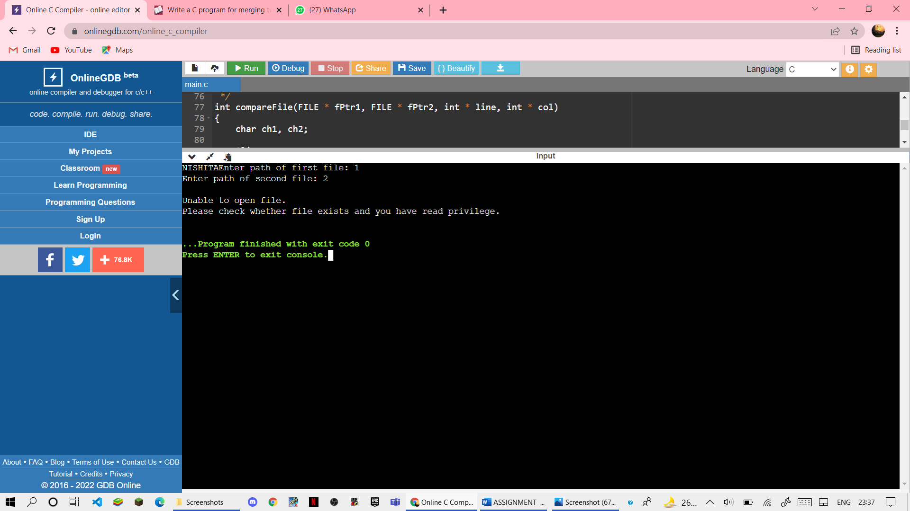

84) Write a program to perform input and make use of file positioning functions on binary files.(using fseek, ftell, rewind functions).

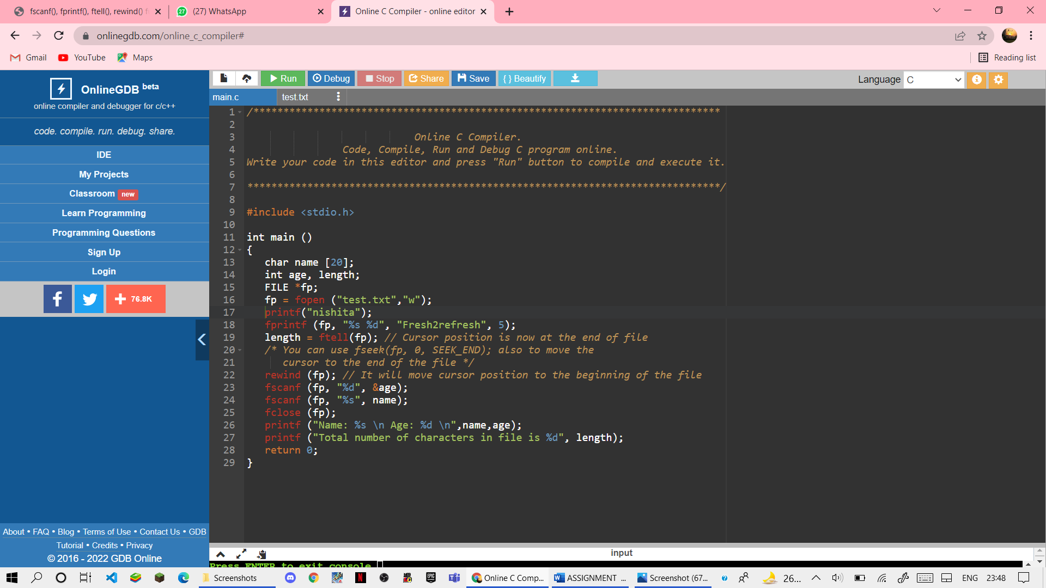

OUTPUT

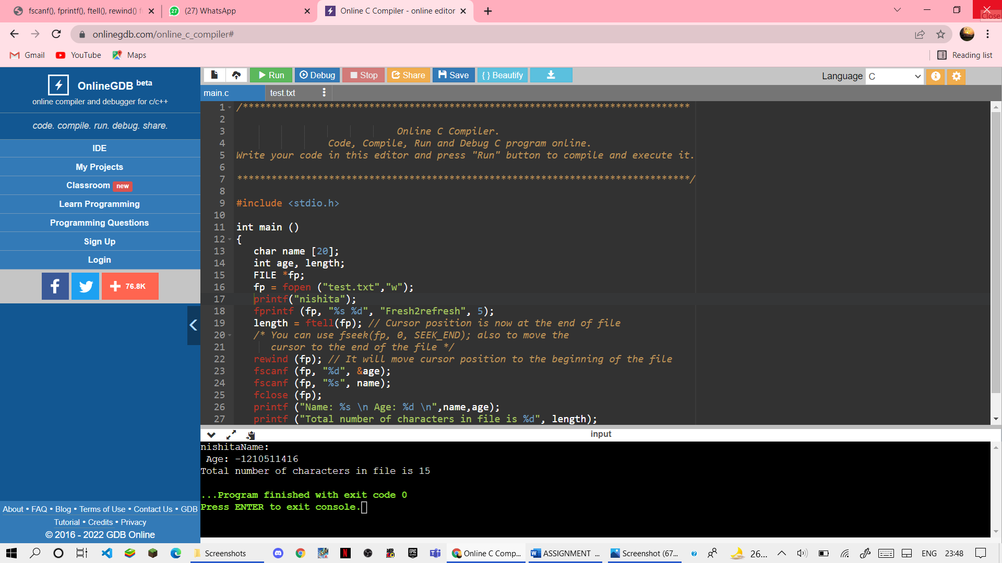

85) Write a menu driven program to implement the following string operations:

1.Calculate length of a string

2.Concatenate at the end of a given

3.Copy one string to another

4.compare contents of two strings

5.Copy nth character string to another

(I)

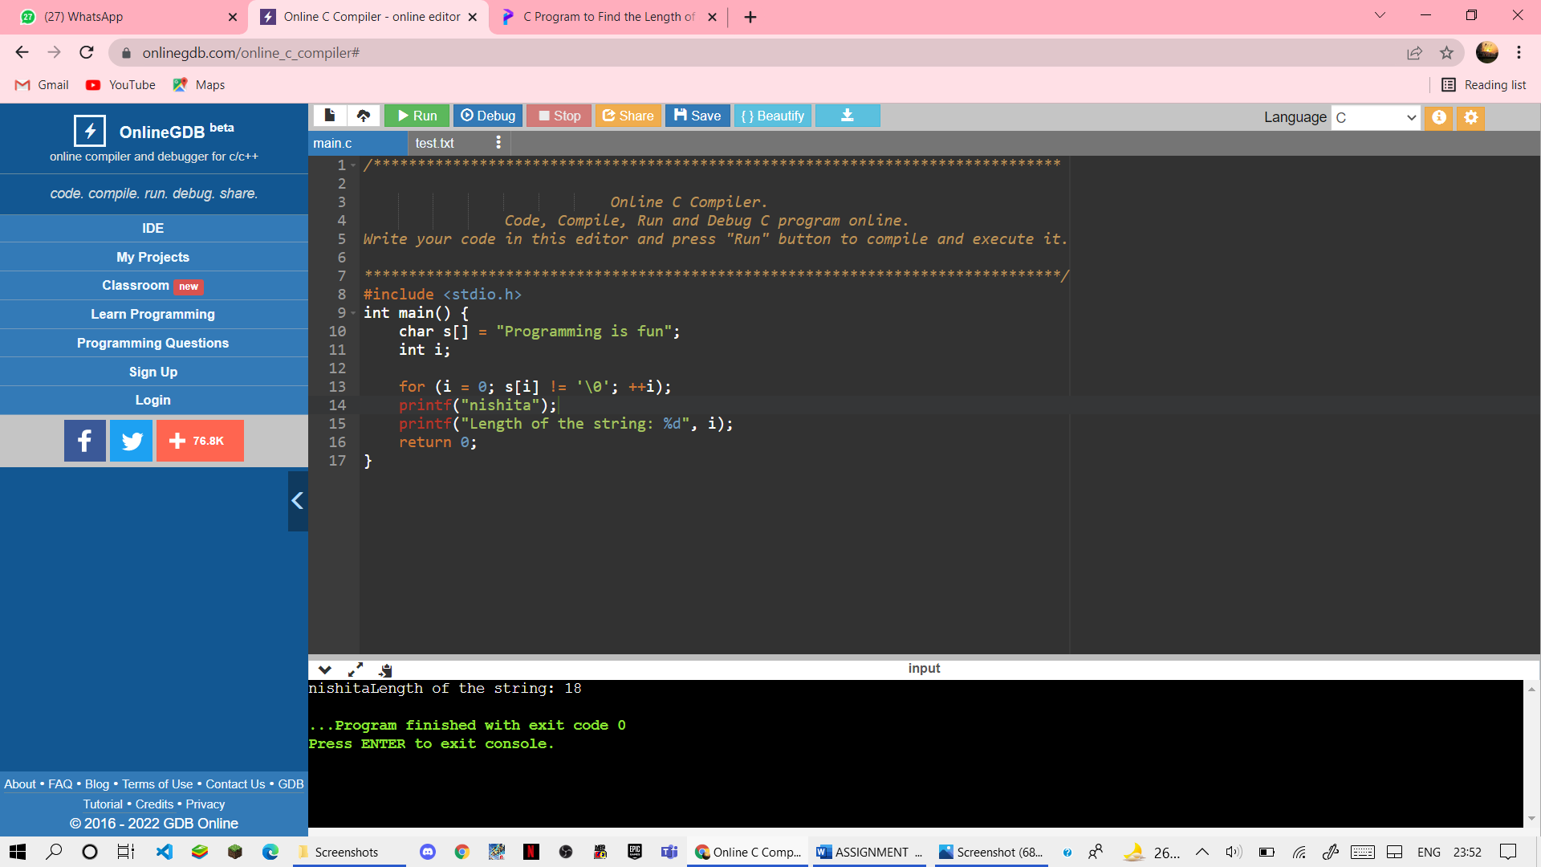

OUTPUT:-



(II)

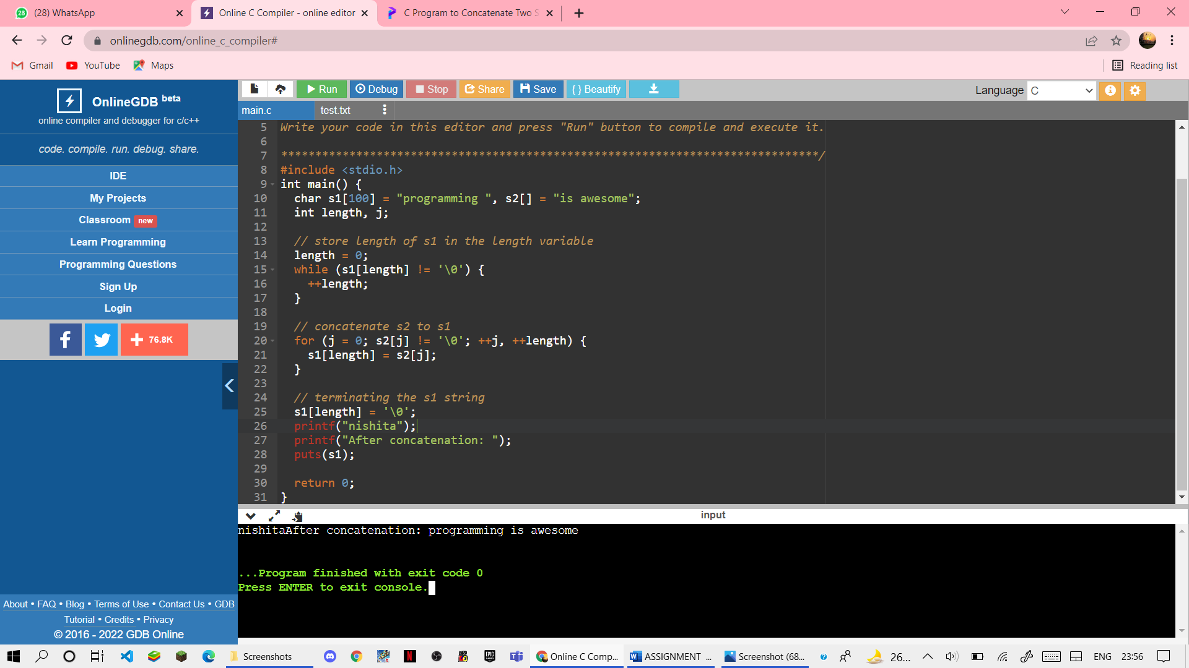

OUTPUT:-



(III)

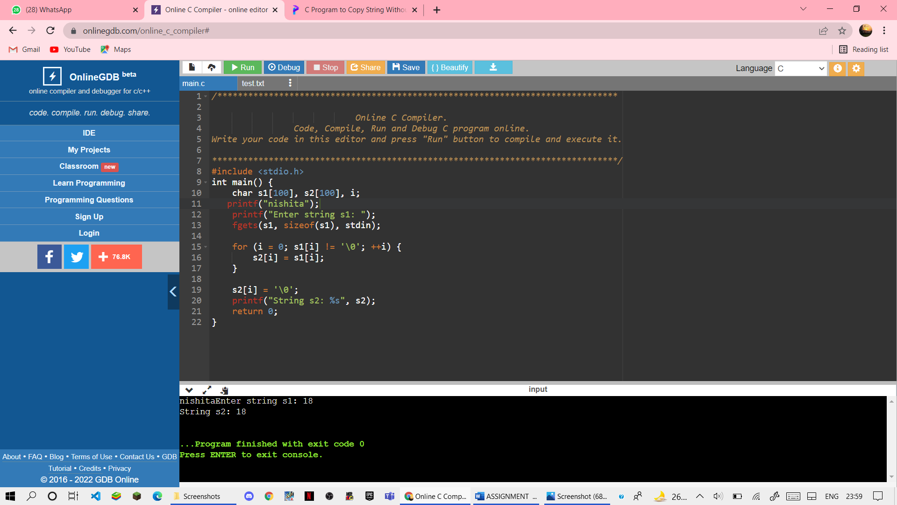

OUTPUT:-



(IV)

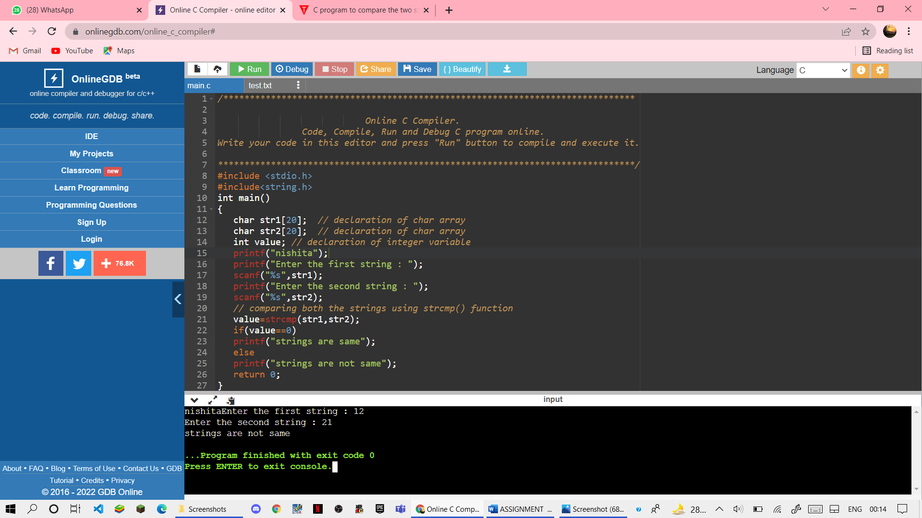

OUTPUT



(V)

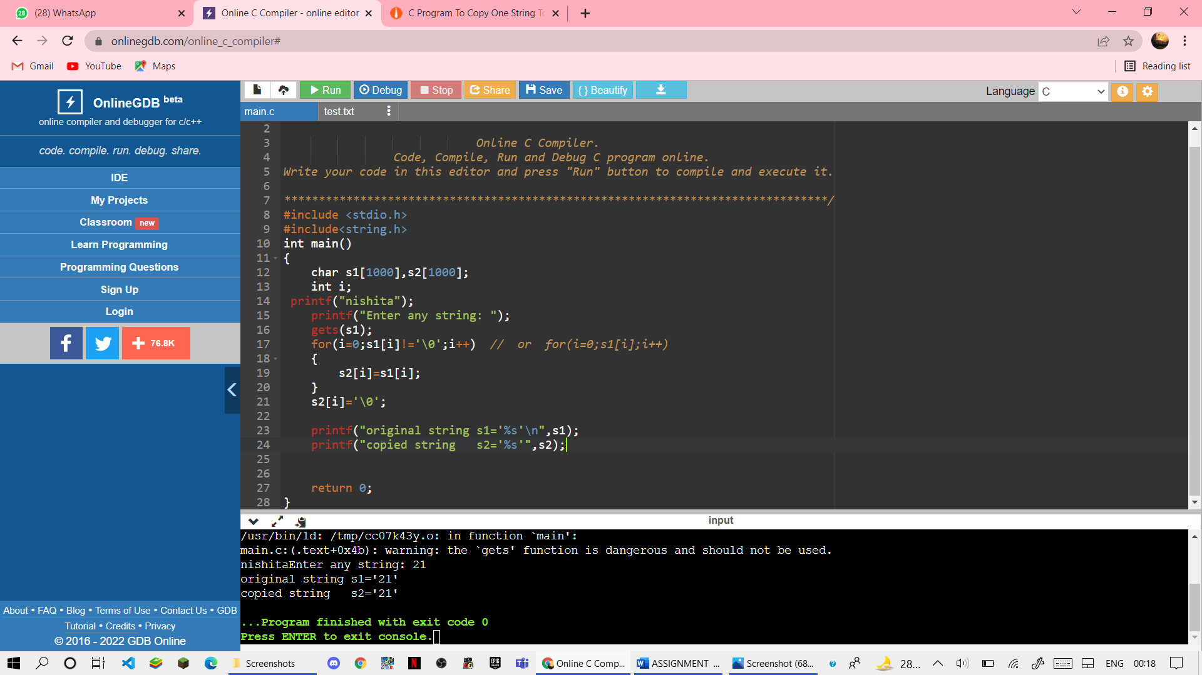

OUTPUT



86) Write a program to read time in string format and extract hours, minutes and second also check time validity.



OUTPUT:-



87) write a program for union function

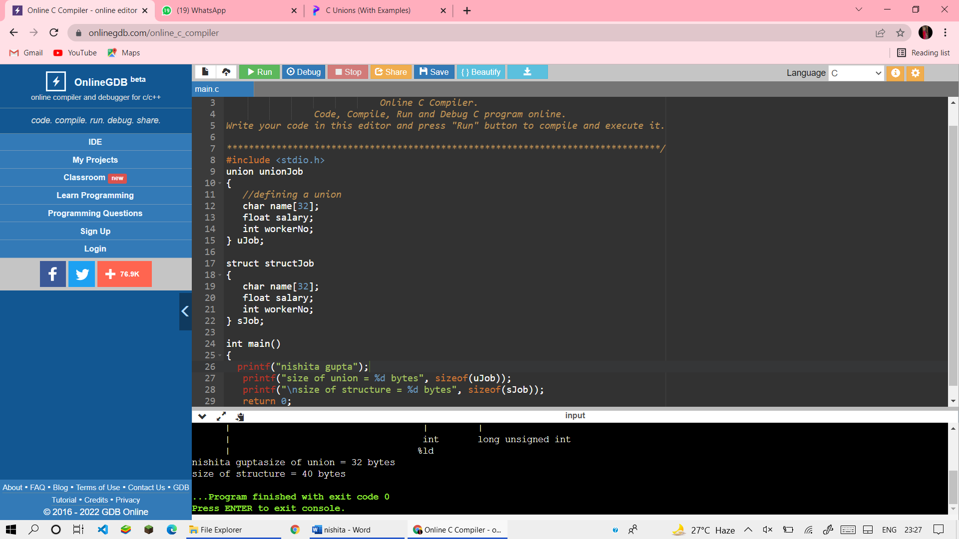

88) write a program to enum function

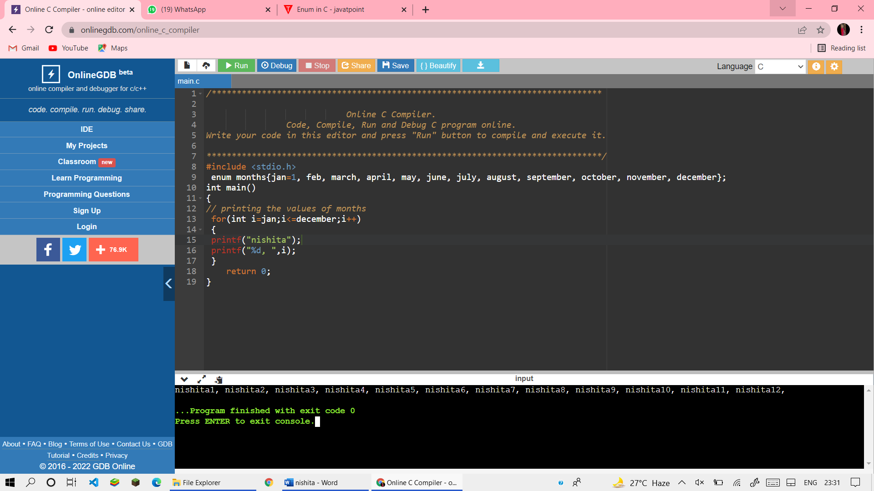

89) write a program to calculate a string using pointer

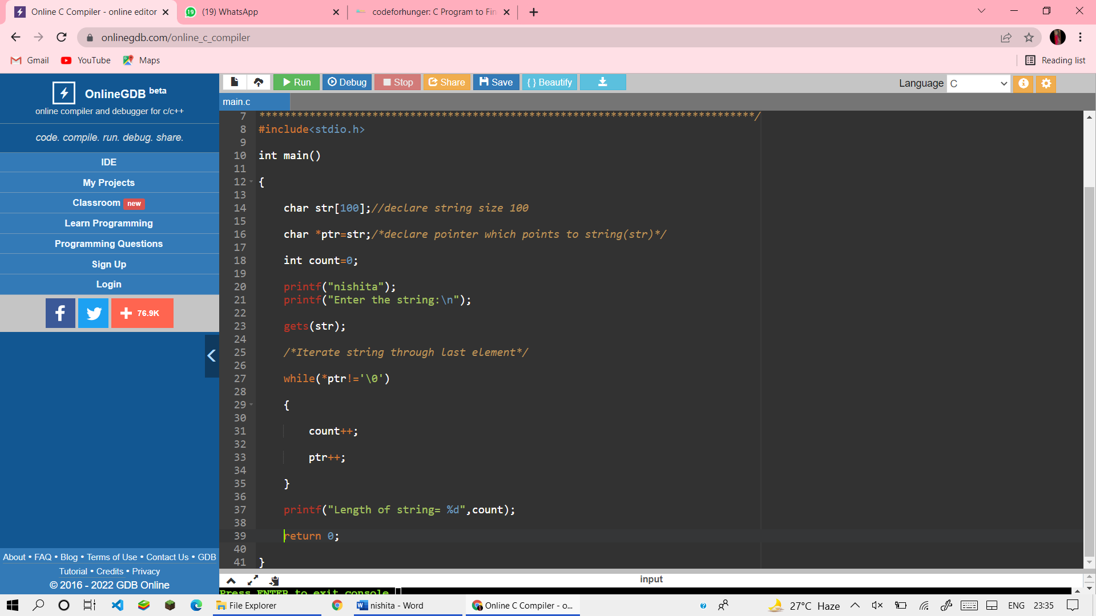

OUTPUT

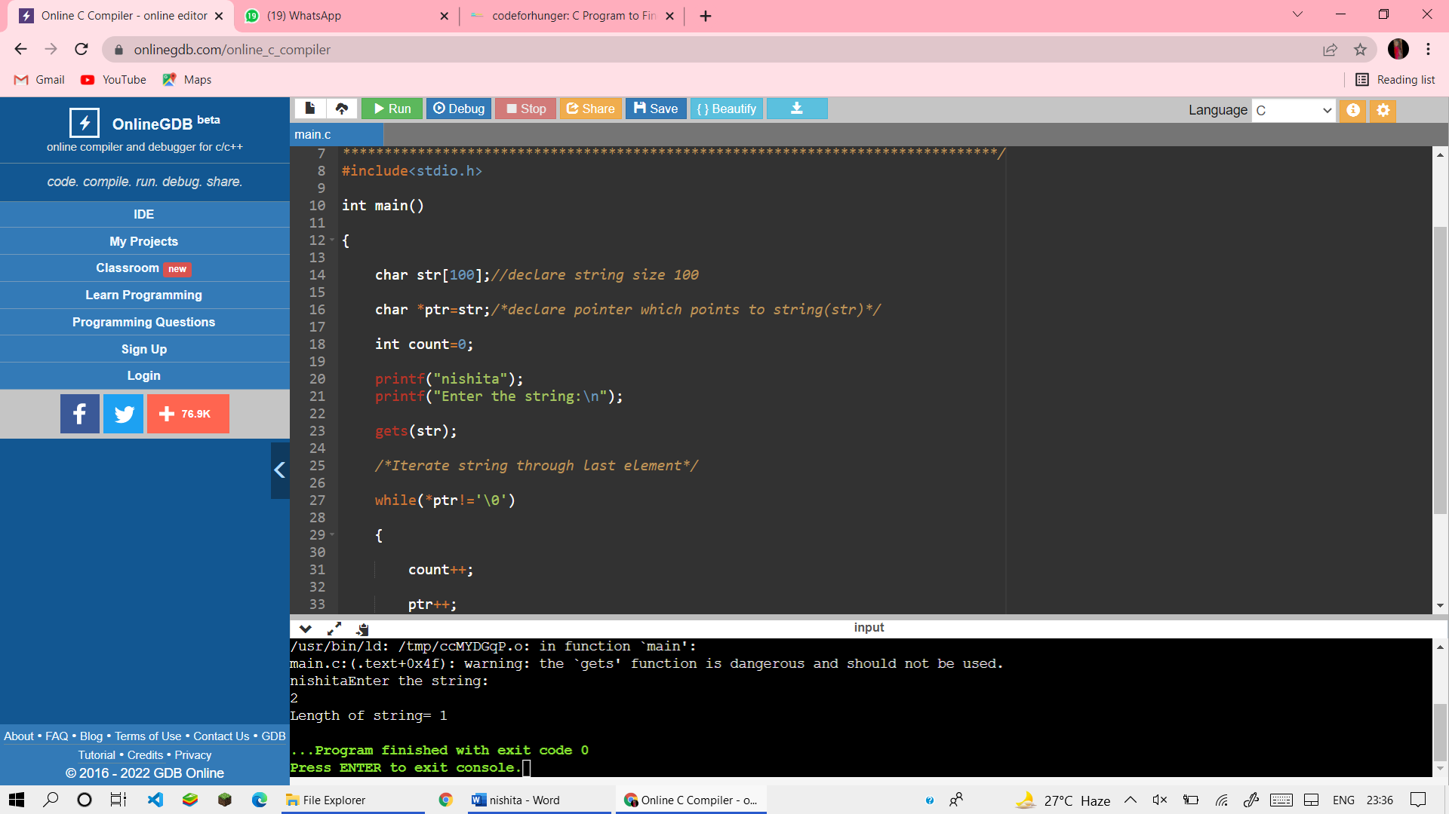

90) WRITE A PROGRAM TO SHOW STRUCTURE FUNCTION

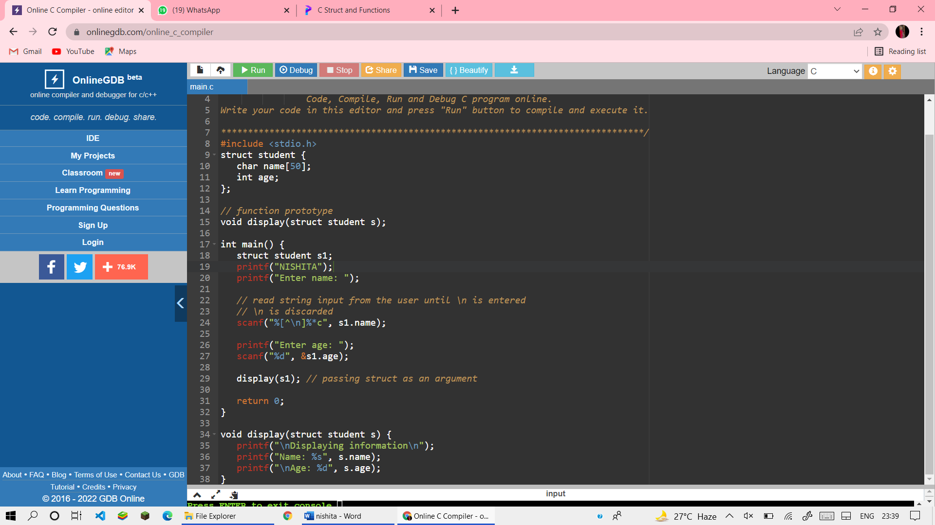

OUTPUT

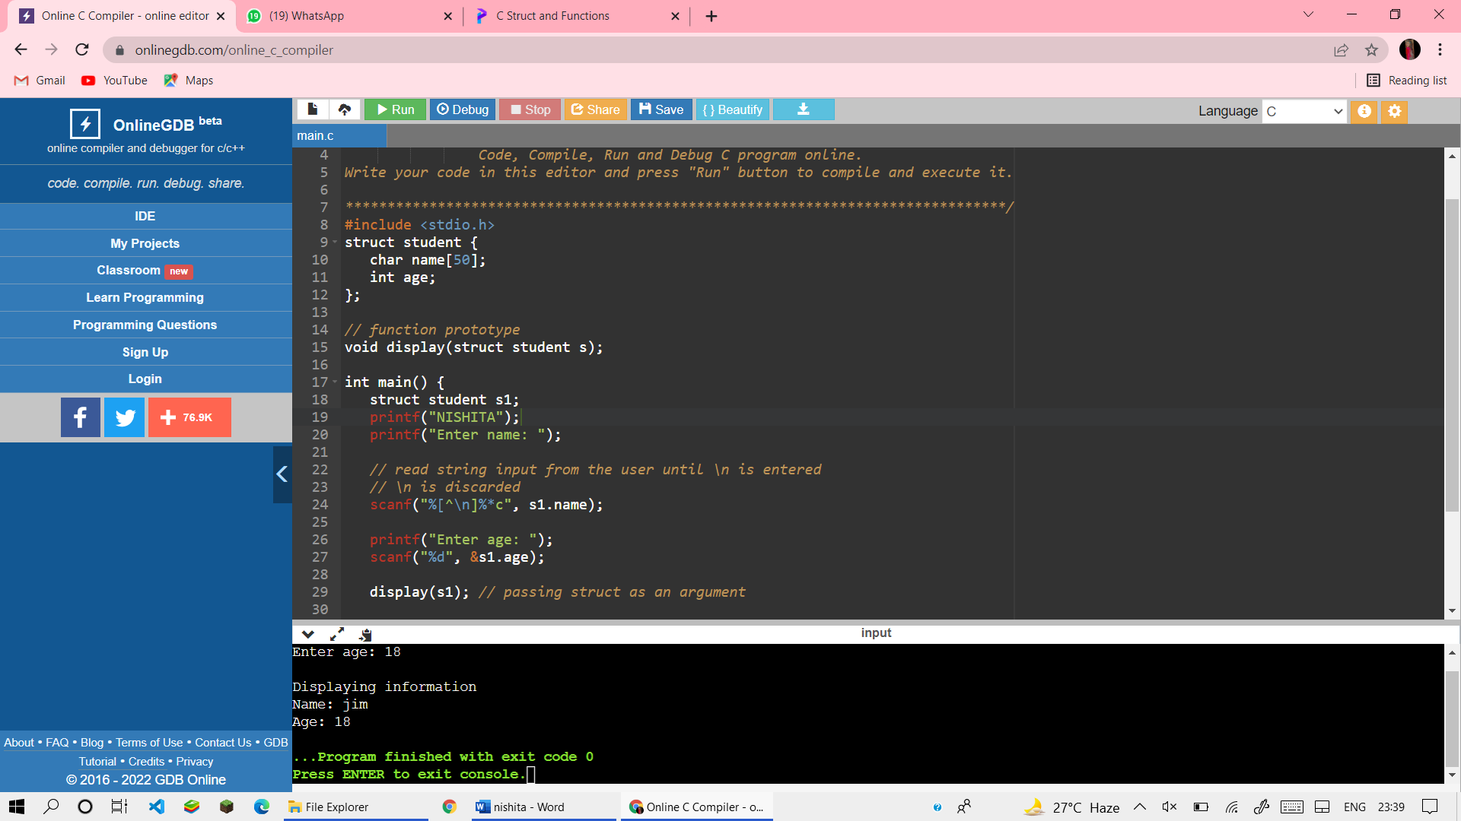

91) write a program to print reverse string using pointer

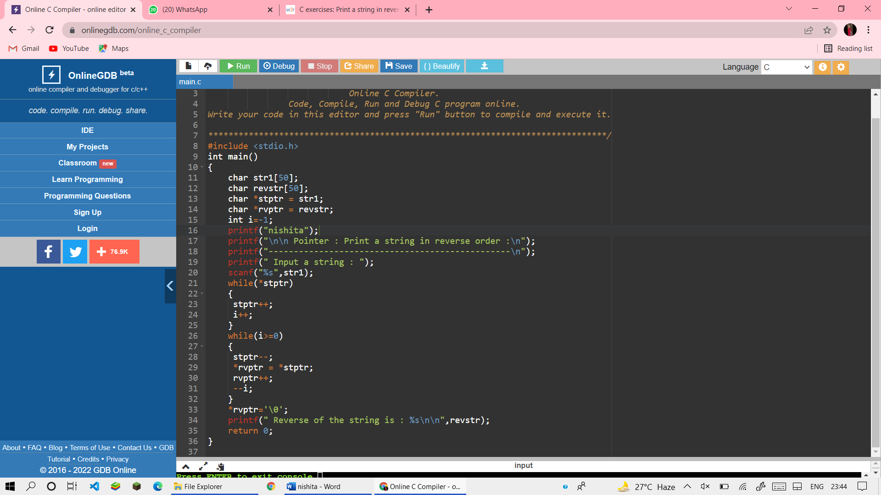

OUTPUT

